Champions 2011

SRF’s Silver Sundown
Eight year-old Silver, is a wonderful horse! He is one of our favorite horses to ride on trail, but he is also spectacular in the show ring whether being ridden by an amateur or a professional. 2010 was a great year for this wonderful stallion. His induction into the AGMH Hall of Fame is testimony to his accomplishments sustained throughout many years of success. On the trail or in the show ring, Silver performs like a true champion. In 2011, SRF’s Silver Sundown will continue his tradition of excellence. He is owned by Steve Heuslein, LaCrescent, MN and trained by Charlie DeAtley. Silver is a breeding stallion. See his pedigree on the Stallion’s page. Just click on previous years to see a record of Silver’s past accomplishments.
- UMH Al Prewitt Memorial Horse Show - Open Western Pleasure - 2nd
- UMH Al Prewitt Memorial Horse Show - Open Amateur Trail - 3rd - Steve
- UMH Al Prewitt Memorial Horse Show - Trail Pleasure Championship - 4th
- UMH North Carolina State Championship - 4+ Open Conformation - 2nd
- UMH North Carolina State Championship - Pro Am Trail Pleasure - 3rd - Charlie & Steve
- UMH North Carolina State Championship - Adult Trail Obstacle - 2nd
- UMH North Carolina State Championship - Stallions Trail Pleasure - 2nd
- UMH North Carolina State Championship - Open Western - 2nd
- UMH North Carolina State Championship - Trail Pleasure Championship - 1st
- UMH North Carolina State Championship - Adult Versatility Award - 1st
- UMH Carson Masters Spring Premier - Adult Trail Obstacle - 1st - Unanimous
- UMH Carson Masters Spring Premier - Stallions Trail - 3rd
- UMH Carson Masters Spring Premier - 4 YO + Open Conf. - 4th
- UMH Carson Masters Spring Premier - Open Western - 2nd
- North Middletown - Stallions Trail - 2nd
- UMH Stidham Memorial - Stallions Trail - 2nd
- UMH Stidham Memorial - Trail Pleasure Championship - 3rd
- UMH Ladies Auxiliary - Open Western - 1st
- UMH Ladies Auxiliary - Stallions Trail - 2nd
- UMH Ladies Auxiliary - Open Amateur Trail - 4th
- UMH Ladies Auxiliary - Adult Trail Obstacle - 1st
- UMH Ladies Auxiliary - Trail Pleasure Championship - 2nd
- UMH Ladies Auxiliary - Versatility Award - 1st
- UMH Bourbon County - Stallions Trail - 1st
- UMH Bourbon County - Trail Pleasure Championship - 1st
- UMH KY State Championship – Trail Obstacle - 3rd
- UMH KY State Championship – Stallions Trail - 5th
- UMH KY State Championship – 4 + Conformation - 5th
- UMH KY State Championship – Open Western - 3rd
- UMH KY State Championship – Trail Pleasure Championship - 5th
- UMH KY State Championship – Adult Versatility Award - 3rd
- RMH KY State Championship - Western Pleasure - 2nd - Robert
- RMH KY State Championship - Amateur Trail - 4th - Kim
- RMH KY State Championship - Trail Pleasure Stallions - 2nd - Robert
- RMH KY State Championship - Working Trail Pleas. w/Obstacles - 3rd
- RMH KY State Championship - Trail Pleas. Championship - 4th - Robert
- RMH Tavares Championship - 5 YO & Over Conf. - 4th - Mike
- RMH Tavares Championship - Western Pleasure - 1st - Robert
- RMH Tavares Championship - Amateur Trail Pleas. - 1st - Kim
- RMH Tavares Championship - Stallions Trail Pleas. - 4th – Robert
- RMH Tavares Championship - Working Trail Pleas. w/Obstacles - 1st - Robert
- UMH/NWHA Gaited Jubilee - Stallions Trail - 1st
- UMH/NWHA Gaited Jubilee - Trail Obstacle - 1st
- UMH/NWHA Gaited Jubilee - Novice Trail - 1st - Kim
- UMH/NWHA Gaited Jubilee - Trail Championship - 4th
- UMH TN State Championship - 4+ Conformation - 5th
- UMH TN State Championship - Open Western - 3rd
- UMH TN State Championship - Adult Trail Obstacle - 2nd
- UMH TN State Championship - Stallions Trail Pleasure - 1st
- UMH TN State Championship - Adult Versatility - 1st
- UMH Summer Celebration - Trail Obstacle - 1st
- UMH Summer Celebration - Stallions Trail Pleasure - 2nd
- UMH Summer Celebration - Open Western - 1st
- UMH Summer Celebration - Trail Pleasure Championship - 3rd
- UMH Summer Celebration - Adult Versatility - 1st
- RMH OH State Championship - 4+ Conformation - 4th
- RMH OH State Championship - Western Pleasure - 2nd
- RMH OH State Championship - Stallions Trail Pleasure - 2nd
- RMH OH State Championship - Trail Pleasure Championship
- RMH Charles Kilburn Memorial - 4+ Conformation - 3rd
- RMH Charles Kilburn Memorial - Western Pleasure - 1st
- RMH Charles Kilburn Memorial - Trail Pleasure Stallions - 2nd
- RMH Charles Kilburn Memorial - Trail Pleasure Championship - 1st
- UMH World Show - Regional Men’s Trail Pleasure - 2nd
- UMH World Show - Pro-Am Trail - 2nd - Steve & Charlie
- UMH World Show - Amateur Trail - 3rd - Steve
- UMH World Show - 4 YO + Stallions In- Hand - 5th
- UMH World Show - Regional Trail Pleasure - 1st - Steve
- UMH World Show - Regional Amateur Trail - 1st
- UMH World Show - Western Pleasure Sr. Horse - 3rd
- UMH World Show - Trail Obstacle Sr. Horse - 2nd
- UMH World Show - Amateur Trail World Grand Champ. - 3rd - Steve
- UMH World Show - Trail Pleasure World Grand Champ. - 6th
- UMH World Show - Open Western World Grand Champ. - 1st (Unanimous)
- RMH International - 5-8 YO Amateur Trail - 2nd - Steve
- RMH International - Amateur Trail Pleas. Grand Champ. - 10th - Steve
- RMH International - 5-8 YO Stallions Trail - 1st
- RMH International - Adult Trail Obstacle - 1st
- RMH International - Pole Bending - 7th
- RMH International - 5+ Stallions Conformation - 6th
- RMH International - 5-8 Western Pleasure - 2nd
- RMH International - Stallion Championship Trail - 6th
- RMH International - Water Glass - 5th
- RMH International - Western Pleasure Grand Championship - 1st (unanimous)
- KMSHA International - Stallion 4+ Conformation - 3rd
- KMSHA International - Open Western Pleasure - 1st (Unanimous)
- KMSHA International - Stallions Trail 7 YO+ - 1st
- KMSHA International - Adult Trail Obstacle - 4th
- KMSHA International - 7 + YO Conformation Championship - 2nd
- RMH Conformation (5 Years & Older) - 4th
- RMH Trail Pleas. Stallions - 2nd
- RMH Western Pleasure - 2nd
- RMH Amateur Trail Pleas. - Kim - 2nd
- RMH Working Trail w/Obst. - Robert - 1st
- UMH High Points - Open Western - 2nd
- UMH High Points - Stallions Trail - 1st
- UMH High Points - Adult Trail Obstacle - 1st
- UMH High Points - Adult Versatility - 1st
- UMH High Points - Trail Pleasure Championship - 2nd
^{[top of page]}

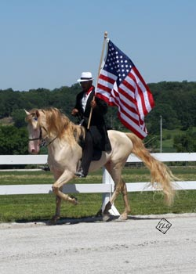
MX Wrangler
Wrangler is a beautiful smoky crème 5 year old stallion with a fantastic temperament! He is a horse with a lot of talent. He has an easy going nature about him and takes everything in stride. He carries the flag with pride, performs well in trail obstacle, and wins on the rail. He has a beautiful canter in the Open Four Gait Class. In 2010 Wrangler was the RMH Show Pleasure Kentucky State Champion, the UMH Super Horse Award Winner, and the KMSHA Al Prewitt Versatility Award winner. We are excited to have this talented stallion in our barn. If you are looking to add a little color to your herd, take a look at Wrangler. He is quadruple registered as well. We know you’ll be as impressed as we are. He is owned by Jim and Kathy Wilkerson from Wappapello, MO and he’s being trained and shown by Michael Butler. For more information, see his pedigree on the stallion page.
- UMH North Carolina State Championship - Classic Pleasure
Stallions- 3rd
- UMH North Carolina State Championship - Open 4 Gait - 1st
- UMH Carson Masters Spring Premier - Adult Trail Obstacle - 5th
- UMH Carson Masters Spring Premier - Stallions Classic - 5th
- UMH Carson Masters Spring Premier - Novice Classic - 1st - Megan Ryan
- UMH Carson Masters Spring Premier - Open 4 Gait - 1st
- Selected as a Finalist for ACTHA’s America’s Favorite Trail Horse
- UMH Stidham Memorial - Open 4 Gait - 1st
- UMH Ladies Auxiliary - Trail Obstacle - 5th
- UMH Ladies Auxiliary - Open 4 Gait - 1st
- UMH Ladies Auxiliary - Stallions Classic - 1st
- UMH Ladies Auxiliary - Classic Championship - 3rd
- UMH Ladies Auxiliary - Versatility Award - 2nd
- UMH Bourbon County - Stallions Classic - 3rd
- UMH Bourbon County - Open 4 Gait - 4th
- UMH KY State Championship – Open 4 Gait - 2nd
- UMH KY State Championship – Trail Obstacle - 4th
- RMH KY State Championship - 4 & 5 YO Show Pleas. - 3rd
- RMH KY State Championship - Show Pleasure Stallions - 3rd
- RMH Tavares Championship - Amateur Show Pleas. - 3rd - Jim
- RMH Tavares Championship - 4 & 5 YO Show Pleas. - 2nd
- RMH Tavares Championship - Show Pleas. Championship - 4th
- UMH/NWHA Gaited Jubilee - Trail Obstacle - 2nd
- UMH/NWHA Gaited Jubilee - Stallions Classic - 2nd
- UMH/NWHA Gaited Jubilee - Open 4 Gait - 1st - Robert
- UMH Summer Celebration - Trail Obstacle - 5th
- UMH Summer Celebration - Open Four Gait - 1st
- RMH International - Adult Trail Obstacle - 8th (30 entries)
- RMH International - 5+ Stallions Conformation - 10th
- UMH World Show - Pro-Am Classic - 4th
- UMH World Show - Trail Obstacle Novice Horse and Rider - 1st
- UMH World Show - Open 4 Gait - 3rd
- RMH Show Pleasure Stallions - 3rd
- RMH Show Pleasure Championship - 2nd
- UMH High Points - Open 4 Gait - 1st
- UMH High Points - Stallions Classic Pleasure - 2nd
^{[top of page]}
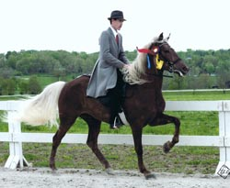
Blueberry Wine
A thrill to watch and a pleasure to ride, Blueberry Wine will continue her show career this year. She is a beautiful mare that is strong and consistent in her gait. Blueberry’s temperament is exceptional. She was the UMH Classic Pleasure Championship High Point award winner in 2010 as well as being a member to the Rocky Mountain Quadrille for the World Equestrian Games. Look for her in versatility events, Classic Pleasure under saddle classes, amateur, and juvenile classes. Blueberry is owned by Steve Heuslein of LaCrescent, MN and is trained by Charlie DeAtley.
- UMH Al Prewitt Memorial Horse Show - Open Amateur Classic Pleasure - 2nd - Steve
- UMH Al Prewitt Memorial Horse Show - Classic Pleasure Championship - 4th
- UMH North Carolina State Championship - 4+ Open Conformation - 5th
- UMH North Carolina State Championship - Adult Trail Obstacle - 3rd
- UMH North Carolina State Championship - Classic Pleasure Championship - 3rd
- UMH North Carolina State Championship - Juvenile 12 – 17 - 2nd - Thomas Howard
- UMH Carson Masters Spring Premier - Youth 12 – 17 Classic - 2nd - Thomas
- UMH Carson Masters Spring Premier - Classic Pleasure Championship - 5th
- North Middletown - Lead line - Ruby
- North Middletown - Mares Classic Pleasure 2nd
- North Middletown - Juvenile 12 – 17 Classic - Thomas - 1st
- North Middletown - Classic Pleasure Championship - 4th
- UMH Ladies Auxiliary - Mares Classic - 2nd
- UMH Bourbon County - Lead Line - 1st - Ruby
- UMH Bourbon County - Youth 12 – 17 Classic - 4th - Thomas
- UMH Bourbon County - Mares Classic Pleasure - 3rd
- UMH KY State Championship – Trail Obstacle - 1st
- UMH KY State Championship – Am Classic - 3rd - Steve
- UMH KY State Championship – Mares Classic - 4th
- UMH KY State Championship – Adult Versatility Award - 1st
- RMH KY State Championship - 5 YO & Over Conf. - 5th
- RMH KY State Championship - Show Pleas. Mares - 2nd
- RMH KY State Championship - Show Pleas. Championship - 3rd
- RMH Tavares Championship - Show Pleas. Mares - 3rd
- RMH Tavares Championship - Show Pleas. Championship - 1st
- UMH/NWHA Gaited Jubilee - Mares Classic - 2nd
- UMH/NWHA Gaited Jubilee - Classic Pleas. Championship - 2nd
- UMH/NWHA Gaited Jubilee - Trail Obstacle - 4th
- UMH TN State Championship - Mares Classic - 2nd
- UMH TN State Championship - Adult Trail Obstacle - 4th
- UMH Summer Celebration - Trail Obstacle 4th
- RMH OH State Championship - Show Pleasure Mares - 2nd
- RMH OH State Championship - Show Pleasure Championship - 2nd
- RMH Charles Kilburn Memorial - Charles Kilburn Championship - 2nd
- RMH International - 5-8 YO Amateur Show Pleasure - 2nd
- RMH International - 5-8 Mares Show Pleasure - 1st
- RMH International - Mares Show Pleasure Championship - 4th
- RMH International - Show Pleasure Championship - 6th
- RMH International - 5+ Mares & Geldings Conformation - 5th
- KMSHA International - Men’s Open Classic - 4th
- KMSHA International - Mare/Gelding 5-6 YO Classic - 5th
- KMSHA International - Mare/Gelding Classic Pleasure Championship - 2nd
- KMSHA International - Adult Trail Obstacle - 2nd
- RMH Show Pleasure Mares - 2nd
- RMH Show Pleasure Championship - 2nd
- UMH High Points - Adult Trail Obstacle - 3rd
- UMH High Points - Mares Classic Pleasure - 2nd
- UMH High Points - Classic Pleasure Championship - 3rd
^{[top of page]}
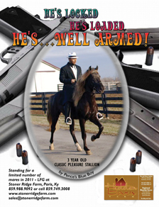
Well Armed
Sired by Pence’s Blue Boy, Well Armed is making his show ring debut in 2011. He has a boat load of talent and with his breeding he is sure to be something special. He has an awesome temperament, gait, and conformation. He’s surefooted and sweet. We are looking forward to seeing his full potential unfold. Well Armed is owned by Don & Nancy Copland and is being trained by Michael Butler.
- North Middletown - 3 Year Old Stallions/Geldings - 3rd
- UMH Stidham Memorial - 3 YO Stallions/Geld. Classic - 4th
- UMH Ladies Auxiliary - 3 YO Stallions/Geld. Classic - 3rd
- UMH Summer Celebration - 2 & 3 YO Trail Pleasure - 4th
- UMH Summer Celebration - 2 & 3 YO Conformation - 4th
- UMH World Show - 2-3 YO Trail Stallions/Geldings - 4th
- UMH World Show - 2-3 YO Stallions/Geldings In-Hand - 4th
- UMH World Show - Western Pleasure Jr. Horse - 2nd
- UMH World Show - Trail Obstacle Jr. Horse - 4th
- UMH World Show - Trail Obstacle Novice Horse & Rider - 2nd
- UMH World Show - Men’s Trail Pleasure - 4th
- RMH International - 3 YO Western Pleasure - 1st
- RMH International - 3 YO Stallions Conformation - 5th
- RMH International - 3 YO Stallions Trail Pleasure - 2nd
- RMH International - 3 YO Stallions Show Pleasure - 4th
^{[top of page]}

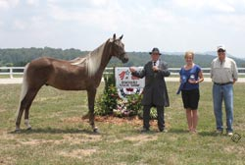
Branson Blue
An up and coming 3 year old, Branson exudes talent on every level. He was the UMH 2 Year Old Classic High Point winner in 2010. He is calm and easy going as he works his way through trail obstacle and is a beauty as he stands for inspection during conformation classes. In 2011 Branson has moved to the 3 – 4 year old Park Division. If you crave excitement, he is one to watch. His natural talent is awesome! Branson is owned by Steve Heuslein, LaCrescent, MN and is trained by Charlie DeAtley.
- UMH Al Prewitt Memorial Horse Show - 3 & 4 YO Park Pleasure - 1st
- UMH North Carolina State Championship - Adult Trail Obstacle - 7th
- UMH North Carolina State Championship - 2 & 3 YO Open Conformation - 1st
- UMH North Carolina State Championship - Adult Versatility - 4th
- UMH Carson Masters Spring Premier - 3 & 4 YO Park - 4th
- UMH Carson Masters Spring Premier - 2 & 3 YO Open Conf. - 3rd
- North Middletown - 3 & 4 Year Old Park - 1st
- UMH Ladies Auxiliary - 3 & 4 YO Open Park - 4th
- UMH Ladies Auxiliary - 2-3 YO Open Conformation - 3rd
- UMH Bourbon County - 3 & 4 YO Park - 3rd
- UMH KY State Championship – 3 & 4 YO Park - 4th
- UMH KY State Championship – 2 & 3 YO Conformation - 4th
- UMH KY State Championship – Pro Am Park - 3rd - Charlie & Steve
- UMH KY State Championship – Adult Versatility Award - 4th
- UMH/NWHA Gaited Jubilee - 2 & 3 YO Conformation - 2nd
- UMH TN State Championship - 3 & 4 YO Open Park - 2nd
- UMH TN State Championship - Adult Trail Obstacle - 3rd
- UMH TN State Championship - 2-3 Jr. Conformation - 2nd
- UMH TN State Championship - Adult Versatility - 3rd
- UMH Summer Celebration - 3 & 4 YO Park - 2nd
- UMH Summer Celebration - 2 & 3 YO Conformation - 2nd
- UMH Summer Celebration - Pro-Am Park - 1st - Charlie & Steve
- UMH Summer Celebration - Adult Versatility - 2nd
- UMH World Show - 2-3 YO Stallions & Geldings In-Hand - 6th
- UMH World Show - 3-4 YO Stallions & Geldings Park - 5th
- UMH World Show - 4 & Under Western Pleasure Jr. Horse - 3rd
- UMH World Show - Trail Obstacle Jr. Horse - 1st
- RMH International - 3 YO Amateur Show Pleasure - 4th - Steve
- RMH International - 3 YO Mares & Geldings Conformation - 2nd
- RMH International - 3 YO Conformation Championship - 3rd
- RMH International - Conformation Grand Champ. - 8th
- RMH International - 3 YO Geldings Show Pleasure - 2nd
- RMH International - Geldings Championship Show Pleasure - 2nd
- RMH International - Show Pleasure Grand Championship - 5th
- RMH International - Sam Tuttle Memorial Award
- KMSHA International - Mare/Gelding 2-3 YO Conformation - 5th
- UMH High Points - 3-4 YO Open Park Pleasure - 1st
- UMH High Points - 2-3 YO Open Conformation
^{[top of page]}
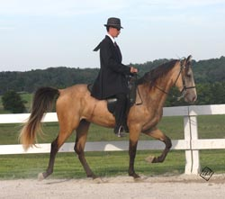
Sam's Little Buddy
A rare silver buckskin, Buddy has many talents even at his young age. He is a balanced mover under saddle or as he cantering around the ring in the Open 4 Gait class. He picks his way carefully through trail obstacle and takes care of his owner when they show in the amateur or novice classes. Buddy is sure and steady. We’re looking forward to him being part of the SRF line-up again this year. Buddy is owned by Tim and Marcia Spencer. He’s trained by Robert Lawson.
- UMH Al Prewitt Memorial Horse Show - 2 & 3 YO Open Trail Pleasure - 2nd
- UMH Al Prewitt Memorial Horse Show - Novice Rider Open Trail - 2nd - Tim
- UMH North Carolina State Championship - Open 4 Gait - 4th
- UMH North Carolina State Championship - 2 & 3 YO Open Trail Pleasure - 3rd - Tim
- UMH Carson Masters Spring Premier - 2 & 3 YO Trail - 5th - Tim
- UMH Stidham Memorial - Geldings Trail - 2nd
- UMH Stidham Memorial - Amateur Trail - 3rd - Tim
- UMH Stidham Memorial - Novice Trail - 1st - Tim
- UMH Stidham Memorial - Open 4 Gait - 4th
- UMH Ladies Auxiliary - Amateur Trail - 5th - Tim
- UMH Ladies Auxiliary - Open Novice - 3rd
- UMH Bourbon County - Open Amateur Trail - 1st
- UMH Bourbon County - Open Novice Trail - 2nd
- UMH Bourbon County - Geldings Trail - 3rd
- UMH High Points - Novice Trail - 3rd - Tim Spencer
- UMH High Points - 2-3 YO Trail Pleasure
^{[top of page]}
RRF Gold Nugget
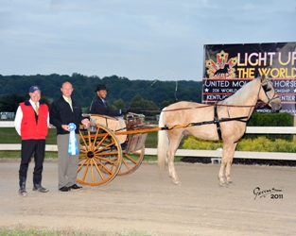
2009 Sam Tuttle Memorial Award winner RRF Gold Nugget has come out strong again in 2011. He won the Al Prewitt Performance Award for the second year in a row in North Carolina. His excellent versatility skills allow him to be competitive in Conformation, Trail Obstacle, Open Driving, Pro-Am, and in on-the-rail classes. His owner, Steve Heuslein from LaCrescent, MN, shows him in the Open Amateur Classic Division as well. He is being trained by Michael Butler. Look for this beautiful palomino in the show ring this year. He is truly a joy to watch.
- UMH Al Prewitt Memorial Horse Show - Men’s Open Classic Pleasure - 4th
- UMH North Carolina State Championship - 4+ Conformation - 6th
- UMH North Carolina State Championship - Adult Trail Obstacle - 1st
- UMH North Carolina State Championship - Geldings Classic - 2nd
- UMH North Carolina State Championship - Adult Versatility - 5th
- UMH North Carolina State Championship - Classic Pleasure Championship - 5th
- UMH Al Prewitt/North Carolina State Championship - Al Prewitt Performance Award
- UMH Carson Masters Spring Premier - Adult Trail Obstacle - 3rd
- UMH Carson Masters Spring Premier - Pro-Am Classic - 3rd
- UMH Carson Masters Spring Premier - Geldings Classic - 3rd
- UMH Ladies Auxiliary - Geldings Classic - 1st
- UMH Ladies Auxiliary - Trail Obstacle - 3rd
- UMH Ladies Auxiliary - Pro-Am Classic - 3rd - Steve & Charlie
- UMH Ladies Auxiliary - Classic Championship - 4th
- UMH Ladies Auxiliary - Versatility Award - 3rd
- UMH Bourbon County - Geldings Classic - 3rd
- RMH KY State Championship - 5 YO & Over Conf. - 4th
- RMH KY State Championship - Youth (12-17) Show Pleas. - 2nd - Thomas
- RMH KY State Championship - Show Pleas. Geldings - 2nd
- RMH KY State Championship - Youth (7-17) Show Pleas. Championship - 2nd
- RMH Tavares Championship - 5 YO & Over Conf. - 5th - Kim
- RMH Tavares Championship - Youth (12-17) Show Pleas. - 5th - Thomas
- RMH Tavares Championship - Show Pleas. Geldings - 2nd
- RMH Tavares Championship - Youth (7-17) Show Pleas. Championship - 3rd
- UMH/NWHA Gaited Jubilee - Trail Obstacle - 5th
- UMH TN State Championship - 4+ Conformation - 6th
- UMH TN State Championship - Adult Trail Obstacle - 1st
- UMH TN State Championship - Geldings Classic - 3rd
- UMH TN State Championship - Classic Pleasure Champ. - 6th
- UMH TN State Championship - Juve. 12 – 17 Classic - 4th - Thomas
- UMH TN State Championship - Adult Versatility - 5th
- UMH Summer Celebration - Trail Obstacle - 3rd
- UMH Summer Celebration - Pro-Am Classic - 3rd - Mike & Steve
- UMH Summer Celebration - Adult Versatility - 5th
- RMH OH State Championship - Show Pleasure Geldings - 1st
- RMH OH State Championship - Show Pleasure Championship - 1st
- RMH Charles Kilburn Memorial - Show Pleasure Geldings - 1st
- RMH Charles Kilburn Memorial - Charles Kilburn Championship - 3rd
- UMH World Show - 4+ Geldings In-Hand - 3rd
- UMH World Show - Pro-Am Classic - 5th - Kim & Robert
- UMH World Show - Regional Am. Classic - 2nd - Steve
- UMH World Show - Trail Obstacle Sr. Horse - 6th
- UMH World Show - Trail Obstacle Novice Horse and Rider - 3rd
- UMH World Show - Open Pleasure Driving - 1st
- RMH International - Men’s Amateur Show Pleasure - 1st - Steve
- RMH International - 5+ Mares & Geldings Show Pleasure - 1st
- RMH International - Pleasure Driving - 1st
- RMH International - Geldings Show Pleasure Championship - 5th
- KMSHA International - Mare/Gelding 4 YO + Conformation - 4th
- KMSHA International - Mare/Gelding 7 YO + Classic - 3rd
- KMSHA International - Adult Trail Obstacle - 2nd
- KMSHA International - Driving - 1st (Unanimous)
- KMSHA International - 7 + YO Conformation Championship - 3rd
- RMH Show Pleas. Geld. - 1st
- RMH Conformation (5 Years & Older) - 4th
- UMH High Points - Geldings Classic Pleasure - 1st
- UMH High Points - Adult Trail Obstacle - 2nd
^{[top of page]}
HP’s Ticket to Ride
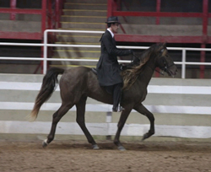
Many folks may remember a very talented mare shown a few years ago by Charlie - My Best Friend Gail. T.K. is a cross between this outstanding mare and Merry Go Blue. Three year old T.K. is an up and coming colt that is very impressive. He’s well balanced and sure footed. He is consistent in his gait and has so many qualities . . . you’ll definitely want to see this impressive fella. We’re looking forward to watching his strengths unfold this year. T.K. is owned by Scott and Barrie Hughes. He’s being trained by Charlie DeAtley.
- UMH Al Prewitt Memorial Horse Show - 2 & 3 YO Open Trail Pleasure - 4th
- UMH North Carolina State Championship - 2 & 3 YO Open Trail Pleasure - 1st
- UMH Carson Masters Spring Premier - 2 & 3 YO Trail Pleasure - 2nd
- UMH Ladies Auxiliary - 2 & 3 YO Open Trail - 2nd
- UMH KY State Championship – 2 & 3 YO Trail - 3rd
- UMH KY State Championship – Trail Pleasure Championship - 4th
- UMH/NWHA Gaited Jubilee - 2 & 3 YO Open Trail - 2nd
- UMH TN State Championship - 4 + Conformation - 3rd - Lisa
- UMH TN State Championship - Open Western - 5th - Mike
- UMH TN State Championship - CTP Mares - 3rd
- UMH TN State Championship - Adult Trail Obstacle - 6th
- RMH TN State Championship - Open CTP - 1st
- UMH TN State Championship - CTP Championship - 5th - Robert
- UMH TN State Championship - Adult Versatility - 4th
- UMH TN State Championship - Stallions Trail Pleasure - 4th
- UMH TN State Championship - 2-3 YO Open Trail - 2nd
- UMH Summer Celebration - 2 & 3 Yo Trail - 3rd
- UMH World Show - Open 2-3 YO Trail Pleasure Stallions/Geldings - 3rd
- UMH World Show - Open 2-3 YO Open Trail Pleasure World Grand Ch. - 4th
- RMH International - Men’s Trail Pleasure - 10th
- RMH International - 3 YO Stallions Trail - 3rd
- KMSHA International - Stallions Trail 3-4 YO - 4th
- UMH High Points - 2-3 YO Trail Pleasure - 1st
^{[top of page]}
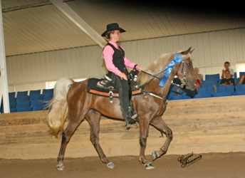
My Sweet Sydney
Five year old Sydney, demonstrated her talent last year when she won the RMH International Open Western class with a professional and won the Amateur Trail Pleasure Class with her owner by unanimous decision. Sydney is intelligent and curious. She is a beauty as well. We are looking forward to working with Sydney as she shows this year in versatility events in the Country Trail Division with her trainer, Charlie DeAtley, and with her owner, Steve Heuslein, LaCrescent, MN.
- UMH Al Prewitt Memorial Horse Show - Open Amateur Country Trail Pleasure - 2nd - Steve
- UMH Al Prewitt Memorial Horse Show - Open Western Pleasure - 5th - Mike Butler
- UMH Al Prewitt Memorial Horse Show - Country Trail Pleasure Championship - 2nd
- UMH North Carolina State Championship - Open Western - 5th - Mike
- UMH North Carolina State Championship - Country Trail Pleasure Mares - 3rd
- UMH North Carolina State Championship - Adult Trail Obstacle - 6th
- UMH Carson Masters Spring Premier - Adult Trail Obstacle - 4th
- UMH Carson Masters Spring Premier - Pro-Am - 3rd - Charlie & Steve
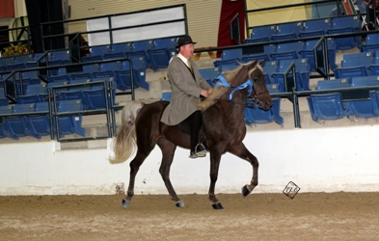
- UMH Carson Masters Spring Premier - Amateur CTP - 2nd - Steve
- UMH Carson Masters Spring Premier - Mares CTP - 4th
- UMH Ladies Auxiliary - Open Western - 3rd - Michael
- UMH Ladies Auxiliary - Mares CTP - 5th
- UMH Ladies Auxiliary - Trail Obstacle - 4th
- UMH Ladies Auxiliary - Open Amateur CTP - 3rd
- UMH Ladies Auxiliary - Versatility Award - 4th
- UMH Bourbon County - Mares Country Trail - 4th
- UMH KY State Championship – Amateur CTP - 1st - Steve
- UMH KY State Championship – Pro Am CTP - 2nd - Charlie & Steve
- UMH KY State Championship – Mares CTP - 2nd
- UMH KY State Championship – Adult Versatility Award - 5th
- RMH KY State Championship - Country Trail Pleas. Mares - 1st
- RMH KY State Championship - Working Trail Pleas. w/Obstacles - 2nd
- RMH KY State Championship - Country Trail Pleas. Championship - 1st - Robert
- RMH Tavares Championship - Country Trail Pleas. Mares - 1st
- RMH Tavares Championship - Working Trail Pleas. w/Obstacles - 3rd - Mike
- RMH Tavares Championship - Country Trail Pleas. Championship - 2nd - Robert
- UMH Summer Celebration - Trail Obstacle - 2nd
- UMH Summer Celebration - Pro-Am Country Trail - 4th - Charlie & Steve
- UMH Summer Celebration - Amateur CTP - 4th - Steve
- UMH Summer Celebration - Adult Versatility - 4th
- RMH OH State Championship - Western Pleasure - 3rd
- RMH OH State Championship - Country Trail Pleasure Mares - 3rd
- RMH OH State Championship - Country Trail Pleasure Champ. - 3rd
- RMH Charles Kilburn Memorial - Western Pleasure - 4th
- RMH Charles Kilburn Memorial - Country Trail Pleasure Mares - 4th
- UMH World Show - Regional CTP - 4th - Steve
- UMH World Show - 4+ Mares In-Hand - 5th
- UMH World Show - Amateur CTP World Grand Champ. - 5th
- RMH International - Amateur Country Trail - 3rd
- RMH International - Men’s Country Trail Pleasure - 1st - Steve
- RMH International - 5+ Mares & Geldings Country Trail - 4th
- RMH International - Mares Country Trail Championship - 5th - Robert
- RMH International - 5+ Mares & Geldings Conformation - 4th
- RMH International - Country Trail Pleasure Grand Championship - 4th
- RMH International - Open Western Pleasure - 4th
- RMH International - Adult Trail Obstacle - 4th
- RMH International - Conformation Grand Championship - 9th
- RMH International - 5+ Conformation Championship - 4th
- KMSHA International - Open Western Pleasure - 4th
- KMSHA International - Open CTP - 3rd
- RMH Country Trail Pleas. Mares - 2nd
- RMH Western Pleasure - 2nd
- RMH Working Trail w/Obst. - Michael - 2nd
- RMH CTP Championship - Robert - 2nd
- UMH High Points - Amateur Country Trail Pleasure - 2nd - Steve
- UMH High Points - Mares Country Trail Pleasure - 3rd
- UMH High Points - Open Western - 3rd UMH High Points

^{[top of page]}
HBF Furious Revenge
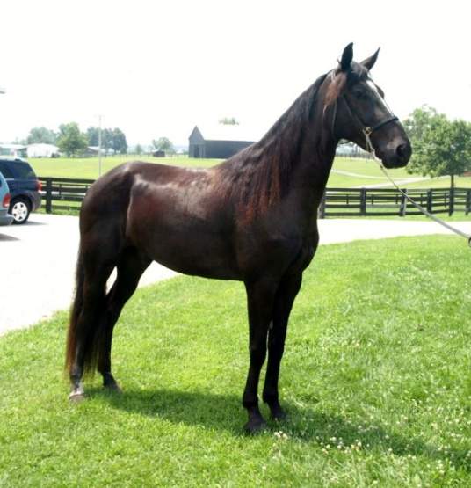
Style baby style is what you’ll see with three year old Furious Revenge better known as “Duncan” around the barn. He has conformation that allows him to move well under saddle and really get your attention in the show ring. He will be showing in the Classic Pleasure Division. You won’t want to miss this youngster’s exciting performances. Duncan is owned by Don and Nancy Copland and is being trained by Robert Lawson.
- UMH Al Prewitt Memorial Horse Show - 3 YO Stallions & Geldings Classic - 4th
- UMH North Carolina State Championship - GAYP Gaited - 1st
- UMH Carson Masters Spring Premier - 3 YO Stallions/Geld - 5th
- North Middletown - 3 Year Old Stallions/Geldings - 5th
- UMH Stidham Memorial - 3 YO Stallions/Geld. Classic - 5th
- UMH Ladies Auxiliary - 3 YO Stallions/Geld. Classic - 4th
- UMH Summer Celebration - 3 YO Stallions & Geldings Classic - 5th
- UMH Summer Celebration - Geldings Classic Pleasure - 5th
- UMH World Show - Classic Pleasure Novice Horse - 2nd
- UMH World Show - 3 YO Classic Stallions/Geldings - 4th
- UMH World Show - 3 YO Classic World Grand Champ - 2nd
- RMH International - 3 YO Geldings Show Pleasure - 4th
^{[top of page]}
LRR Jimmy Joe
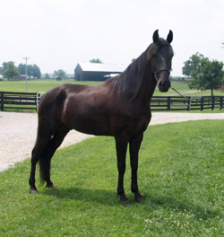
Excitement is generated when Jimmy Joe enters the ring. He has a style and quality all his own. His presence is eye-catching as he shows in the Classic Pleasure Division. Jimmy Joe is co-owned by Tim & Marcia Spencer and the Howards: Timmy, Fran, and Thomas. They will be showing him in novice, amateur, and juvenile classes. He is being trained by Charlie DeAtley.
- UMH Al Prewitt Memorial Horse Show - SE Regional Classic Pleasure - 2nd
- UMH North Carolina State Championship - GAYP Gaited - 2nd
- UMH Carson Masters Spring Premier - Geldings Classic - 5th
- UMH Ladies Auxiliary - Geldings Classic - 2nd
- UMH Ladies Auxiliary - Hats Off to Charlie . . . - 2nd
- UMH Bourbon County - Geldings Classic - 4th
- UMH Summer Celebration - Geldings Classic - 5th
- UMH World Show - Open Classic Pleasure Novice Horse - 5th
- UMH World Show - Open Men’s Classic Pleasure - 6th
- RMH International - 5-8 YO Geldings Show Pleasure - 4th
- RMH International - Men’s Show Pleasure - 8th
^{[top of page]}
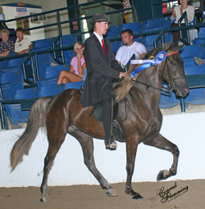
Pepper’s Capital Venture
Capital Venture made his show-ring debut during the Kentucky State Championship in 2008 at the new Kentucky Equestrian Center in Winchester. He did a great job! Venture is fluid and exciting to watch. He has an outstanding gait and a beautiful flowing mane. We’re going to enjoy watching this 5 year old in 2011. He is talented and accomplished – winning a High Point Award in both years of showing. Watch for him in the Open Geldings and other Classic Pleasure classes this year. We’re sure you’ll like what you see! Capital Venture is owned by Steve Heuslein, LaCrescent, MN and trained by Charlie DeAtley.
- UMH North Carolina State Championship - Geldings Classic Pleasure - 4th
- UMH Carson Masters Spring Premier - Geldings Trail - 3rd
- UMH Stidham Memorial - Geldings Trail - 4th
- UMH Ladies Auxiliary - Geldings Trail - 4th
- UMH Bourbon County - Geldings Trail - 4th
- UMH KY State Championship – Geldings Trail - 4th
- UMH KY State Championship – Men’s Open Trail - 5th
- UMH KY State Championship – Pro Am Trail - 5th - Charlie & Steve
- UMH TN State Championship - Geldings Trail - 2nd
- UMH TN State Championship - Men’s Open Trail - 1st
- RMH TN State Championship - Open Trail Pleas. - 2nd
- UMH Summer Celebration - Geldings Trail Pleasure - 4th
- UMH Summer Celebration - Men’s Open Trail - 5th
- UMH Summer Celebration - Pro-Am Trail - 5th
- RMH International - Men’s Amateur Trail - 8th
- RMH International - 5-8 YO Geldings Trail
- UMH World Show - 4+ Trail Pleasure Geldings - 4th
- UMH High Points - Geldings Trail - 3rd
^{[top of page]}

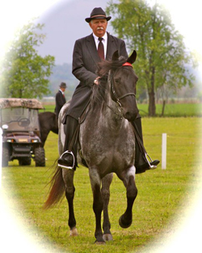
Silver’s Blue Plate Special (see more)
Affectionately called “Penny” around the barn, this filly is accomplished in Western, Under Saddle, Conformation, Trail Obstacle, Gaited Dressage, as well as having a lovely canter. She was started by Robert using the Foundation First Rocky Mountain Horse Training TM system for which he has become so well known. Penny went through the program effortlessly demonstrating intelligence and a willing attitude. Since that time, Penny has had many great accomplishments. She was the gaited horse selected by Gill Merrick, U.S.A. Dressage Olympic Team Leader, as the World Show Gaited Dressage demo horse. After riding her in the exhibition, Gill absolutely raved about the quality of her canter. She had a great year in 2008 culminating the Super Horse Award. She was re-entered into training here at Stoner Ridge Farm for competition again in 2010 and continues to be ridden and trained by Robert. Penny is also for sale. Please contact Robert for additional information 859.749.3008.
- UMH Al Prewitt Memorial Horse Show - Novice Rider Trail - 5th - Kim
- UMH North Carolina State Championship - Open 4 Gait - 5th
- UMH Carson Masters Spring Premier - Adult Trail Obstacle - 2nd - Kim
- UMH Carson Masters Spring Premier - Open Four Gait - 3rd - Kim
- UMH Carson Masters Spring Premier - Youth 17 & Under Equitation 2nd - Paige Denniston
- North Middletown - Amateur Country Trail - Kim - 2nd
- UMH Stidham Memorial - Mares CTP - 3rd - Kim
- UMH Stidham Memorial - Open 4 Gait - 5th - Kim
- UMH Ladies Auxiliary - Youth 17 & Under Western - 2nd
- UMH Ladies Auxiliary - Pro-Am CTP - 4th - Robert & Kim
- UMH Ladies Auxiliary - Adult Trail Obstacle - 2nd - Kim
- UMH Ladies Auxiliary - Youth Showmanship - 1st
- UMH Ladies Auxiliary - Open 4 Gait - 4th
- UMH Ladies Auxiliary - Youth 17 & Under Equitation - 2nd
- UMH Ladies Auxiliary - Versatility Award - 5th
- UMH Ladies Auxiliary - Youth Versatility Award - 1st - Lauren
- UMH Bourbon County - Open 4 Gait - 3rd - Kim
- UMH KY State Championship – Youth 17 & Under Showmanship - 1st - Lauren
- UMH KY State Championship – Youth 17 & Under Western - 2nd - Lauren
- UMH KY State Championship - Youth Versatility - 2nd - Lauren
- UMH Summer Celebration - Youth 12-17 Trail Obstacle - 1st - Lauren
- UMH Summer Celebration - Open Four Gait - 4th - Kim
- UMH Summer Celebration - Showmanship - 1st Lauren
- UMH Summer Celebration - Youth Versatility Award
- UMH World Show - Trail Obstacle Youth 17 & Under - 2nd - Lauren
- UMH World Show - Open Amateur Trail Obstacle - 1st - Kim
- UMH World Show - Youth 17 & Under Showmanship - 2nd - Lauren
^{[top of page]}

FR's Derby Blue
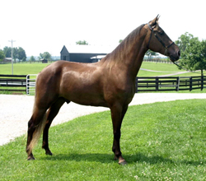
- UMH Carson Masters Spring Premier - 4 YO + Open Conf. - 2nd
- UMH Carson Masters Spring Premier - Stallions/Geld CTP - 3rd
- UMH Stidham Memorial - Open CTP Stallions/Geldings - 1st
- UMH Ladies Auxiliary - Open 4 Gait - 5th
- UMH Bourbon County - Open 4 Gait - 5th
- UMH Bourbon County - Stallions/Geld CTP - 5th
- UMH KY State Championship – Stallions/Geld. CTP - 2nd
- UMH KY State Championship – 4 + Conformation - 3rd
- UMH KY State Championship – Open 4 Gait - 4th
- UMH KY State Championship – CTP Championship - 4th
- UMH KY State Championship – Adult Versatility Award - 2nd
- RMH KY State Championship - Jr. Conf. 3 & 4 YO - 4th
- RMH KY State Championship - Country Trail Pleas. Geldings - 2nd
- RMH KY State Championship - Country Trail Pleas. Championship - 3rd - Mike
- RMH Tavares Championship - Jr. Conf. 3 & 4 YO - 2nd
- RMH Tavares Championship - Country Trail Pleas. Geldings - 3rd
- UMH/NWHA Gaited Jubilee - 4+ Open Conformation - 4th
- UMH/NWHA Gaited Jubilee - Open 4 Gait - 4th
- UMH/NWHA Gaited Jubilee - Stallions/Geldings CTP - 4th
- UMH TN State Championship - Open Four Gait - 1st
- UMH TN State Championship - Adult Trail Obstacle - 5th
- UMH TN State Championship - CTP Stallions/Geld. - 2nd
- UMH TN State Championship - 4+ Conformation - 4th
- UMH TN State Championship - Adult Versatility - 2nd
- UMH World Show - 4+ Geldings In-Hand - 2nd
- UMH World Show - Trail Obstacle Jr. Horse - 2nd
- UMH World Show - Open 4 Gait - 2nd
- KMSHA International - Open 4 Gait - 2nd
- RMH Junior Conformation (3 & 4 Year Olds) - 2nd
- RMH Country Trail Pleas. Geld. - 3rd
- RMH CTP Championship - Derby - 3rd
- UMH High Points - Stallions/Geldings CTP - 3rd
- UMH High Points - 4+ YO Conformation - 3rd
^{[top of page]}

Totally Swept Away
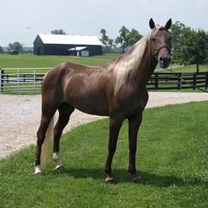
- UMH Carson Masters Spring Premier - Novice Classic - 3rd
- UMH Carson Masters Spring Premier - Youth 12 – 17 Classic - 4th - Lauren
- UMH Ladies Auxiliary - Youth 12 – 17 Classic - Lauren - 5th
- UMH Ladies Auxiliary - 14.3 & Under Classic - 3rd - Kim
- UMH Bourbon County - Open Amateur Classic - 5th - Kim
- UMH KY State Championship – Novice Classic - 1st - Kim
- UMH KY State Championship – Youth 17 & Under Equitation - 1st - Lauren
- RMH KY State Championship - Amateur Show Pleas. - 3rd - Kim
- RMH KY State Championship - Amateur Show Pleas. Championship - 2nd
- RMH Tavares Championship - Amateur Show Pleas. - 4th - Kim
- UMH TN State Championship - Novice Classic - 1st - Kim
- RMH TN State Championship - Open Amateur Show Pleas. - 3rd
- UMH TN State Championship - Juve. 17 & Under Classic Champ. - Thomas
- UMH Summer Celebration - Novice Classic - 2nd - Kim
- UMH Summer Celebration - Youth 12 – 17 Equitation - 2nd - Lauren
- UMH World Show - Novice Rider Classic Pleasure - 2nd - Kim
- UMH World Show - Equitation - 17 & Under - 1st - Lauren
- RMH International - 5-8 YO Amateur Show Pleasure - 5th - Kim
- RMH International - Ladies Amateur Show Pleasure - 10th - Kim
- RMH Ladies Show Pleasure - Kim - 4th
- RMH Amateur Show Pleas. - Kim - 4th
^{[top of page]}

Gobel's Wind Chill
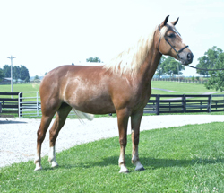
- UMH Carson Masters Spring Premier - Youth 12 – 17 CTP - 2nd - Thomas
- UMH Carson Master’s Spring Premier - Mares CTP - 5th
- UMH Stidham Memorial - Mares CTP - 1st
- UMH Ladies Auxiliary - Youth 12 – 17 CTP - 1st - Thomas
- UMH Ladies Auxiliary - Pro-Am CTP - 1st - Liz & Michael
- UMH Ladies Auxiliary - Mares CTP - 1st
- UMH Ladies Auxiliary - Amateur CTP - 2nd
- UMH Ladies Auxiliary - CTP Championship - 1
- UMH Bourbon County - Mares CTP - 2nd
- UMH Bourbon County - Country Trail Championship - 2nd
- UMH KY State Championship – Pro Am CTP - 1st - Mike & Liz
- UMH KY State Championship – Amateur CTP - 2nd - Liz
- UMH KY State Championship – 12 – 17 Youth CTP - 1st - Thomas
- UMH KY State Championship – Mares CTP - 1st
- UMH KY State Championship – CTP Championship - 2nd
- UMH Summer Celebration - Pro-Am CTP - 2nd - Mike & Liz
- UMH Summer Celebration - Amateur CTP - 1st - Liz
- UMH Summer Celebration - Mares CTP - 2nd
- UMH Summer Celebration - Youth 12-17 CTP - 1st - Thomas
- UMH Summer Celebration - Country Trail Championship - 3rd
- UMH World Show - Youth 12 – 17 - 5th - Thomas
- UMH World Show - Amateur Country Trail - 4th - Liz
- UMH High Points - 12-17 Country Trail Pleasure - 2nd
- UMH High Points - Mares Country Trail Pleasure - 2nd
- UMH High Points - Country Trail Pleasure Championship - 2nd
^{[top of page]}

RGF Uncle Russell
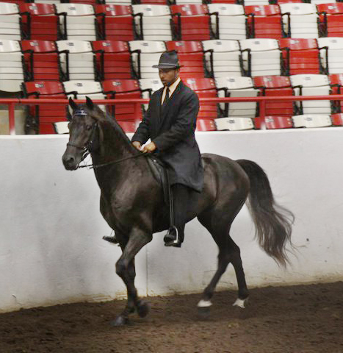
- RMH KY State Championship - Trail Pleas. Stallions - 2nd
- RMH KY State Championship - 4 & 5 YO Trail Pleasure - 1st
- RMH Tavares Championship - Trail Pleas. Stallions - 2nd
- RMH Tavares Championship - Trail Pleas. Championship - 2nd
- RMH OH State Championship - 4+ Conformation - 5th
- RMH OH State Championship - Trail Pleasure Stallions - 3rd
- RMH OH State Championship - Trail Pleasure Championship - 3rd
- RMH Charles Kilburn Memorial - Trail Pleasure Stallions - 4th
- RMH Trail Pleas. Stallions - 3rd
^{[top of page]}

HBF Hidden Agenda
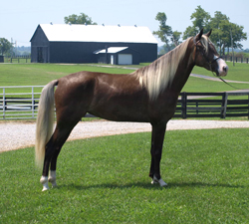
- UMH World Show - 2-3 YO Mares In-Hand - 4th
- UMH World Show - 2-3 YO CTP Mares - 4th
^{[top of page]}

Charlie Joe, Jr.
- RMH OH State Championship - Trail Pleasure Geldings - 1st
- RMH OH State Championship - Ladies Trail Pleasure - 1st
- RMH Charles Kilburn Memorial - Trail Pleasure Geldings - 4th
- RMH Charles Kilburn Memorial - Ladies Trail Pleasure - 2nd
^{[top of page]}

Barb's Stormy Knight
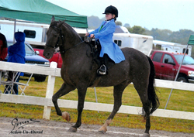
- UMH World Show - Trail Obstacle Sr. Horse - Robert - 1st
- UMH World Show - Bourbon Class - Michael - 5th
- RMH International - 5+ Mares & Geldings Conformation - 7th - Jessica
- RMH International - Adult Trail Obstacle - 6th
- RMH International - Geldings Trail Pleasure - 4th
- RMH International - Youth 7-11 Country Trail - 2nd - Ella Tillery
- RMH International - Youth 12-17 Mentor and me - 3rd - Thomas
- KMSHA International - 11 & Under CTP - 5th - Ella
^{[top of page]}

SHF Coco Calypso
We welcomed “Coco” to the SRF show string shortly after the Bowling Green show. Katie and Mike Minasola from Pierson, MI purchased her from Kathy and Jim Wilkerson (Wrangler’s owners). She is sure sweet in addition to being a cutie. Robert is working with her in the Yearling Conformation classes and the Trail Obedience classes. Welcome Coco along with Mike and Katie.
- UMH World Show - Open Yearling Fillies - 3rd
- UMH World Show - Open Trail Obstacle Obedience Under 2 - 2nd
- UMH World Show - Open Yearling World Grand Champ. - 5th
- RMH International - Yearling Fillies & Colts B Conformation - 2nd
- RMH International - Baby Trail Obstacle - 1st
- RMH International - Yearling Conformation Championship - 3rd
- KMSHA International - Yearling Conformation - 3rd
^{[top of page]}

ACFS Peacock Blue
- RMH International - 5-8 YO Geldings Trail - 6th
- RMH International - Ladies Amateur Country Trail - 6th - Lori Javorsky
^{[top of page]}

Pepper's Just Plain Pretty
- UMH World Show - Youth 12 – 17 CTP - Lauren - 3rd
- UMH World Show - Youth 17 & Under Western Stake - 1st
- UMH World Show - Trail Obstacle Youth 17 & Under - 1st
- UMH World Show - Open 4 Gait - 5th - Erin
- UMH World Show - Open 17 & Under CTP World Grand Champ. - 4th
^{[top of page]}
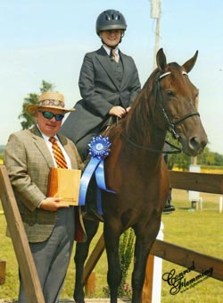
Lauren Hickey
Here at SRF we are happy to have 16 year old Lauren Hickey back showing with us again this year. She is a dedicated equestrienne and strives to improve her horsemanship with each and every practice session. She and Erin have developed a strong bond during their lessons. Lauren is also an outstanding author. She frequently writes about horses and has published several stories and poems. Last summer, Lauren wrote about the joy she feels with a horse beneath her and the wind in her hair. Click here to read and enjoy Simple Freedom by Lauren Hickey.
- UMH Carson Masters Spring Premier - Penny - Showmanship - 1st
- UMH Carson Masters Spring Premier - Tessa – Youth 12 – 17 Classic - 4th
- UMH Ladies Auxiliary - Youth 17 & Under Western - Penny - 2nd
- UMH Ladies Auxiliary - Youth 12 – 17 Classic - Totally Swept Away - 5th
- UMH Ladies Auxiliary - Youth Trail Obstacle - Penny - 1st
- UMH Ladies Auxiliary - Youth Showmanship - Penny - 1st
- UMH Ladies Auxiliary - Youth 17 & Under Equitation - Penny - 2nd
- UMH Ladies Auxiliary - Youth Versatility Award - Penny/Tessa - 1st
- UMH KY State Championship – Youth 17 & Under Showmanship - 1st - Penny
- UMH KY State Championship – Youth 17 & Under Western - 2nd - Penny
- UMH KY State Championship – Youth 17 & Under Equitation - 1st - Tessa
- UMH KY State Championship – Youth Versatility 2nd
- UMH Summer Celebration - Totally Swept Away - 2nd - Youth 12-17 Equitation
- UMH Summer Celebration - Silver’s Blue Plate Special - Youth 12-17 Trail Obstacle - 1st
- UMH Summer Celebration - Silver’s Blue Plate Special - Showmanship
- UMH Summer Celebration - Youth Versatility Award
- UMH World Show - Trail Obstacle Youth 17 & Under - 2nd - Lauren
- UMH World Show - Youth 17 & Under Showmanship - 2nd - Lauren
- UMH World Show - Equitation - 17 & Under - 1st - Lauren
- UMH World Show - Youth 12 – 17 CTP - Lauren - 3rd
- UMH World Show - Youth 17 & Under Western Stake - 1st
- UMH World Show - Trail Obstacle Youth 17 & Under - 1st
- UMH World Show - 17 & Under CTP World Grand Champ. - 4th
- UMH High Points - 2011- Youth Trail Obstacle - 2nd
- UMH High Points - Youth Versatility - 2nd
^{[top of page]}

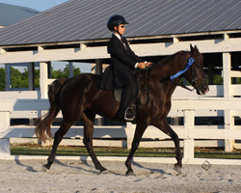
Thomas Howard
Twelve year old Thomas started taking lessons from Erin two years ago. He has a great work ethic and had been wanting to show for some time. Thomas finally got his wish. He made his first show on Gaitway’s Jasmine Joy at the Bourbon County Fair and Horse Show on June 17th. His hard work and dedication paid off earning him a blue ribbon. Thomas wants to continue showing. He just loves it. Congratulations Thomas!
- UMH North Carolina Championship – Youth 12 – 17 Classic Blueberry Wine - 2nd
- UMH Carson Masters Spring Premier - Chili - Youth 12 – 17 CTP - 2nd
- UMH Carson Masters Spring Premier - Blueberry - Youth 12 – 17 Classic - 2nd
- UMH Ladies Auxiliary - Youth 12 – 17 CTP - 1st - Thomas
- UMH Bourbon County - Blueberry Wine - 12 – 17 Classic - 4th
- UMH KY State Championship – 12 – 17 Youth CTP - 1st - Chili
- RMH KY State Championship - Youth (12-17) Show Pleas. - 2nd - Nugget
- RMH KY State Championship - Youth (12-17) Show Pleas. Championship - 2nd - Nugget
- RMH Tavares Championship - Youth (12-17) Show Pleas. - 5th - Nugget
- RMH Tavares Championship - Youth (7-12) Show Pleas. Championship - 3rd
- UMH TN State Championship - Juve. 12 – 17 Classic - 4th - Nugget
- UMH TN State Championship - Juve. 17 & Under Classic Champ. - 5th
- UMH Summer Celebration - Gobel’s Wind Chill - 1st - Youth 12-17 CTP
- RMH International - Youth 12-17 Mentor and me - 3rd - Barb’s Stormy Knight
- RMH Youth 12-17 Show Pleasure - 5th
- UMH High Points 2011 - 12-17 Country Trail Pleasure – Gobel’s Wind Chill - 2nd
^{[top of page]}

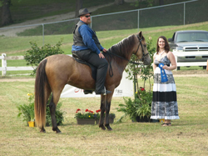
Tim Spencer
UMH High Points - Novice Trail - 3rd
^{[top of page]}

Kim Pitts
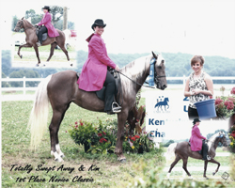
UMH High Points - Novice Classic Pleasure - 1st

