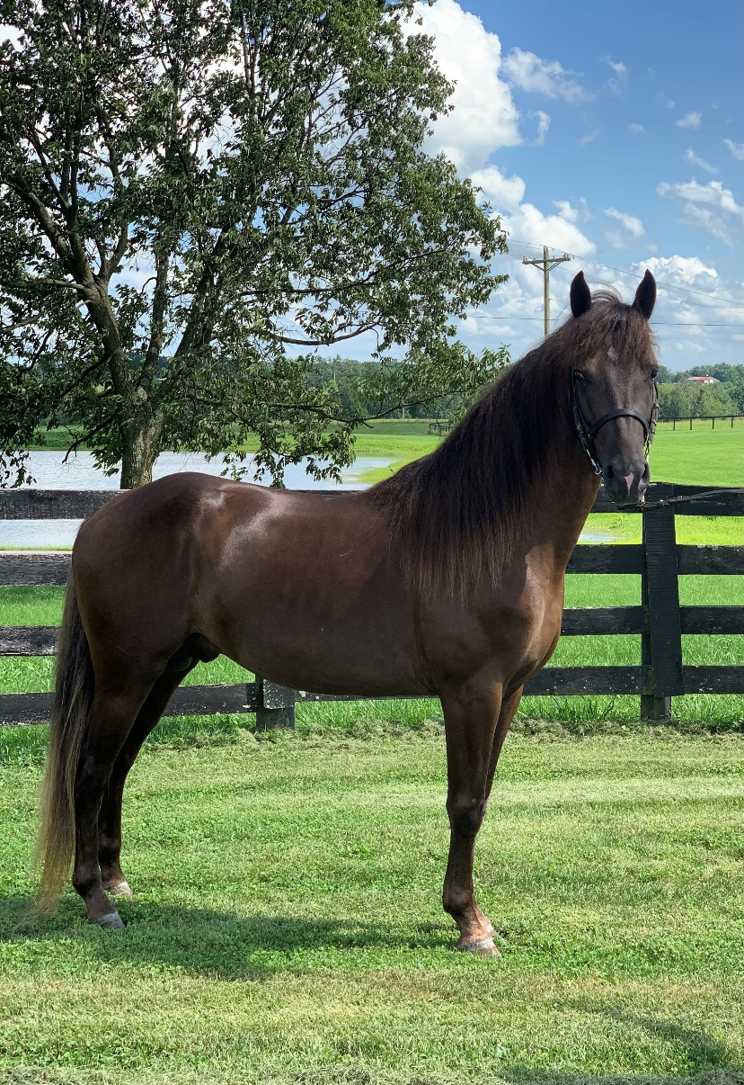

**Red River Diamond owned by Julie Tucker**

Spring Kickoff Open 3 & 4 yo Show Pleasure - 1st

Bluegrass Showcase Open 3 & 4 YO Show Pleas. - 1st

Get Your Pink On Open Show/Classic Pleasure - 4th

RMHA International 3-4 yo Conformation - 5th

RMHA International Men’s Show Pleasure - 5th