Black Market Diamond
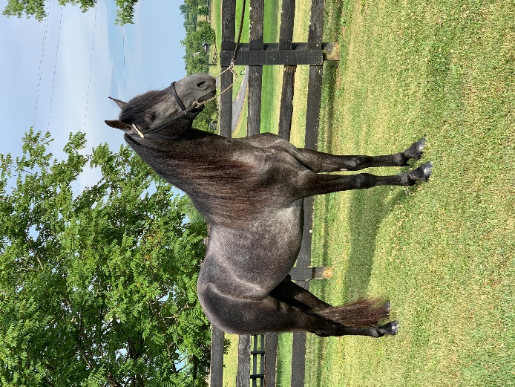
Black Market Diamond is an outstanding 2017 colt sired by Diamond Dock out of Vergeland First Lady. He is homozygous for the dominant “E” allele, and genetically has black points with a black body color. He will pass the “E” allele to his offspring and will always produce foals with genetically black points. This horse does not have the “red factor” and will not produce chestnuts/sorrels. He also has a copy of the STX17 mutation that causes gray coloration that he received from his dam. He is heterozygous for this mutation (Gr/N). Black Marke Diamond’s coat will lighten progressively as he ages and he will pass the gray gene to at least 50% of his offspring. Jim does not have the silver dapple gene (N/N).
Besides his color Jim has outstanding traits that he will pass on to his foals. This young stallion has a wonderful temperament and a kind eye. He is a solid competitor in the Trail Pleasure Division. He is a trail obstacle competitor and is showing skill in the western division as well. Black Market has wonderful muscling which makes him an excellent competitor in conformation. He was shown successfully as a 3 year-old and will be campaigned again in 2021. This young horse is just beginning to define who he will become and where his talent and strength lie. We are excited to see the foals he will produce. Contact Charlie DeAtley 859.749-8982 for more information about this outstanding Rocky Mountain stallion.

