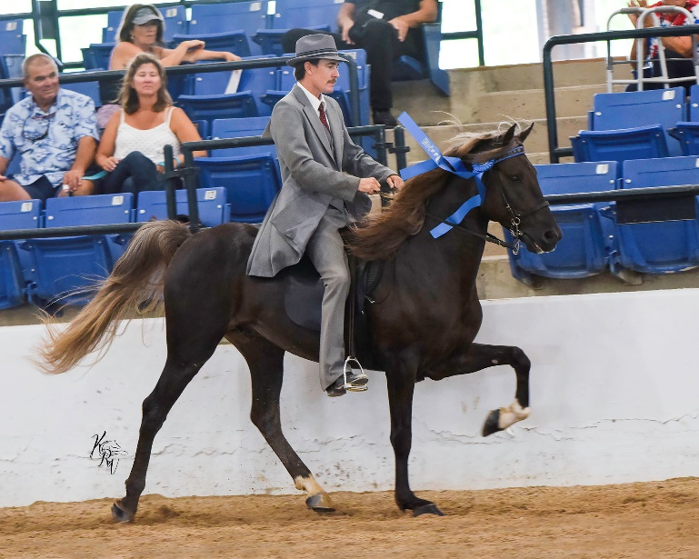

PBF’s Simon Barjonah
Owners: Steve & Susan Heuslein

RMHA Get Your Pink On Stallons Show Pleasure - 2nd
RMHA Get Your Pink On Open Show Pleasure Championship - 4th
RMHA Owingsville Lions Stallions Show Pleas. - 5th
RMHA International Stallions Show Pleas. Champ. 5th

