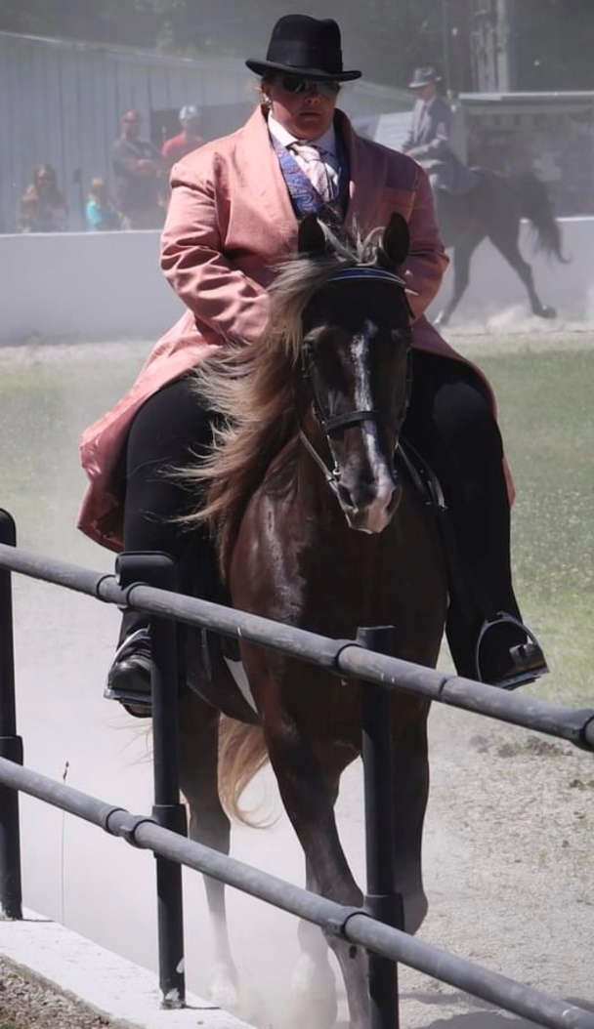

**RNB Choco Dock’s Marietta**

**Owned by Steve & Susan Heuslein**

RMHA Sharon Copher Memorial M/G Trail - 2nd - MK

RMHA Sharon Copher Memorial Trail Championship - 5th - Charlie

RMHA Bluegrass Showcase M/G Trail - 2nd - MK

RMHA Bluegrass Showcase Trail Championship - 4th - MK

RMHA Lee County Saddle Club Summer Celebration M/G CTP - 1st - MK

Get Your Pink On Jack Benny - 1st - Susan

RMHA Get Your Pink On Open Trail Pleasure Championship - 5th - Susan

RMHA Owingsville Lions Club M/G Trail - 1st - MK

RMHA Tollesboro Lions Club M/G Trail - 4th - MK

RMHA Tollesboro Lions Club Open Trail Pleas. Champ. - 4th - MK

RMHA Gaited Horse Gala M/G Trail - 2nd - MK

RMHA Annual Carter County Shrine Show Pleasure M/G Trail - 2nd - MK

RMHA High Point Mares Trail Pleasure 2nd