Plan Your Clinic

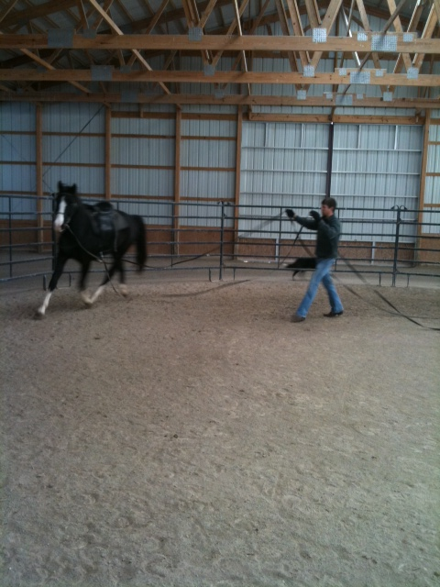
At Your Farm
Clinics are available in a variety of venues. Charlie (either as an individual or with assistant trainers) can come to your facility. Rates are available by the day or week.
At our Facility
The facility at Stoner Ridge Farm is also available for your use. There is an 84’ x 207’ indoor arena. There is also a trail obstacle course, round pens, and a regulation size dressage pad available. Clinics are custom designed to meet your individual needs or the needs of your group.
By the Hour or by the Day
Private or group clinics are also available and charged by the hour or by the day. If you plan to show or you have a juvenile who would enjoy showing or learning how to care for their horse, we can schedule clinics as frequently as necessary to insure success.

