HCR’s Heart Attack
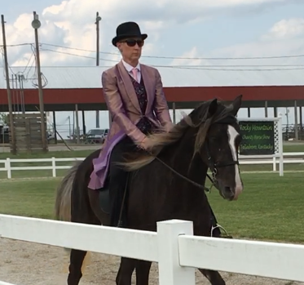

2018
RMHA Lady Eagles – Open CTP Mares/Geld. - 3rd
RMHA Tollesboro Lions Club - Amateur - 4th - Juile
RMHA Tollesboro Lions Club - CTP Mares & Geldings - 1st
RMHA Tollesboro Lions Club - CTP Trail Pleasure Championship - 3rd
RMHA Tollesboro Lions Club - AOT, Amateur & Novice CTP Championship - 4th - Julie
KHBIF Trail Challenge Cup and Horse Show - RMHA Mares & Geldings CTP - 2nd
KHBIF Trail Challenge Cup and Horse Show - RMHA Amateur CTP - 4th - Julie
RMHA Red Neck Barn Show - Amateur CTP - 5th
RMHA Red Neck Barn Show - Open CTP M/G – 5th
Red Neck Barn Show - Bareback - 3rd - Julie
KMSHA Summer Kick-Off - 4 YO Open CTP Fri. - 2nd - Julie
KMSHA Summer Kick-Off - Open CTP - 1st
KMSHA Summer Kick-Off - 4 YO Open CTP Sat. - 2nd - Julie
RMHA Mountain Horse Celebration - 1st
RMHA Get Your Pink On - 4th
RMHA High Point Awards - Country Trail Pleasure Mares - 2nd

