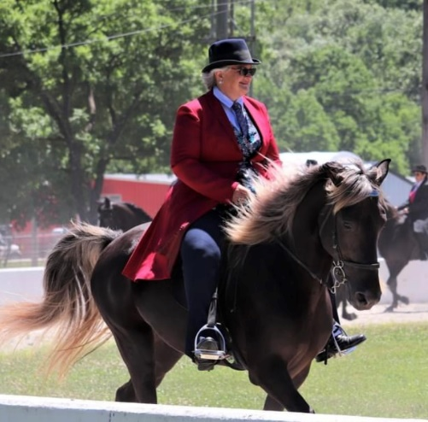

DMH’s Bella Angel owned by Julie Tucker
RMHA Sharon Copher Memorial Amateur CTP - Julie T.
RMHA CTP Championship - 5th - MK
RMHA Bluegrass Showcase M/G CTP - 5th - Julie T.
RMHA Lee County Saddle Club Summer Celebration M/G CTP - 5th
RMHA Lewisburg-Millcreek Lions Club M/G CTP - 1st
RMHA Lewisburg-Millcreek Lions Club Open CTP Champ. - 3rd
Get Your Pink On Adult Trail Obstacle – 3rd
RMHA Tollesboro Lions Club Open CTP - 2nd
RMHA Tollesboro Lions Club Open CTP Championship - 2nd
Gaited Horse Gala Open CTP - 2nd
RMHA Gaited Horse Gala CTP - 1st
RMHA Gaited Horse Gala CTP Championship - 2nd
RMHA Gaited Horse Gala Amateur Trail - 4th - Julie T.
RMHA Annual Carter County Shrine Show Pleasure M/G CTP - 1st - MK
RMHA I White Pine CTP Ladies Pleasure - 1st - MK
RMHA I White Pine CTP M/G - 4th - MK
RMHA II White Pine CTP Ladies - 3rd - MK
RMHA International 6-9 M/G CTP - 2nd
RMHA International Ladies CTP - 5th
RMHA High Point CTP Championship 3rd
RMHA International High Point Mary Kelley Tucker 2nd with DMH’s Bella Angel

