PBF’s Simon Barjonah
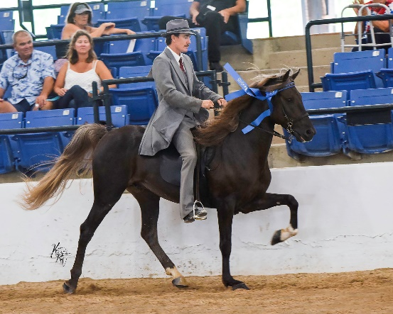
2018
RMHA Gaited Gala – Show Pleasure Stallions - 5th
RMHA Gaited Gala - Show Pleasure Championship - 4th - Mary Kelley
RMHA Mountain Horse Celebration - Show Pleasure Stallions - 2nd
RMHA Mountain Horse Celebrations - Show Pleasure Championship - 4th
RMHA Lady Eagles – Stallions Show Pleasure - 1st
RMHA Lady Eagles – Open Show Pleasure Championship - 1st
KMSHA Summer Kick-Off - 5+ Stallions Classic Pleasure Fri. - 3rd
KMSHA Summer Kick-Off - Open Classic Pleasure - 2nd
KMSHA Summer Kick-Off - 5+ Stallions Classic Pleasure Sat. - 5th
RMHA Get Your Pink On - Show Pleasure Stallions - 4th
KMSHA Summer Kick-Off - Classic Pleasure Championship - 4th
RMHA Red Neck Barn Show - Show Pleasure Stallions - 4th
RMHA Red Neck Barn Show - Open Show Pleasure Championship 4th
ODGHA RMHA Show Pleasure Statllions - 1st
ODGHA RMHA Open Show Pleasure - 1st
ODGHA RMGA Show Pleasure Championship - 1st
RMHA International - 4-5 yo Stallions Show Pleasure - 1st
KMSHA International - Open Classic Pleasure - 1st
RMHA High Point Awards - Show Pleasure Stallions - 2nd
RMHA High Point Awards - Show Pleasure Championship - 3rd

