Champions 2009

SRF’s Silver Sundown
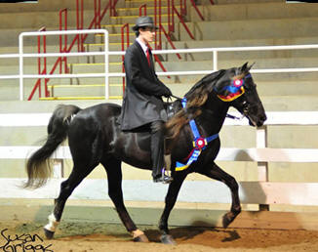
As winner of the 2007 High Point Award in the 4 Year Old Stallions and Geldings Classic division and winner of the Classic Pleasure Stallion High Point Award in 2008, SRF’s Silver Sundown demonstrated his talent on the rail. His versatility was clearly shown when he was declared the High Point winner at the Three Phase Event last year. Now, as a six year old breeding stallion, Silver continues to excel in some of the most competitive classes showing on the UMH circuit in the Trail Pleasure division. His phenomenal temperament allows him to compete equally in versatility classes as well as in conformation and on the rail classes. He is also a great ride out on the trails. Silver’s first foal crop was sold quickly. His second crop of foals, now yearlings, are outstanding! More information about his pedigree is available on the Stallions Page. Look for him in the Trail Pleasure Stallions, Conformation, Trail Obstacle, Pro-Am, Western, Open Amateur, and in the Trail Pleasure Championship classes this year under the direction of his trainer, Charlie DeAtley. He is owned by Steve Heuslein of LaCrescent, MN.
- UMH Al Prewitt Memorial Horse Show – Friday - Open Western – 1st
- UMH Al Prewitt Memorial Horse Show – Friday - Stallions Trail - 1st
- UMH Al Prewitt Memorial Horse Show – Friday - Trail Pleasure Championship - 1st
- UMH Al Prewitt Memorial Horse Show – Friday - Amateur Trail – 3rd
- UMH Al Prewitt Memorial Horse Show - Saturday - Adult Trail Obstacle - 1st
- UMH Al Prewitt Memorial Horse Show - Saturday - Amateur Trail - Steve Heuslein - 2nd
- UMH Al Prewitt Memorial Horse Show - Saturday - 4 & Older Conformation - 4th
- UMH Al Prewitt Memorial Horse Show - Saturday - Open Western - 3rd
- UMH Al Prewitt Memorial Horse Show - Saturday - Trail Pleasure Championship - 1st
- UMH Al Prewitt Memorial Horse Show - Saturday - Adult Versatility Award - 1st
- KMSHA Junior Robinson 20th Anniversary Celebration - 4 year old and older Conformation - 3rd
- KMSHA Junior Robinson 20th Anniversary Celebration - Trail Obstacle - 2nd
- KMSHA Junior Robinson 20th Anniversary Celebration - Open Western Pleasure - 2nd
- KMSHA Junior Robinson 20th Anniversary Celebration - 5 year old and older Stallion Trail - 1st
- KMSHA Junior Robinson 20th Anniversary Celebration - Trail Pleasure Championship - 3rd
- KMSHA Junior Robinson 20th Anniversary Celebration - 20th Annual Jr. Robinson Award - 2nd
- Three Phase Event - Adult Novice Over All - 2nd
- Three Phase Event - Cross Country - 1st
- Three Phase Event - Trail Obstacle - 2nd
- UMH Carson Masters Spring Premier - Stallions Trail Pleasure - 2nd
- UMH Carson Masters Spring Premier - Men’s Open Trail - 1st
- UMH Carson Masters Spring Premier - Trail Obstacle - 1st
- UMH Carson Masters Spring Premier - Pro Am Trail - Charlie & Steve - 1st
- UMH Carson Masters Spring Premier - Open Western - 3rd
- UMH Carson Masters Spring Premier - Trail Pleasure Championship - 1st
- UMH Carson Masters Spring Premier - Adult Versatility Award - 1st
- UMH North Middletown Charity Horse Show - Stallions Trail Pleasure - 2nd
- UMH Ladies Auxiliary Horse Show - Open Western - 3rd
- UMH Ladies Auxiliary Horse Show - Stallions Trail Pleasure - 2nd
- UMH Ladies Auxiliary Horse Show - Ladies Auxiliary Trail - 1st - Lyngle
- UMH Ladies Auxiliary Horse Show - Adult Trail Obstacle - 1st
- UMH Ladies Auxiliary Horse Show - Pro/Am Trail - 3rd - Charlie and Lyngle
- UMH Ladies Auxiliary Horse Show - Men’s Open Trail - 5th
- UMH Ladies Auxiliary Horse Show - Trail Pleasure Championship - 4th
- UMH Ladies Auxiliary Horse Show - Adult Versatility - 1st
- UMH Stidham Memorial - Stallions Trail - 2nd
- UMH Stidham Memorial - Trail Championship - 3rd
- RMH Kentucky Downs Classic - Open Western - 2nd
- RMH Kentucky Downs Classic - Trail Pleasure Stallions - 1st
- RMH Kentucky Downs Classic - Men’s Trail Pleasure - 5th
- RMH Kentucky Downs Classic - Trail Pleasure Championship - 5th
- RMH Tavares Championship Classic - Open Western - 1st
- RMH Tavares Championship Classic - Trail Pleasure Stallions - 3rd
- UMH Bourbon County Fair - Stallions Trail - 3rd
- UMH Bourbon County Fair - Non-Pro Trail - 1st - Lyngle
- UMH KY State Championship – Stallions Trail - 4th
- UMH KY State Championship – Open Western - 4th
- UMH KY State Championship – Amateur Trail - 3rd - Steve Heulsein
- Great Smoky Mtn. Championship - Open Western - 1st
- Great Smoky Mtn. Championship - Stallions Trail - 1st
- Great Smoky Mtn. Championship - Trail Pleasure Championship - 4th
- TN State Championship - Adult Trail Obstacle - 3rd
- TN State Championship - Stallions Trail - 2nd
- TN State Championship - Trail Pleasure Championship - 2nd
- TN State Championship - Adult Versatility - 5th
- UMH Summer Celebration - Open Western - 2nd
- UMH Summer Celebration - Men's Open Trail - 1st
- UMH Summer Celebration - Stallion Trail - 2nd
- UMH Summer Celebration - Adult Versatility - 5th
- UMH World Show - Water Glass - 5th
- UMH World Show - Western Pleasure Sr. Horse - 2nd
- UMH World Show - 4 + Trail Pleasure Stallions - 3rd
- UMH World Show - Trail Obstacle - 1st
- UMH World Show - Trail Pleasure World Grand Championship - 5th
- UMH World Show - Western Pleasure World Grand Championship - 1st
- RMH International - Amateur Trail Pleasure - 10th - Steve Heuslein
- RMH International - 6-9 YO Stallions Conformation - 4th
- RMH International - 6-9 YO Stallions Trail Pleasure - 1st
- RMH International - 6-9 YO Western Pleasure - 1st
- RMH International - Stallion Championship Trail - 6th
- RMH International - Western Pleasure Grand Championship - 3rd
- RMH International - Adult Trail Obstacle - 1st
- RMH International - Pole Bending - 1st
- RMH International - Water Glass - 4th
- KMSHA International - Trail Obstacle - 1st
- KMSHA International - Open Western - 4th
2009 High Point Awards
- 1st - UMH Open Western
- 1st - UMH Stallions Trail Pleasure
- 1st - UMH Trail Pleasure Championship
- 1st - UMH High Money Horse
- 2nd - UMH Adult Versatility
- 2nd - Men’s Open Trail Pleasure
- 2nd - KMSHA/SMH Adult Trail Obstacle
- 4th - RMH Open Western
^{[top of page]}
Sandman’s Taking Chances (Manny)
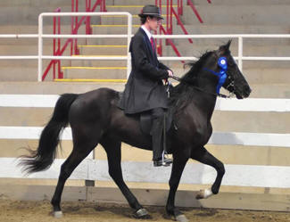
Sired by Dock’s Mr. Sandman, this handsome 3 year old gelding is already getting off to a good start in the show ring. He is calm and demonstrates a superior way of going. At his very first show, he was placed first in the Open Four Gait class with his trainer, Charlie DeAtley, in the irons. He is a smooth, smooth ride. Watch for him in the Trail Pleasure division this year. He is owned by Don and Nancy Copland from Brookville, IN.
- UMH Al Prewitt Memorial Horse Show - Friday - Geldings Trail - 6th
- UMH Al Prewitt Memorial Horse Show - Saturday - Open Four Gait - 1st
- UMH Al Prewitt Memorial Horse Show - Saturday - Men’s Open Trail - 5th
- UMH Al Prewitt Memorial Horse Show - Saturday - 2 - 3 year old Trail - 3rd
- UMH Carson Masters Spring Premier - Open Four Gait - 2nd
- UMH Ladies Auxiliary Horse Show - Open Four Gait - 3rd
- UMH Bourbon County Fair - Open Four Gait - 5th
- UMH KY State Championship - Open 4 Gait - 2nd
- TN State Championship - Open 4 Gait - 2nd
- TN State Championship - 2 & 3 YO Trail - 5th
2009 High Point Awards
- 2nd - UMH Open Four Gait
^{[top of page]}
Gaitway’s Jasmine Joy
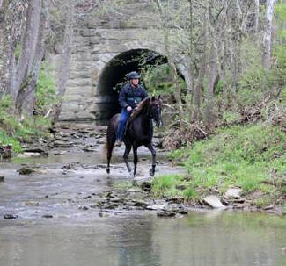
As a UMH Reserve World Grand Champion Western Pleasure horse, “Jazzy” will be competing again in 2009. She has lots of talent and versatility. At the Three Phase Event last year, she and her trainer, Robert Lawson, received the highest dressage scores of anyone in the competition (several 8’s and 9’s). She will continue to have a juvenile rider or two this year. In addition to Steve and Robert showing her in the Country Trail Pleasure and versatility classes, Lauren and J.T. Hickey will be showing her in Showmanship, Equitation, Dressage, Cross Country, Trail Obstacle, Western and on the rail classes. She’s well built and has a fantastic gait. She is owned by Steve Heuslein, LaCrescent, MN.
- UMH Al Prewitt Memorial Horse Show - Friday - Open Western - 4th
- UMH Al Prewitt Memorial Horse Show - Friday - CTP Pro-Am - Robert & Steve - 2nd
- UMH Al Prewitt Memorial Horse Show - Friday - CTP Championship - 4th
- UMH Al Prewitt Memorial Horse Show - Saturday - CTP Mares - Steve Heuslein - 1st
- UMH Al Prewitt Memorial Horse Show - Saturday - Amateur CTP - Steve Heuslein - 1st
- UMH Al Prewitt Memorial Horse Show - Saturday - Adult Trail Obstacle - 2nd
- UMH Al Prewitt Memorial Horse Show - Saturday - CTP Championship - Steve Heuslein - 2nd
- UMH Al Prewitt Memorial Horse Show - Saturday - Open Western - 4th
- UMH Al Prewitt Memorial Horse Show - Saturday - Adult Versatility - 2nd
- Three Phase Event - Novice Youth - 1st - Lauren Hickey up
- Three Phase Event - Adult Novice - 4th - Robert Lawson up
- UMH Carson Masters Spring Premier - Trail Obstacle - 5th
- UMH Carson Masters Spring Premier - Country Trail Pleasure Mares - Steve Heuslein up - 2nd
- UMH Carson Masters Spring Premier - Pro Am Country Trail - Robert & Steve - 4th
- UMH Carson Masters Spring Premier - Open Western - 1st
- UMH Carson Masters Spring Premier - Adult Versatility Award - 3rd
- UMH Carson Masters Spring Premier - Non-Pro Country Trail - 4th - Steve Heuslein up
- UMH Carson Masters Spring Premier - Adult Trail Obstacle - 5th
- UMH Carson Masters Spring Premier - Adult Versatility - 3rd
- UMH North Middletown Charity Horse Show - 12 – 17 Country Trail – 4th - Lauren Hickey
- UMH Ladies Auxiliary Horse Show - Open Western – 5th
- UMH Ladies Auxiliary Horse Show - Juvenile 12 -17 - 2nd - Lauren Hickey
- UMH Ladies Auxiliary Horse Show - Pro/Am Country Trail - 1st - Robert & Lyngle
- UMH Ladies Auxiliary Horse Show - Mares Country Trail - 3rd
- UMH Ladies Auxiliary Horse Show - Adult Trail Obstacle - 3rd
- UMH Ladies Auxiliary Horse Show - Juvenile Trail Obstacle - 3rd - J.T. Hickey
- UMH Ladies Auxiliary Horse Show - Showmanship - 2nd - Lauren Hickey
- UMH Ladies Auxiliary Horse Show - 11 and Under Country Trail - J.T. Hickey
- UMH Ladies Auxiliary Horse Show - 17 and Under Western - 3rd - Lauren Hickey
- UMH Ladies Auxiliary Horse Show - Adult Versatility - 2nd
- UMH Ladies Auxiliary Horse Show - Juvenile Versatility - 5th - J.T. Hickey
- UMH Stidham Memorial - Mares Country Trail Pleasure - 1st
- UMH Stidham Memorial - Juvenile 11 and Under CTP - 2nd - J.T. Hickey
- RMH Kentucky Downs Classic - Open Western - 4th
- RMH Tavares Championship Classic - Trail Pleasure Mares - 1st
- RMH Tavares Championship Classic - Open Western - 5th
- RMH Tavares Championship Classic - Mentor and Me - 3rd -Robert / Emma Deweese
- UMH Bourbon County Fair - Mares Country Trail - Robert 1st
- UMH KY State Championship - 11 & Under Country Trail - 3rd - J.T. Hickey
- UMH KY State Championship - Juvenile Trail Obstacle - 3rd - J.T. Hickey
- UMH KY State Championship - 17 & Under Western - 2nd - Lauren Hickey
- UMH KY State Championship - Adult Versatility - 1st
- UMH KY State Championship - Amateur Country Trail - 4th - Steve Heuslein
- UMH KY State Championship – Adult Trail Obstacle - 1st
- UMH KY State Championship – Non Pro Country Trail - 3rd - Lyngle Lawson
- UMH KY State Championship - 4 + Conformation - 3rd
- UMH KY State Championship - Mares Country Trail - 3rd
- UMH KY State Championship - Open Western - 2nd
- Great Smoky Mtn. Championship - Country Trail Mares - 4th
- TN State Championship - Country Trail Mares - 2nd
- TN State Championship - Trail Obstacle - 5th
- TN State Championship - Country Trail Championship - 5th
- UMH Summer Celebration - Lead Line - 1st - Ruby DeAtley
- UMH Summer Celebration - Country Trail Mares - 4th
- UMH Summer Celebration - Adult Trail Obstacle - 1st
- UMH Summer Celebration - Non-Pro Country Trail - 5th - Steve Heuslein
- UMH Summer Celebration - Juvenile Trail Obstacle - 3rd
- UMH Summer Celebration - Amateur Country Trail - 5th
- UMH Summer Celebration - Pro – Am Country Trail - 4th - Steve/Robert
- UMH Summer Celebration - Open Western - 4th
- UMH Summer Celebration - Juvenile Western - 4th - Lauren Hickey
- UMH Summer Celebration - 11 and Under Country Trail - 3rd - J.T. Hickey
- UMH Summer Celebration - Adult Versatility Award - 1st
- UMH Summer Celebration – Juvenile Versatility Award - 3rd - J.T. Hickey
- UMH Summer Celebration - 4 + Conformation - 1st
- UMH World Show - 4 + Country Trail Pleasure Mares - 6th
- UMH World Show - Western Pleasure Sr. Horse - 5th
- UMH World Show - Trail Obstacle Sr. Horse - 2nd
- UMH World Show - Amateur Country Trail Pleasure - 5th
- UMH World Show - Youth 11 & Under - 3rd - J.T. Hickey
- UMH World Show - Youth Western Pleasure - 3rd - Lauren Hickey
- UMH World Show - Youth Trail Obstacle - J.T. Hickey - 4th
- UMH World Show - Am. Country Trail World Grand Championship - 3rd - Steve Heuslein
- UMH World Show - Youth Showmanship - 3rd - Lauren Hickey
- UMH World Show - 4 YO and Older Mares In-Hand - 6th
- RMH International - 6-9 YO Mares Conformation - 2nd
- RMH International - 6-9 YO Mares Trail Pleasure - 4th
- RMH International - 14.2 – 14.3 Trail Pleasure - 7th
- RMH International - Western Pleasure - 5th
- RMH International - 6-9 YO Western Pleasure - 4th
- RMH International - Adult Trail Obstacle - 3rd
- RMH International - 6 and Over Championship Conformation - 5th
- KMSHA International - 5+ Mare/Gelding Conformation - 3rd
- KMSHA International - Open Western - 5th
2009 High Point Awards
- 1st - UMH Adult Versatility
- 1st - UMH Mares Country Trail Pleasure
- 3rd - UMH Open Western
- 3rd - UMH Open Amateur Country Trail Pleasure – Steve
- 2nd - UMH Juvenile Trail Obstacle - J.T. Hickey
- 2nd - UMH Juvenile 17 & Under Western - Lauren Hickey
- 2nd - UMH Youth Versatility - Lauren Hickey
- 3rd - UMH 11 & Under Country Trail Pleasure - J.T. Hickey
- 3rd - UMH Youth Versatility - J.T. Hickey
^{[top of page]}
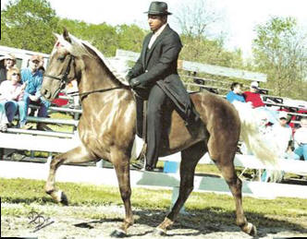
L.A.’s Buds Rock My World
“Roxie” is a beautiful chocolate mare owned by Howard and Terry Kleier of California, KY. She has an awesome gait with lots of natural lift. Folks sit up and take notice when she’s in the ring. She’ll be showing this year in the 4 year old Classic Pleasure class and the Mares Classic Pleasure division. In addition to being shown by her trainer, Mike Butler, she’ll be shown in the juvenile classes by the Kleier’s niece, Cassie Thompson. You won’t want to miss the performances of this flashy mare.
- UMH Al Prewitt Memorial Horse Show - Saturday - Juvenile 12 – 17 Classic - Cassie Thompson - 4th
- UMH Al Prewitt Memorial Horse Show - Saturday - 4 yo Mares Classic - 4th
- UMH North Middletown Charity Horse Show - Mares Classic Pleasure - 1st
- UMH Ladies Auxiliary Horse Show - Pro/Am Classic - 1st - Mike and Cassie Thompson
^{[top of page]}

Sonny’s Smokey Mountain
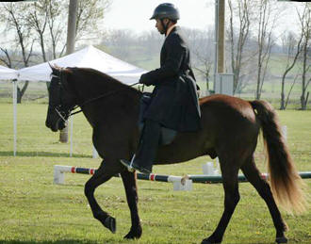
Smokey is another fine horse owned by the Kleier’s. He a 10 year old gelding that continues to have the stamina and energy to show well or to take folks out on the trails. Smokey is truly a horse that ‘has done it all!’ He has won everything from Classic High Point Awards to World Grand Championships and Super Horse. He has performed with the Mountain Rhythm Riders yet gladly takes folks out on the trails. Smokey will be shows occasionally this year. He is for sale. Contact SRF if you have any questions about Smokey.
- UMH Al Prewitt Memorial Horse Show - Saturday - Men’s Open Classic - 2nd
- UMH Al Prewitt Memorial Horse Show - Saturday - Adult Trail Obstacle - 5th
- KMSHA Junior Robinson 20th Anniversary Celebration - Trail Obstacle - 3rd
- KMSHA Junior Robinson 20th Anniversary Celebration - 5 and older Classic Pleasure - 4th
- KMSHA Junior Robinson 20th Anniversary Celebration - 20th Annual Jr. Robinson Award - 2nd
- KMSHA Junior Robinson 20th Anniversary Celebration - Beginner Novice Over all - 3rd
- Three Phase Event - Beginner Novice - 3rd - Mike Butler up
- UMH Carson Masters Spring Premier - Pro Am Classic - Mike & Howard - 5th
- UMH Carson Masters Spring Premier - Geldings Classic - 5th
- UMH Carson Masters Spring Premier - Non Pro Classic Pleasure - Howard & Mike - 5th
^{[top of page]}

Mountain Vista Thunder
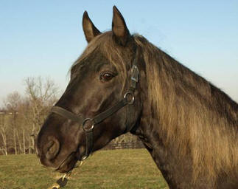
New to the Stoner Ridge Farm stallion line-up for 2009 is Mountain Vista Thunder. He is a beautiful five year old chocolate colt that will impress you with his great conformation and solid gait. He is just beginning his show career so be sure to watch for him. You won’t be disappointed. He’ll be showing in the Classic Stallions classes. Thunder’s trainer is Mike Butler and he’s owned by Bob and Marty Morris of New Bloomfield, PA. More information is available on the Stallion’s page.
- UMH Al Prewitt Memorial Horse Show - Friday - Stallions Classic - 6th
- RMH International - 5 YO Stallions Trail - 5th

^{[top of page]}

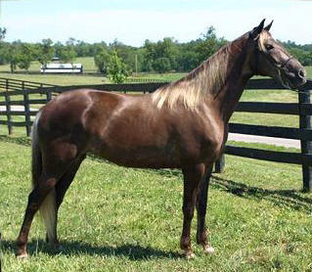
Highland’s Poudre Lyric
As a four year old, Lyric will be an awesome presence in the Trail Pleasure division this year. She received 9 first place ties in 2008 including two championships. She has such a solid gait, we’re sure she’ll continue to excel this year. She is being trained by Charlie DeAtley and is owned by Myra Montfort, Highlands Farm LLC, Fort Collins, CO.
- UMH Al Prewitt Memorial Horse Show - Saturday - Men’s Open Trail - 6th
^{[top of page]}

RRF Gold Nugget
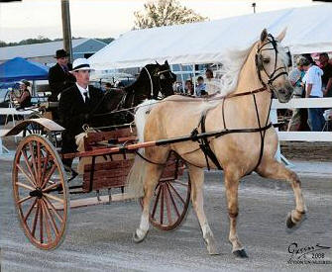
UMH Classic Pleasure Non-Pro World Grand Champion RRF Gold Nugget will come out strong again in 2009. He’ll be showing in many versatility classes which include Conformation, Trail Obstacle, Open Driving, Pro-Am, and on-the-rail classes. His owner, Steve Heuslein from LaCrescent, MN, will be showing him in the Open Amateur Classic Division and Lyngle will continue in the Non-Pro classes. His trainer, Charlie DeAtley, will be in the irons for the remaining classes. Charlie and Nugget received the 4 yo Classic Pleasure Stallions & Geldings High Point for 2008. Lyngle and Nugget also received the Non-Pro Classic Pleasure High Point award last year. Look for this beautiful palomino. He’s a joy to watch.
- UMH Al Prewitt Memorial Horse Show - Saturday - Non-Pro Classic - Lyngle Lawson - 6th
- UMH Carson Masters Spring Premier - Pro Am Classic - 4th - Steve & Charlie up
- UMH Carson Masters Spring Premier - Non Pro Classic - Lyngle up - 1st
- UMH Carson Masters Spring Premier - Geldings Classic - 1st
- UMH Carson Masters Spring Premier - Classic Pleasure Championship - 5th
- UMH Ladies Auxiliary Horse Show - Trail Obstacle - 2nd
- UMH Ladies Auxiliary Horse Show - Non-Pro Classic - 4th - Lyngle
- UMH Stidham Memorial - Non-Pro Classic - 5th - Lyngle
- RMH Kentucky Downs Classic - Ladies Show Pleasure - 2nd - Lyngle
- RMH Kentucky Downs Classic - Show Pleasure Geldings - 1st
- RMH Tavares Championship Classic - Ladies Show Pleasure - 1st - Lyngle
- RMH Tavares Championship Classic - Trainers Class - 4th
- UMH Bourbon County Fair - Non-Pro Classic - 5th - Lyngle
- UMH KY State Championship – Non Pro Classic - 3rd - Lyngle Lawson
- UMH KY State Championship - Geldings Classic - 2nd
- TN State Championship - 4 + Conformation - 2nd - Robert
- TN State Championship - Non Pro Classic - 1st - Lyngle
- TN State Championship - Adult Trail Obstacle - 4th
- TN State Championship - Classic Pleasure Championship - 1st
- TN State Championship - Pro Am Classic - 1st - Charlie/Lyngle
- TN State Championship - Geldings Classic - 1st
- TN State Championship - Adult Versatility - 1st
- Great Smoky Mtn. Championship - Non Pro Classic - 2nd - Lyngle
- UMH Summer Celebration - Non Pro Classic - 4th - Lyngle
- UMH Summer Celebration - Classic Pleasure Championship - 4th
- UMH Summer Celebration - Pro Am Classic - 5th - Charlie/Steve
- UMH Summer Celebration - Geldings Classic - 2nd
- UMH World Show - 4 + Classic Pleasure Geldings - 1st
- UMH World Show - Amateur Men’s Classic - 2nd - Steve Heuslein
- UMH World Show - Non-Pro Classic - 2nd - Lyngle Lawson
- UMH World Show - 4+ Geldings In Hand - 5th
- UMH World Show - Men’s Classic Pleasure - 4th
- UMH World Show - Trail Obstacle Sr. Horse - 4th
- UMH World Show - Pro Am Classic - 5th - Charlie & Steve
- UMH World Show - Open Driving - 1st
- UMH World Show - Non-Pro Classic World Grand Championship - 4th - Lyngle Lawson
- UMH World Show - Groom’s Class - 5th - Lisa Sidwell
- RMH International - Men’s Amateur Show Pleasure - 2nd - Steve Heuslein
- RMH International - 4-5 YO Amateur Show Pleasure - 7th - Steve Heuslein
- RMH International - 3-5 YO Geldings Conformation - 1st
- RMH International - 5 YO Geldings Show Pleasure - 1st
- RMH International - Pleasure Driving - 1st
- RMH International - Show Pleasure Grand Championship - 7th
- RMH International - Adult Trail Obstacle - 2nd
- RMH International - 3-5 YO Open Conformation Championship - 1st
- RMH International - Conformation Grand Championship - 2nd
- RMH International - Sam Tuttle Memorial Award
- RMH International - Geldings Show Pleasure Championship - 1st
- KMSHA International - Open Driving - 1st
- KMSHA International - Trail Obstacle - 4th
- KMSHA International - 5+ Mare/Gelding Conformation - 4th
- KMSHA International - Men’s Open Classic - 5th
2009 High Point Awards
- 1st - UMH Geldings Classic Pleasure
- 2nd - Non Pro Classic - Lyngle Lawson
^{[top of page]}

Legendary Lady
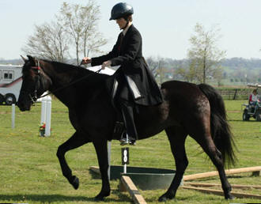
. . . . the Lady IS Legendary! And she’s back. Yes, two time Sam Tuttle Memorial Award winner, Legendary Lady, is back in training at Stoner Ridge Farm. She began training for the Three Phase and then her owners, Judy and Michael Brummer, decided to take her to the Al Prewitt Memorial Show in North Carolina where she won the Mares Trail Pleasure class with Judy in the irons. Lady is a wonderful mare that can do it all . . . we’re thrilled to have her back at her home place once again.
- UMH Al Prewitt Memorial Horse Show - Friday - Mares Trail - 2nd
- UMH Al Prewitt Memorial Horse Show - Saturday - Open Western - 6th
- UMH Al Prewitt Memorial Horse Show - Saturday - Mares Trail - Judy Brummer - 1st
- UMH Al Prewitt Memorial Horse Show - Saturday - Adult Trail Obstacle - Judy Brummer - 4th
- UMH Al Prewitt Memorial Horse Show - Saturday - Trail Pleasure Championship - Judy Brummer - 6th
- UMH Al Prewitt Memorial Horse Show - Saturday - Adult Versatility Award - 3rd
- Three Phase Event - Adult Beginner Novice Over All - 1st - Judy Brummer up
- Three Phase Event - AGMH High Point Horse
- Three Phase Event - Trail Obstacle - 1st - Judy Brummer up
- Three Phase Event - Adult Novice Over All - 3rd - Robert Lawson up
- Three Phase Event - Dressage - 2nd - Robert Lawson up
- UMH Carson Masters Spring Premier - Trail Obstacle - Judy Brummer up - 2nd
- UMH Carson Masters Spring Premier - Amateur Trail - Judy Brummer up - 5th
- UMH Carson Masters Spring Premier - Non-Pro Trail - Judy Brummer up - 3rd
- UMH Carson Masters Spring Premier - Adult Versatility Award - Judy Brummer up - 5th
^{[top of page]}
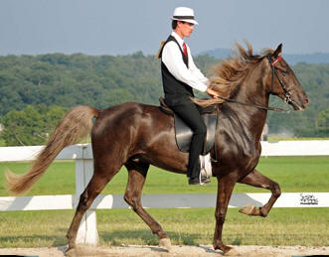
Pepper’s Capital Venture
Capital Venture made his show-ring debut during the Kentucky State Championship last year at the new Kentucky Equestrian Center in Winchester. He did a great job! This up-and-coming guy is fluid and exciting to watch. He has an outstanding gait and a beautiful flowing mane. We’re going to enjoy watching this 3 year old as he grows up. He is a half brother to Pepper’s Just Plain Pretty. Watch for him in the three year old classic pleasure classes this year. We’re sure you’ll like what you see! Capital Venture is owned by Steve Heuslein, LaCrescent, MN and trained by Charlie DeAtley.
- UMH Al Prewitt Memorial Horse Show - Friday - 3 yo Stallions/Geldings Classic - 6th
- UMH Al Prewitt Memorial Horse Show - Saturday - Men’s Open Classic - 5th
- UMH Al Prewitt Memorial Horse Show - Saturday - 3 yo Stallions/Geldings Classic - 3rd
- KMSHA Junior Robinson 20th Anniversary Celebration - 3 year old Mares and Geldings Classic - 5th
- UMH Carson Masters Spring Premier - 3 Year Old Stallions & Geldings - 2nd
- UMH North Middletown Charity Horse Show - 3 yo Stallions & Geldings - 1st
- UMH Ladies Auxiliary Horse Show - Geldings Classic - 2nd
- RMH Kentucky Downs Classic - 3 YO Show Pleasure - 1st
- RMH Tavares Championship Classic - 3 YO Show Pleasure - 3rd
- RMH Tavares Championship Classic - Show Pleasure Geldings - 4th
- UMH Bourbon County Fair - 3 YO Stallions/Geld. Classic - 1st
- UMH KY State Championship - 3 yo Classic - 5th
- Great Smoky Mtn. Championship - 3 YO Stallions & Geldings - 2nd
- TN State Championship - 3 YO Stallions & Geldings - 5th
- UMH Summer Celebration - 3 YO Stallions & Geldings - 3rd
- UMH World Show - 3 yo Classic Stallions/Geldings - 4th
- RMH International - 3 YO Amateur Trail Pleasure - 3rd - Steve Heuslein
- RMH International - 3 YO Amateur Show Pleasure - 3rd - Steve Heuslein
- RMH International - 3 YO Gelding Trail Pleasure - 1st - Michael Butler
- RMH International - 3 YO Gelding Show Pleasure - 1st
- RMH International - Geldings Championship Trail - 7th - Michael Butler
- KMSHA International - 3 & 4 yo Mare/Gelding Conformation - 3rd
2009 High Point Awards
- 1st - UMH 3 Year Old Stallions & Geldings Classic Pleasure
^{[top of page]}

RPM’s Squirrel’s Blackfoot
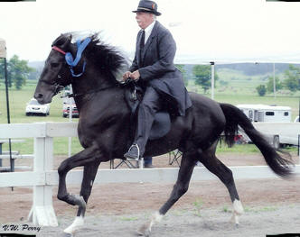
“Squirrel” is a beautiful 3 year old stallion. He has a great mind and is a pleasure to work with. You would never know he is a stallion. He made his debut at the UMH World Show last September and we’re excited to have the opportunity to train and show this fine colt. He is owned by Randy and Regina Jones from Conway, AR.
- KMSHA Junior Robinson 20th Anniversary Celebration - Open Four Gait - 1st
- KMSHA Junior Robinson 20th Anniversary Celebration - Open Novice Trail - 2nd - Regina Jones up
- UMH Carson Masters Spring Premier - 2 & 3 Year Old Open Trail Pleasure - 1st
- UMH Carson Masters Spring Premier - 2 & 3 Year Old Open Conformation - 5th
- UMH Carson Masters Spring Premier - Pro Am Trail - Robert & Amanda Dunn - 5th
- UMH Carson Masters Spring Premier - Open Four Gait - 1st
- UMH Carson Masters Spring Premier - Adult Versatility Award - 2nd
- UMH Ladies Auxiliary Horse Show - Open Four Gait - 1st - Unanimous Decision
- UMH Ladies Auxiliary Horse Show - Trail Obstacle - 5th
- UMH Ladies Auxiliary Horse Show - Adult Versatility - 3rd
- UMH Stidham Memorial - 2 & 3 YO Trail - 5th
- RMH Kentucky Downs Classic - Amateur Trail - 3rd - Regina Jones
- RMH Tavares Championship Classic - Amateur Trail Pleasure - 2nd - Regina Jones
- UMH Bourbon County Fair - Open 4 Gait - 4th
- UMH KY State Championship - Open 4 Gait - 1st Unanimous
- UMH KY State Championship - Amateur Trail - 5th - Randy Jones
- TN State Championship - 2 & 3 YO Conformation - 2nd
- TN State Championship - Open 4 Gait - 1st
- TN State Championship - 2 & 3 YO Trail - 1st
- TN State Championship - Pro Am Trail - 3rd - Robert/Tim Spencer
- TN State Championship - Adult Versatility - 4th
- Great Smoky Mtn. Championship - 2 & 3 YO Conformation - 3rd
- UMH Summer Celebration - 2 & 3 YO Conformation - 1st
- UMH Summer Celebration - - Open 4 Gait - 1st
- UMH Summer Celebration - 2 & 3 YO Trail - 3rd
- UMH Summer Celebration - Adult Versatility - 3rd
- UMH World Show - Water Glass Class - 2nd - Randy Jones
- UMH World Show - Am/Non Pro 2+ In-Hand - 3rd - Randy Jones
- UMH World Show - Western Pleasure Jr. Horse - 5th
- UMH World Show - Novice Gentleman Rider - 3rd - Randy Jones
- UMH World Show - Trail Obstacle Jr. Horse - 1st
- UMH World Show - Trail Obstacle Open Am/Non Pro - 5th - Randy Jones
- UMH World Show - Open 4 Gait - 2nd
- UMH World Show - Regional Amateur Trail - 2nd - Randy Jones
- UMH World Show - Novice Ladies Trail - 2nd - Regina Jones
- UMH World Show - KY Bourbon Class - 6th - Randy Jones
- UMH World Show - Amateur Versatility - 3rd - Randy Jones
- UMH World Show - Barb's Stormy Knight Award - 6th
2009 High Point Awards
- 1st - UMH 2-3 Year Old Open Trail Pleasure
- 1st - UMH Open Four Gait
- 3rd - KMSHA/SMH Open Four Gait
^{[top of page]}
Highland’s Poudre Belle
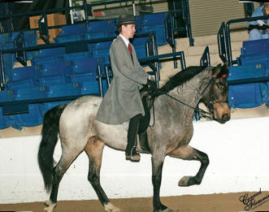
Just beginning her show career in 2009, this nice three year old filly has a pretty canter and is really easy to work with. She will be shown in the trail pleasure and open four gait classes by her trainer, Charlie DeAtley. Belle is owned by Myra Montfort, Highland’s Farm L.L.C., Fort Collins, CO.
- KMSHA Junior Robinson 20th Anniversary Celebration - Open Four Gait - 2nd
- KMSHA Junior Robinson 20th Anniversary Celebration -
3 yo Mares/Geldings Trail - 4th
^{[top of page]}

Highland’s Poudre Java
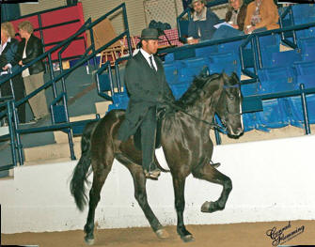
As a three year old, Java has a solid gait and nice temperament. He will be competing in the trail pleasure classes under the direction of his trainer, Mike Butler. Be sure to watch for this great gelding in the show ring this summer. He is owned by Myra Montfort, Highland’s Farm L.L.C., Fort Collins, CO.
- KMSHA Junior Robinson 20th Anniversary Celebration - 3 year old Mares/Geldings Trail Pleasure - 3rd
^{[top of page]}
Barb’s Stormy Knight
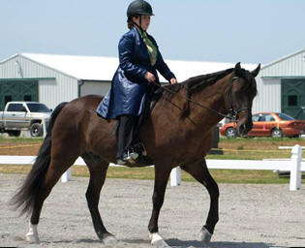
Ten year old Barb’s Stormy Knight continues his illustrious career in 2009. Even though he’s in the AGMH Hall of Fame and has been the winner of numerous World Grand Championships including the Western World Grand Championships in all three Mountain Horse associations, he continues to ‘learn new tricks.’ At the 2009 Three Phase Event, Stormy received the Novice High Point Award. He also received the highest dressage score of any competitor at the event (including walk, trot, canter breeds). Stormy is also busy this year giving lessons and introducing the novice and juvenile rider to the show ring for the first time. While Erin won at the Three Phase, he continues to be trained by Robert. He’s owned by Don and Nancy Copland of Brookville, IN.
- KMSHA Junior Robinson 20th Anniversary Celebration - Open Novice Trail 3rd - Marcia Spencer up
- KMSHA Junior Robinson 20th Anniversary Celebration - Ladies Amateur Trail 3rd - Marcia Spencer up
- KMSHA Junior Robinson 20th Anniversary Celebration - Amateur Trail Championship 3rd - Nancy Copland up
- Three Phase Event - Adult Novice Over all - 1st - Erin DeAtley up
- Three Phase Event - Beginner Novice/Novice High Point
- Three Phase Event - Dressage - 1st (over all horses competing including walk, trot, canter horses) Erin up
- Three Phase Event - Beginner Novice Youth - 2nd - Lauren Hickey up
- UMH North Middletown Charity Horse Show - 11 & Under Trail – 4th - J.T. Hickey
- UMH North Middletown Charity Horse Show - 12 – 17 Trail - 2nd - Lauren Hickey
- KMSHA/SMH Spring Spectacular - Fun Class Open Trail - 1st - Tim Spencer
- KMSHA/SMH Spring Spectacular - Open Amateur Trail - 4th - Marcia Spencer
- UMH Ladies Auxiliary Horse Show - I Show/Should Show Trail - 2nd - Lyngle & Tim
- UMH Ladies Auxiliary Horse Show - 11 and Under Trail - 3rd - J.T. Hickey
- UMH Ladies Auxiliary Horse Show - Juvenile Trail Obstacle - 4th - Lauren Hickey
- UMH Ladies Auxiliary Horse Show - Novice Trail 2nd - Marcia Spencer
- UMH Ladies Auxiliary Horse Show - Juvenile 12-17 Trail - 2nd - Lauren Hickey
- UMH Ladies Auxiliary Horse Show - Amateur Trail - 3rd - Tim Spencer
- UMH Ladies Auxiliary Horse Show - Juvenile Versatility - 2nd - Lauren Hickey
- UMH Stidham Memorial - Gelding Trail - 1st - Tim Spencer
- UMH Stidham Memorial - Amateur Trail - 2nd - Marcia Spencer
- UMH Stidham Memorial - Juvenile 12-17 - 1st - Lauren Hickey
- UMH Stidham Memorial - Juvenile 11 & Under - 3rd - J.T. Hickey
- UMH Bourbon County Fair - Novice Trail - 1st - Tim
- UMH Bourbon County Fair - Open Amateur Trail - 4th - Tim
- UMH KY State Championship - Juvenile Trail Obstacle - 4th – Lauren Hickey
- UMH KY State Championship - 17 and Under Equitation - 2nd - Lauren Hickey
- UMH KY State Championship - Showmanship - 3rd - Lauren Hickey
- UMH KY State Championship - Juvenile Versatility - 2nd - Lauren Hickey
- UMH KY State Championship - Ladies Auxiliary Trail - 5th - Nancy Copland
- UMH KY State Championship - Lead Line - Ella Tillery
- KMSHA KY State Championship - Novice Trail - 1st - Marcia Spencer
- KMSHA KY State Championship - Amateur Trail - 5th - Tim Spencer
- KMSHA KY State Championship - Trail Obstacle - 4th - Robert Lawson
- Great Smoky Mtn. Championship - Open Novice Rider - 2nd - Marcia Spencer
- TN State Championship - Amateur Trail - 2nd - Tim Spencer
- TN State Championship - Open Novice - 1st - Marcia Spencer
- UMH Summer Celebration - Open Novice Rider - 1st - Marcia Spencer
- UMH Summer Celebration - Amateur Trail - 1st - Tim Spencer
- UMH Summer Celebration - Geldings Trail - 3rd - Nancy Copland
- UMH Summer Celebration - 17 & Under Equitation - 1st - Lauren Hickey
- UMH Summer Celebration - Juvenile Trail Obstacle - 4th - Lauren Hickey
- UMH Summer Celebration - 12 – 17 Juvenile Trail - 5th - Lauren Hickey
- UMH Summer Celebration - 17 & Under Showmanship - 3rd - Lauren Hickey
- UMH Summer Celebration - Juvenile Versatility Award - 2nd - Lauren Hickey
- UMH Summer Celebration - Lead Line - 1st - Ruby DeAtley
- KMSHA Camp Horsin’ Around - Oven Novice Trail - 3rd - Marcia Spencer
- KMSHA Camp Horsin’ Around - Open Amateur Trail - 6th - Tim Spencer
- UMH World Show - Non-Pro Trail Pleasure - 4th - Nancy Copland
- UMH World Show - Novice Gentleman Rider - 1st - Tim Spencer
- UMH World Show - Trail Obstacle Open Amateur - 4th - Tim Spencer
- UMH World Show - Youth Trail Obstacle - 1st - Lauren Hickey
- UMH World Show - Youth Equitation - 4th - Lauren Hickey
- UMH World Show - Amateur World Grand Championship - Tim Spencer
- UMH World Show - Lead Line - 1st - Ella Tillery & Ruby DeAtley
- KMSHA International - Trail Obstacle - Tim Spencer - 3rd
2009 High Point Awards
- 1st - KMSHA/SMH Novice Trail Pleasure - Marcia Spencer
- 3rd - UMH Juvenile Trail Obstacle - Lauren Hickey
- 2nd - UMH Open Novice Trail Pleasure - Marcia Spencer
- Lead Line - Ella Tillery
- Lead Line - Ruby DeAtley
^{[top of page]}
Merry Go Blue
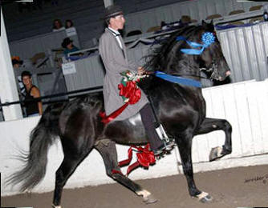
World Grand Champion Merry Go Blue is a 13 year old stallion who has beautiful conformation, gait, and a disposition that you simply won't believe for a breeding stallion! His foals carry his phenomenal attributes and are simply a pleasure to watch gait in the field (See the Stallions page). He is so light and responsive he can be ridden with a halter and lead rope. He will be competed lightly this year with his trainer, Charlie DeAtley. Merry Go Blue is co-owned by the Copland's and the Lawson's.
- UMH Carson Masters Spring Premier - Stallions Classic Pleasure - 3rd
- UMH North Middletown Charity Horse Show - Classic Pleasure Championship - 3rd
- UMH World Show - UMH/AGMH Classic Pleasure - 2nd
^{[top of page]}
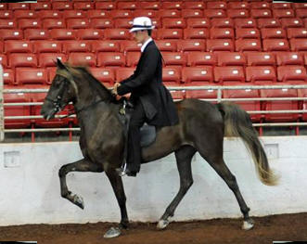
C.D.'s Girl's Got Rhythm
- UMH Carson Masters Spring Premier - Men’s Open Pleasure - 4th
- UMH Bourbon County Fair - 3 YO Fillies - 3rd
- TN State Championship - 3 YO Fillies Classic - 3rd
- Great Smoky Mtn. Championship - 3 YO Fillies Classic - 4th
- UMH Summer Celebration - 3 YO Fillies Classic - 5th
- UMH World Show - Open Four Gait - 4th
^{[top of page]}

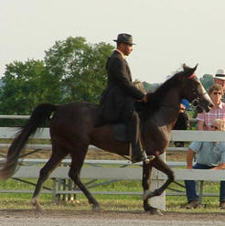
The Cross Filly
This outstanding trail pleasure filly has been under the direction of Michael Butler all season. She’s performed well and has been pleasure to have here at SRF. Congratulations to Dale and Edwina Honn from Lexington, KY!
- KMSHA/SMH Spring Spectacular - Mares Trail Pleasure - 3rd
- KMSHA/SMH Spring Spectacular - Men’s Open Trail - 3rd
- UMH Stidham Memorial - 2 & 3 YO Trail - 1st
- UMH Stidham Memorial - Mares Trail - 3rd
- KMSHA KY State Championship - 2 & 3 yo Open Trail - 4th
- KMSHA KY State Championship - Mares Trail - 4th
2009 High Point Awards
- 2nd - KMSHA 2 & 3 Year Old Fillies
^{[top of page]}

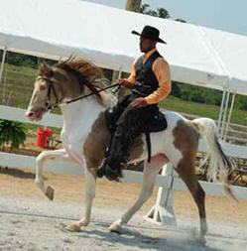
Blue's Magical Charm (Mojo)
Three year old Mojo is one talented horse. He has a great gait, he canters, shows well in conformation, and western. Looking for a Spotted Mountain Horse stallion? He’s one that you will love. His owners, Tim and Marcia Spencer, have decided to sell him as they don’t really need a stallion at this time. He is currently being trained by Michael Butler. Call Stoner Ridge Farm for additional information.
- KMSHA/SMH Spring Spectacular - Open Four Gait - 3rd
- KMSHA/SMH Spring Spectacular - SMHA Trail Pleasure - 4th
- KMSHA KY State Championship – 14.3 and Under Trail - 5th
- KMSHA KY State Championship - Open 4 Gait - 1st
- SMHA KY State Championship – Open Trail - 3rd
- KMSHA Camp Horsin’ Around - SMHA Open Trail Pleasure - 2nd
- UMH World Show - Open Spotted Mountain Horse - 3rd
- KMSHA International - SMHA Stallions Trail Pleasure - 1st
- KMSHA International - Open 4 Gait - 2nd
- KMSHA International - SMHA Trail Pleasure Championship - 4th
2009 High Point Awards
- 2nd - KMSHA/SMH Open Four Gait
- 3rd - SMH Trail Pleasure
^{[top of page]}
Little Anne
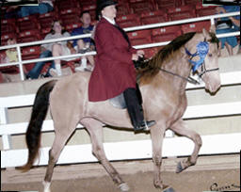
We are happy to have World Grand Champion Little Anne as a new addition to our 2009 show line up at Stoner Ridge Farm. She has a great 4 beat gait she is smooth as silk. Little Anne is a very versatile horse with 4 Four Gait, Trail Obstacle, Western, and Under Saddle wins to her credit. She will be shown in the Ladies Auxiliary and Amateur classes this summer by her owner, Nancy Copland. Little Anne is being trained by Michael Butler.
- TN State Championship - Mares Trail - 3rd
- TN State Championship - Open 4 Gait - 3rd
- TN State Championship - Trail Obstacle - 6th
- UMH Summer Celebration - Open 4 Gait - 3rd
- UMH Summer Celebration - Trail Obstacle - 4th
- UMH World Show - Water Glass Class - 4th
- UMH World Show - Trail Obstacle Sr. Horse - 3rd
- UMH World Show - Open Four Gait - 1st
^{[top of page]}
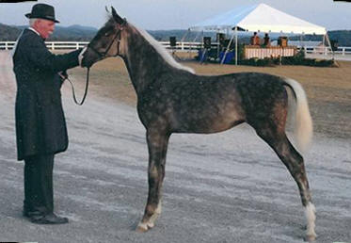
HBF Hidden Agenda
What a knock-out! This little chocolate filly will steal your heart with her sweet, curious nature. Out of Nicholei’s Sophie by WGC Merry Go Blue, she is already making waves in the show ring. She is owned by Don and Nancy Copland of Brookville, IN and trained by Robert Lawson.
- UMH World Show - Weanling Fillies - 3rd
- UMH World Show - Breeder’s Cup - 10th
- RMH International - Weanling Fillies “A” - 2nd
- RMH International - Weanling Championship - 3rd
^{[top of page]}

Branson Blue
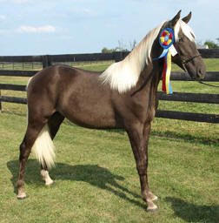
Many folks who have been showing for awhile will remember Lyngle’s show mare, One Chance Fancy. She was Amateur Classic High Point two years in a row. Fancy’s foals have begun making their way to the show ring. You are sure to be impressed with this yearling colt out of Fancy by WGC Merry Go Blue. He’s awesome! Now owned by Steve Heuslein, Branson Blue is the 2009 RMHA International Yearling Champion and is trained by Robert Lawson.
- UMH World Show - Yearling Colts In-Hand - 2nd
- UMH World Show - Yearling Amateur/Non Pro - 2nd - Robin Tucker
- UMH World Show - Yearling Conformation World Grand Championship - 3rd
- UMH World Show - Breeder’s Cup - 2nd
- RMH International - Yearling Colts “A” - 2nd
- RMH International - Yearling Championship - 1st

