Champions 2005

Congratulations to the 2005 High Point Gelding, Barb's Stormy Knight winner of the 2005 Junior Robinson Memorial Award, the Al Prewitt Versatility Award, and the Rea Swan Versatility Award.
Barb's Stormy Knight
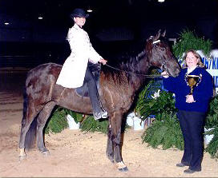
Congratulations to Nancy Copland for winning her first blue ribbon in the Open Novice Trail class on Barb's Stormy Knight at the North Carolina State Championship. Way to go Nancy! (Pictured with Jessica Shannon up). Barb's Stormy Knight, owned by Don and Nancy Copland, Brookville, IN.
- UMH/KMSHA/SMH Florida Kick-Off Versatility Award Winner
- UMH/KMSHA/SMH Florida Kick-Off Geldings Trail Pleasure
- Al Prewitt Memorial NC State Championship Versatility Award
- Al Prewitt Memorial NC State Championship Gelding Trail Pleasure
- Al Prewitt Memorial NC State Championship Open Novice
- Madison County Horse Show UMH/KMSHA Geldings Trail Pleasure
- Madison County Horse Show UMH/KMSHA Open Amateur Trail
- Madison County Horse Show UMH/KMSHA Trail Pleasure Championship
- Carson Masters Spring Premier Geldings Trail Pleasure
- Carson Masters Spring Premier Trail Obstacle
- South Carolina State Championship Geldings Trail Pleasure
- South Carolina State Championship Open Novice Trail – Nancy Copland up
- KMSH Juvenile Drill Team Benefit Open Amateur Trail – Nancy Copland up
- South Carolina State Championship Trail Obstacle
- Powell County Boy’s Basketball Stidham Memorial Open Amateur Trail – Nancy Copland up
- Geldings Trail Pleasure - Summer Celebration
- Novice Trail Pleasure - Summer Celebration - Nancy Copland Up
- Versatility Award - Summer Celebration
- Reserve Trail Pleasure Champion - Summer Celebration
- KMSHA Kentucky State Championship
- Geldings Trail Pleasure - Kentucky State Championship (unanimous decision)
- Reserve Amateur Trail Pleasure - Kentucky State Championship - Nancy Copland up
- Reserve KMSHA Amateur Trail Pleasure - Ky. State Championship - Nancy Copland up
- Geldings Trail Pleasure-Stamping Ground Ruritan Horse Show
- Trail Pleasure Championship-Tennessee UMH/KMSHA Horse Show
- Geldings Trail Pleasure-Tennessee UMH/KMSHA Hose Show
- Reserve Amateur Trail-Tennessee UMH/KMSHA Horse Show-Nancy Copland up
- Geldings Trail Pleasure-Tennessee State Championship
- Geldings Trail Pleasure-KMSHA Ohio Mountain Horse Extravaganza
- Reserve Trail Obstacle-UMH Ohio Mountain Horse Extravaganza
- Geldings Trail Pleasure-UMH Ohio Mountain Horse Extravaganza
- Reserve Amateur Trail Pleasure-UMH Ohio Mountain Horse Extravaganza
UMH World Show
- UMH World Show 6-9 Year Old Geldings
- UMH World Show Reserve Trail Obstacle
- UMH World Show Reserve Ladies Trail
RMH International
- Rea Swan Versatility Award
- Reserve 6- 9 yo Geldings
- Reserve 6-9 yo Western
- 1st Trail Obstacle Senior Horse
- Reserve Ladies Novice Class with Nancy
KMSHA International
- 1st 5+ Gelding Trail
- Reserve 6+Gelding Conf.
- 1st Western Sr. Horse
- Reserve Ladies Am Trail with Nancy up
- 1st Senior Horse Trail Ob.
- 2nd Pole Bending
- 1st Gelding Trail. Championship
- 1st Gelding Conformation Championship
- Reserve Conformation Grand Championship
- 1st Western Grand Championship
- Al Prewitt Versatility Award
- Junior Robinson Memorial Award
^{[top of page]}

Jax Magic Colors
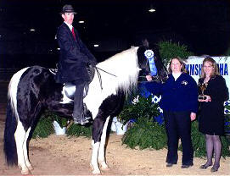
Nothing but blue for Jax Magic Colors at the Al Prewitt Memorial and the North Carolina Championship shows! Charlie DeAtley rode Magic to win all his Country Trail Pleasure Stallion/Gelding classes including the Championship. (Pictured with Charlie DeAtley up). Jax Magic Colors, owned by Don and Nancy Copland, Brookville, IN.
- UMH/KMSHA/SMH Florida Kick-Off reserve Country Trail Pleasure Stallions/Geldings
- UMH/KMSHA/SMH Florida Kick-Off Country Trail Pleasure Championship
- Al Prewitt Memorial Country Trail Pleasure Stallions/Geldings
- Al Prewitt Memorial NC State Championship Country Trail Pleasure Stallions/Geldings
- Al Prewitt Memorial NC State Championship Country Trail Pleasure Championship
- Carson Masters Spring Premier SMH Open Western
- South Carolina UMH/KMSHA Horse Show Country Trail Pleasure Stallions/Geldings
- South Carolina State Championship Country Trail Pleasure Stallions/Geldings
- Reserve Country Trail Pleasure Stallions/Geldings - Summer Celebration
- Reserve SMH Open Western - Summer Celebration
- Reserve Country Trail Pleasure Stallions/Geldings-Stamping Ground Ruritan Horse Show
- Reserve Country Trail Pleasure Championship-Stamping Ground Ruritan Horse Show
- Reserve Country Trail Pleasure Stallions/Geldings-Tennessee State Championship
- Country Trail Pleasure Stallions/Geldings-KMSHA Ohio Mountain Horse Extravaganza
- Country Trail Pleasure Championship-KMSHA Ohio Mountain Horse Extravaganza
- Reserve Country Trail Pleasure-UMH Ohio Mountain Horse Extravaganza
- Reserve Country Trail Pleasure Championship-UMH Ohio Mountain Horse Extravaganza
KMSHA International
- 1st 2/3 yo S/G Country Trail
- Reserve CTP Champ
^{[top of page]}

Sam's Blazing Star

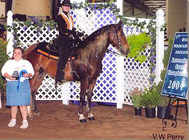
Terry Kleier had a fantastic ride in the Novice Trail Pleasure class at the Carson Masters Spring Premier and won her first UMH blue ribbon on Sam's Blazing Star (better known to us who love her as "Sissy"). This outstanding Trail Pleasure mare also won the Versatility Award with the combined efforts of Terry and Jessica. Congratulations ladies, on your outstanding success! (Pictured with Jessica Shannon up.) Sam's Blazing Star, owned by Howard and Terry Kleier, California, KY.

- Al Prewitt Memorial NC State Championship Ladies Open Trail
- Al Prewitt Memorial NC State Championship Trail Pleasure Championship
- Carson Masters Spring Premier Versatility Award Winner
- Carson Masters Spring Premier Open Novice Trail - Terry Kleier up
- Clark County Saddle Club Omen Amateur Trail - Terry Kleier up
- South Carolina State Championship Mares Trail Pleasure
- South Carolina State Championship Trail Pleasure Championship
- South Carolina Versatility Award
- Mares Trail Pleasure - Pilot View Horse Show
- Amateur Trail Pleasure - Summer Celebration - Terry Kleier up
- Reserve KMSHA Mares Trail Pleasure - Ky. State Championship
- Open Trail Pleasure Novice - Ky. State Championship - Terry Kleier up
- Reserve Open Western Pleasure - Ky. State Championship - Lyngle Lawson up
- Trail Pleasure Pro Am - Ky. State Championship - Jessica & Terry up
- Reserve Trail Pleasure Championship - Ky. State Championship - Lyngle Lawson up
- Mares Trail Pleasure - Ky. State Championship - Jessica Shannon up
- Reserve Adult Trail Obstacle - Ky. State Championship - Jessica Shannon up
- Versatility Award - Ky. State Championship
- Open Novice Trail - Ky. State Championship - Terry Kleier up
- Reserve Mares Trail Pleasure- Stamping Ground Ruritan Horse Show
- Reserve Novice Trail-Stamping Ground Ruritan Horse Show-Howard Kleier up
- Mares Trail Pleasure-Tennessee UMH/KMSHA Horse Show
- Juvenile 12-17 Trail Pleasure-Tennessee UMH/KMSHA Horse Show-Cassie Thompson up
- Mares Trail Pleasure-Tennessee State Championship
- Amateur Trail Pleasure-Tennessee State Championship-Terry Kleier up
- Trail Pleasure Championship-Tennessee State Championship
- Mares Trail Pleasure - KMSHA Ohio Mountain Horse Extravaganza
- Open Western - KMSHA Ohio Mountain Horse Extravaganza- Terry Kleier up
- 12-17 Juvenile Trail-KMSHA Ohio Mountain Horse Extravaganza -Cassie Thompson up
- Amateur Trail - KMSHA Ohio Mountain Horse Extravaganza- Terry Kleier up
- Trail Obstacle- UMH Ohio Mountain Horse Extravaganza
- Amateur Trail - UMH Ohio Mountain Horse Extravaganza-Terry Kleier up
- Western Championship-UMH Ohio Mountain Horse Extravaganza
^{[top of page]}
New Addition
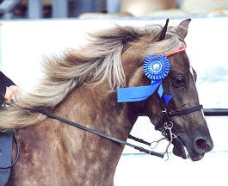
Congratulations to Cassie Thompson, Howard and Terry's niece, for working hard to place second in the competition for the Juvenile Versatility Award at the Carson Masters Spring Premier. It was only her second time to show and her first time to show Western, Showmanship, and Trail Obstacle (which she won). Terry says Cassie would ride 12 hours a day if she'd let her. That's what it takes! Way to go Cassie! New Addition, owned by Howard and Terry Kleier, California, KY. Pictured with Charlie DeAtley up.

- Al Prewitt Memorial NC State Championship Men's Open Trail Pleasure
- Al Prewitt Memorial NC State Championship Open Western Pleasure
- Carson Masters Spring Premier Juvenile Trail Obstacle - Cassie Thompson up
- South Carolina State Championship Juvenile Western - Cassie Thompson up
- Powell County Boy's Basketball Stidham Memorial Mares Trail Pleasure
- Powell County Boy's Basketball Stidham Memorial - Reserve Trail Pleasure Championship
- Ladies Open Trail - Summer Celebration - Lyngle Lawson up
- Adult Trail Obstacle - Summer Celebration - Charlie DeAtley up
- Reserve Juvenile Trail Obstacle - Summer Celebration - Cassie Thompson up
- Juvenile 12-17 Western - Summer Celebration - Cassie Thompson up
- Reserve KMSHA Juv. 12-17 Trail Pleasure - Ky. State Championship - Cassie Thompson
- Reserve Juvenile Western Pleasure - Ky. State Championship - Cassie Thompson up
- Reserve Mares Trail Pleasure - Charlie DeAtley up
- Adult Trail Obstacle - Ky. State Championship (unanimous decision) - Charlie DeAtley up
- Novice Trail Pleasure-Tennessee UMH/KMSHA Horse Show-Howard Kleier up
- Trail Obstacle-Tennessee State Championship
- Reserve Mares Trail Pleasure-Tennessee State Championship
- Reserve Men's Trail Pleasure-Tennessee State Championship
- Reserve Open Western-KMSHA Ohio Mountain Horse Extravaganza-Howard Kleier up
- Reserve Amateur Trail Pleasure-KMSHA Ohio Mountain Horse Extravaganza-Howard Kleier up
- Trail Obstacle - KMSHA Ohio Mountain Horse Extravaganza
- Mares Trail Pleasure-UMH Ohio Mountain Horse Extravaganza
- Reserve 12-17 Trail Pleasure-UMH Ohio Mountain Horse Extravaganza-Cassie Thompson up
- Trail Pleasure Championship-UMH Ohio Mountain Horse Extravaganza
- Versatility Award-Tennessee State Championship
^{[top of page]}
Patches Pride of Ebony
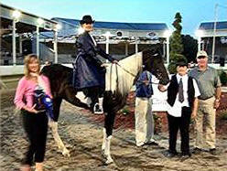
Patches Pride of Ebony (April) has had a great show season. She is owned by Don and Nancy Copland and was trained and shown this year by Erin Lawson Among her many awards was winning the blue at the Kentucky State Championship in the SMH Trail Pleasure class. She also won the Southeast Region High Point Award and the reserve SMH High Point Award for 2005. Congratulations Erin and April! Patches Pride of Ebony, owned by Don and Nancy Copland, Brookville, IN.
- Al Prewitt Memorial NC State Championship SMH Open Trail Pleasure
- KMSH Juvenile Drill Team Benefit SMH Trail - Erin Lawson up
- South Carolina UMH/KMSHA Horse Show - Erin Lawson up
- Reserve SMH Open Trail Pleasure - Summer Celebration
- SMH Open Trail Pleasure - Kentucky State Championship
- Reserve SMH Trail Pleasure-KMSHA Ohio Mountain Horse Extravaganza
- Reserve SMH Trail Pleasure-UMH Ohio Mountain Horse Extravaganza
- KMSHA International - Reserve Water Glass
^{[top of page]}

Toco's Last Chance
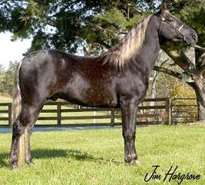
Charlie DeAtley rode Toco's Last Chance to win the Stallion Trail Pleasure class at the North Carolina State Championships. Charlie and Chance are a great team and made a fantastic show. Toco's Last Chance, owned by Howard and Terry Kleier, California, KY. Charlie DeAtley, Trainer.

- Al Prewitt Memorial NC State Championship Open Stallion Trail Pleasure
- Madison County Horse Show UMH/KMSHA Stallions Trail Pleasure
- South Carolina UMH/KMSH Horse Show Stallions Trail Pleasure - Robert Lawson up
- South Carolina UMH/KMSH Horse Show Trail Pleasure Championship - Robert Lawson up
- Stallions Trail Pleasure-KMSHA Ohio Mountain Horse Extravaganza
- Trail Pleasure Championship-KMSHA Ohio Mountain Horse Extravaganza
- Reserve Stallions Trail Pleasure-UMH Ohio Mountain Horse Extravaganza
^{[top of page]}

Sonny's Smokey Mountain
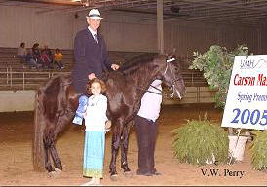
Congratulations to Howard Kleier, owner and exhibitor of Sonny’s Smokey Mountain, winner of the Open Novice Classic Pleasure at the Carson Masters Spring Premier. Howard made an outstanding ride as Smokey performed flawlessly. Howard and Smokey are a great team. Look for Howard in the Novice Classic class and Charlie in the Stallion Classic class throughout the 2005 show season.

- Carson Masters Spring Premier Open Novice Classic- Howard Kleier up
- Reserve Stallions Classic Pleasure - Pilot View Horse Show
- Reserve Stallion Classic Pleasure - Kentucky State Championship
- Amateur Classic-Tennessee UMH/KMSHA Horse Show
- Amateur Classic-Tennessee State Championship
- Reserve Stallions Classic Pleasure-KMSHA Ohio Mountain Horse Extravaganza
- Reserve Amateur Classic Pleasure-KMSHA Ohio Mountain Horse Extravaganza-Howard Kleier up
- Stallions Classic Pleasure-UMH Ohio Mountain Horse Extravaganza
^{[top of page]}

Dock's Mr. Sandman
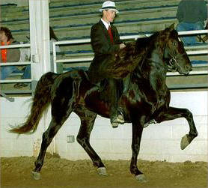
Hear the rhythm and see the excitement of the Park Pleasure Stallion class and the Park Championship this season. The competition is awesome! Congratulations to Charlie and Sandman on their outstanding performances.
- Carson Masters Spring Premier - Reserve Park Stallion
- KMSH Juvenile Drill Team - Reserve Park Stallion
- Powell County Boy's Basketball Stidham Memorial Park Stallion
- Park Pleasure Stallions - Summer Celebration
- Park Pleasure Stallions - Pilot View Horse Show
- Reserve Stallions Park Pleasure-Tennessee UMH/KMSHA Horse Show
- Stallions Park Pleasure-Tennessee State Championship
- Stallions Park Pleasure-UMH Ohio Mountain Horse Extravaganza
- Park Pleasure Championship-UMH Ohio Mountain Horse Extravaganza
- UMH World Show Park Pleasure Stallions
- KMSHA International - Reserve Stallion. Park Grand. Championship
^{[top of page]}

Glenn's Personal Princess
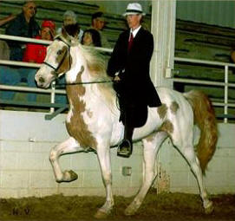
Be sure to catch the excitement of Charlie and Glenn's Personal Princess in the Spotted Mountain Horse Classic division. They are a fantastic team to watch. Princess has stride and reach and paints a pretty picture in the show ring. Congratulations to Glenn Johnson and Val Kleinheitz on their magnificent three year old filly.
- Wolfe County Basketball Boosters - Reserve SMH Classic
- Powell County Boy's Basketball Stidham Memorial - Reserve SMH Classic
Summer Celebration
- Pilot View Horse Show
- Reserve Kentucky State Champion
^{[top of page]}

Sarah's Desperado
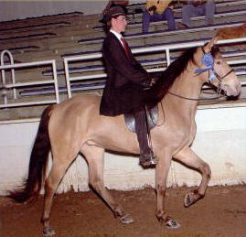
Desperado is back in the show ring this year and competing strong. He is great in the Country Trail Pleasure classes and does exceptionally well in Trail Obstacle. His remarkable Champaign coloring attracts attention in the show ring and on the trail. Howard and Terry Kleier are proud owners of Desperado but would be willing to sell him to the right buyers. They are fortunate to have too many outstanding trail pleasure horses to ride themselves. Congratulations the Kleiers and Desperado!
- Powell County Boy's Basketball Stidham Memorial Country Trail Pleasure Stallions/Geldings
- Reserve Juvenile Trail Obstacle - Kentucky State Championship - Cassie Thompson up
- Country Trail Pleasure Stallions/Geldings - Ky. State Championship - Erin Lawson up
- Juvenile 12-17 Country Trail Pleasure - Cassie Thompson up
Country Trail Pleasure Stallions/Geldings-Stamping Ground Ruritan Horse Show
- Reserve Trail Obstacle-Tennessee State Championship
- Juvenile 12-17 Trail Pleasure-Tennessee State Championship-Cassie Thompson up
- Reserve Novice Trail Pleasure-Tennessee State Championship-Howard Kleier up
- Reserve Juvenile 12-17 Country Trail Pleasure-KMSHA Ohio Mountain Horse Extravaganza-Cassie Thompson up
- Reserve Country Trail Pleasure Stallions/Geldings-KMSHA Ohio Mountain Horse Extravaganza
- Reserve Trail Obstacle-KMSHA Ohio Mountain Horse Extravaganza-Cassie Thompson up
- Country Trail Pleasure Stallions/Geldings-UMH Ohio Mountain Horse Extravaganza
- Juvenile 12-17 Country Trail Pleasure - UMH Ohio Mountain Horse Extravaganza-Cassie Thompson up
- Country Trail Pleasure Championship-UMH Ohio Mountain Horse Extravaganza-Jessica Shannon up
^{[top of page]}

FairWinds TNT
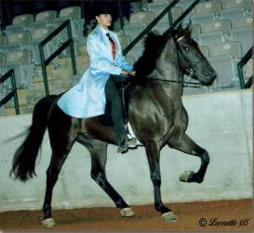
New on the show circuit is FairWinds TNT, affectionately known around the barn as Boomer. At his very first show, he was not the least concerned about the excitement of the crowd. He is making great progress and placing well in the Classic Gelding class. Jessica just loves his temperament and way of going. Don and Nancy Copland are proud owners of Boomer and have really enjoyed watching him develop. Look for Jessica and Boomer in the Gelding Classic and 3 Year Old Classic division throughout the show season.

- KMSH Juvenile Drill Team Benefit - Reserve Geldings Classic
- Powell County Boys Basketball Stidham Memorial - Reserve Geldings Classic
- Reserve Geldings Classic Pleasure Pilot View Horse Show
- Reserve Geldings Classic Pleasure - Summer Celebration
- Reserve Geldings Classic Pleasure - Kentucky State Championship
- Geldings Classic Pleasure-KMSHA Ohio Mountain Horse Extravaganza
- Geldings Classic Pleasure-UMH Ohio Mountain Horse Extravaganza

^{[top of page]}

Silver's Blue Plate Special
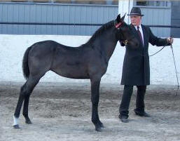
She's a knock out and drop dead gorgeous! This little blue roan filly has what it takes to win. Her conformation is simply fantastic. Congratulations to Robert & "Penny" on their Kentucky State Championship win (by unanimous decision).
- Kentucky State Championship win (by unanimous decision).
Open Weanlings - Kentucky State Champion
KMSHA International
- 1st KMSHA Futurity Wean.
- 1st Weanling Fillies
- 1st Open Weanling Champ.
^{[top of page]}

Legendary Lady
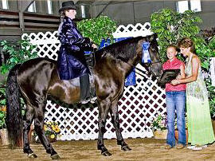
At the shows this summer, be on the look out for Erin and Legendary Lady. They are working on Trail Obstacle, Western, and Mares Country Trail Pleasure classes. What a striking pair they are! Legendary Lady is owned by Mike and Judy Brummer from Shumway, IL. Judy is also riding Lady in the Amateur classes and doing a fantastic job. Congratulations ladies!
- UMH/KMSH Madison County Hors Show - Reserve Country Trail Pleasure Mares
- Carson Masters Spring Premier - Reserve Country Trail Pleasure Mares
- South Carolina UMH/KMSH Horse Show - Reserve Country Trail Pleasure Mares
- South Carolina State Championship - Reserve Country Trail Pleasure Mares
- Reserve Country Trail Pleasure Mares-Stamping Ground Ruritan Horse Show
- Reserve Country Trail Pleasure mares-Tennessee State Championship
- Country Trail Pleasure Mares-KMSHA Ohio Mountain Horse Extravaganza
- Reserve Country Trail Pleasure Championship-KMSHA Ohio Mountain Horse Extravaganza
- Reserve 4+ Conformation - UMH Ohio Mountain Horse Extravaganza
- Country Trail Pleasure Mares-UMH Ohio Mountain Horse Extravaganza
RMH International
- Reserve Trail Obstacle
- Reserve 5 yo Amateur
- 1st 5 yo Trail Pleasure
- 1st 5 yo Western
- Reserve Western Grand Championship
- Reserve Rea Swan Versatility
^{[top of page]}

Stone's Miss Hollywood
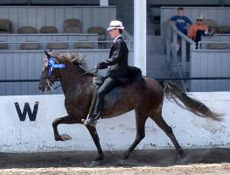
Mares Classic Pleasure - Pilot View Horse Show
- Mares Classic Pleasure - KMSHA Kentucky State Championship
- Mares Classic Pleasure - Kentucky State Championship (unanimous decision)
- Mares Classic Pleasure-Tennessee State Championship
- Classic Pleasure Championship-Tennessee State Championship
- Reserve Mares Classic Pleasure-KMSHA Ohio Mountain Horse Extravaganza
- Mares Classic Pleasure-UMH Ohio Mountain Horse Extravaganza
- Classic Pleasure Championship-UMH Ohio Mountain Horse Extravaganza
^{[top of page]}

Silverheels Jake
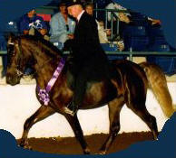
Silverheels Jake is a superb stallion. He was recently featured on the UMH's program aired by RFD-TV due to his beautiful conformation. He returned to SRF after a successful as a young stallion. He has such illustrious wins as the RMH Kentucky State Champion 2 Year Old Stallion and RMH Reserve High Point 2 Year Old and Older Conformation winner. Jake was only at SRF a couple of months this summer for a "tune-up." If you're looking for a breeding stallion, Jake produces foals with an exceptional temperament and a luxurious manes and tails. He's truly something special.
- Reserve Stallions Trail-Stamping Ground Ruritan Horse Show
- Reserve Trail Pleasure Championship-Stamping Ground Ruritan Horse Show
^{[top of page]}

Strike it Rich
Congratulations to Erin Lawson and Strike it Rich - 2005 World Champion!
Trail Obstacle Junior Horse award winner. It isn't often that a 2 year old that has been under saddle only 3 or 4 months can experience such success. Erin started Strike it Rich back in May and has developed a special bond with her. Strike it Rich is owned by Joe and Gail Evans, Crozier, VA.
- UMH World Show Trail Obstacle Junior Horse
- RMH International - 1st 2 yo Trail Pleasure
- RMH International - 1st 2 yo Western Pleasure
^{[top of page]}
Erin's High Cotton
What a beauty! Erin's High Cotton is a chocolate yearling filly with a snow white mane and tail. She is out of Mid-Summer's Night by award winning Santa Anna. She made her show debut at the RMH International and took all the excitement in stride. She is being offered for sale and is priced at $6,000. Due to her exceptional quality, that price will only be in effect until she is started under saddle.
- RMH International - Reserve Yearling Fillies (B)
^{[top of page]}

