Whole Lot of Blue
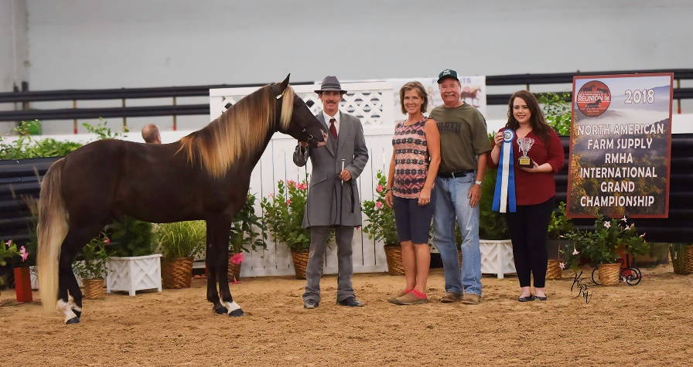

Registered: RMHA and KMSHA

Whole Lot of Blue is a young, chocolate stallion born May 8, 2016. He is owned by Steve & Susan Heuslein. “Blue” was born and bred in Kentucky and is an excellent horse to compete in the KHBIF program. Not only is he beautiful but he is supremely well gaited. See his 2018 accomplishments below his pedigree. If you are looking for a phenomenal stallion to cross with your mares in 2020 and beyond, contact Charlie DeAtley at Stoner Ridge Farm for more information 859.749.8982 or email charlied8282@gmail.com.

Whole Lot of Blue Pedigree
 |  |  |  | Tobe
 |  |  | Sam Clemon’s Tim | Tuttle Stock
 |  | Blue Mountain Rumbo |  | Smith’s Ginger
 | Merry Go Blue |  | Misty Lady | Sun’s Merry Ella B
 |  |  | Copper (Lacy’s) | Unknown
 |  | Denniston’s Susie |  | Unknown
Whole Lot of Blue |  |  | Taulbee’s Mare | Buckie
 |  |  |  | Unknown
 |  |  | Choco Dock | Dock
 |  | Pence’s Blue Boy |  | Fonzie
 | Blueberry Wine |  | Lorraine | Rocky Mountain Stock
 |  |  |  | Rocky Mountain Stock
 |  |  | Blue Mountain Tip | Blue Mountain Rumbo
 |  | Blue Mtn. Red Wine |  | Spookie
 |  |  | Applette | Dock
 |  |  |  | Ebony Delight
2018 Accomplishments
RMHA International 2 YO Conformation winner
RMHA International 2 YO & Under Champion Conformation winner

