Pepper’s Just Plain Pretty
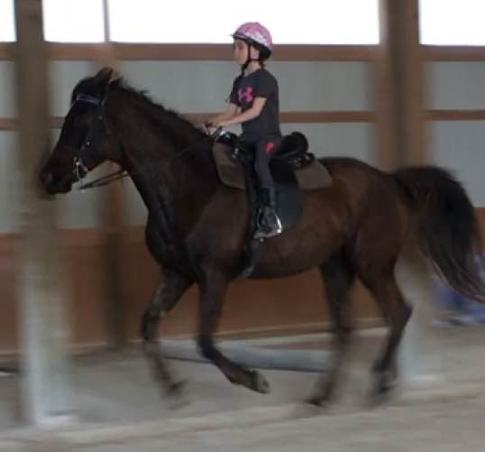
2018
RMHA Lady Eagles – RMHA Youth Western Pleasure - 2nd - Ruby
RMHA Lady Eagles – RMHA Youth CTP – 1st - Ruby
RMHA Lady Eagles – RMHA Youth Trail/CTP Championship - 2nd - Ruby
RMHA Tollesboro Lions Club - RMHA 17 & Under CTP - 3rd - Ruby
RMHA Tollesboro Lions Club - RMHA 17 & Under Youth CTP Championship - 1st - Ruby
RMHA Gaited Gala - Youth Western Pleasure - 2nd
RMAH Gaited Gala - Youth 11 & Under CTP - 1st
RMHA Gaited Gala - Youth CTP Championship - 2nd
RMHA Mountain Horse Celebration - KMSHA Juve. CTP (17 & Under) - 3rd
RMHA Mountain Horse Celebration - Youth CTP (17 & Under) - 5th
RMHA Get Your Pink On - RMHA Trail Obstacle - 2nd
RMHA Get Your Pink On - Pink Class 17 & Under - 3rd
KHBIF Trail Challenge Cup - RMHA Youth CTP (17 & Under) - 1st - Ruby
KMSHA Summer Kick-Off - 11 & Under CTP Friday - 1st
KMSHA Summer Kick-Off - 11 & Under CTP Saturday - 1st
KMSHA Summer Kick-Off - 11 & Under Trail Pleasure Championship - 1st
RMHA Red Neck Barn Show - Youth Western - 2nd
RMHA Red Neck Barn Show - Youth Country Trail Pleasure - 5th
RMHA Red Neck Barn Show - Youth Trail Pleasure - 5th
RMHA Red Neck Barn Show - Youth CTP Championship - 2nd
RMHA International - Youth Trail Obstacle - 1st
RMHA International - Youth 11 & Under Western - 2nd
RMHA International - Youth 11 & Under CTP - 2nd
RMHA International - Youth 11 & Under Equitation - 2nd
RMHA International - Youth Showmanship - 2nd
RMHA International - Youth 11 & Under CTP Championship - 2nd
RMHA International - Pink Class - 1st
KMSHA International - Juvenile Trail Obstacle - 1st
KMSHA Juvenile Western - 3rd
KMSHA Juvenile 11 & Under CTP - 1st
KMSHA Juvenile 11 & Under CTP Championship - 1st
KMSHA Carson Masters Juvenile Versatility Award
RMHA High Point Awards - 11 & Under CTP - 1st
RMHA High Point Awards - 11 & Under CTP Championship - 1st
RMHA High Point Awards - 11 & Under Trail Pleasure - 1st
RMHA Youth Western Pleasure - 2nd
KHBIF Competitive Trail - Gold Level

