Barb’s Stormy Knight

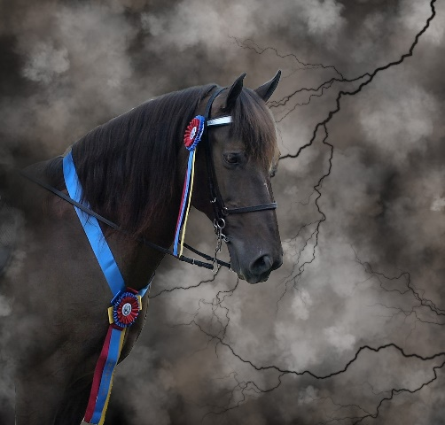

2018
RMHA Gaited Gala - Ladies CTP - 2nd - Nancy
RMHA Gaited Gala - Open M/G CTP - 4th - Nancy
RMHA Get Your Pink On - Adult Trail Obstacle - 1st

