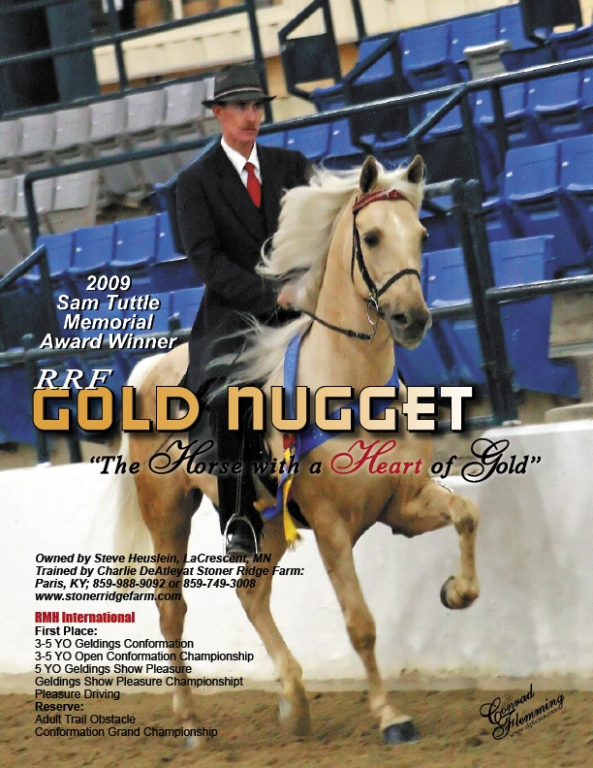
Performance Horse Clinic

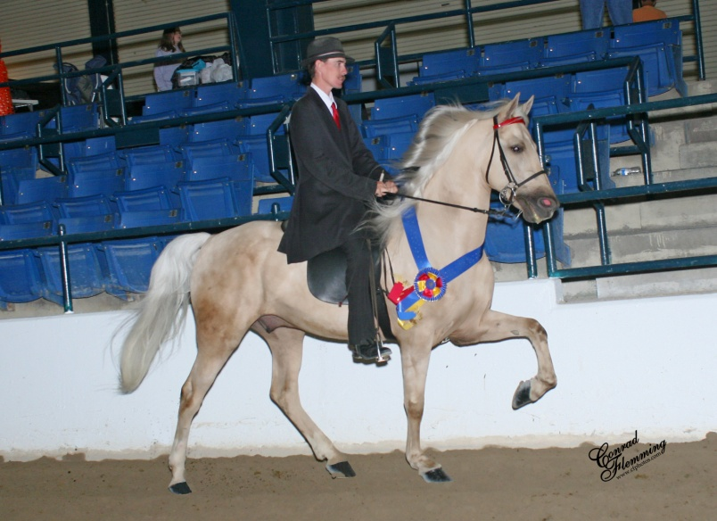
The Performance Horse Clinic is designed to help individuals new to the show ring or folks who want to hone their presentation skills to a higher level. Attendees will learn what to look for in a horse used for competition and how to present the competition horse to the highest level possible. Robert and his staff are accomplished in the show ring and will help you learn how to follow in their footsteps.
Elements include:
- Suitability of your horse
- Safety
- Equipment
- Presentation
- Clothing
- Different Disciplines/Divisions
- Strategy
- Stamina
- Seat
- Hands
- Collection

