Champions 2010

Blueberry Wine
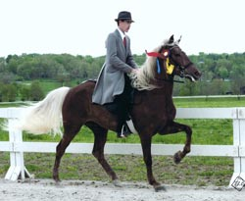
A thrill to watch and a pleasure to ride, Blueberry Wine is returning to the show ring this year. She is a beautiful mare that is strong and consistent in her gait. Blueberry’s temperament is exceptional. Our congratulations goes out to her for winning the Al Prewitt Memorial Classic Pleasure Championship on her first trip back to the show ring in over a year. Look for her in versatility events, classic pleasure under saddle classes, and with Nancy in the amateur class. Blueberry is owned by Steve Heuslein of LaCrescent, MN. and her trainer is Charlie DeAtley.
- Al Prewitt Memorial - Classic Pleasure Championship - 1st
- Al Prewitt Memorial - Pro Am Classic - 2nd - Robert & Nancy
- Al Prewitt Memorial - Mares Classic Pleasure - 5th
- Al Prewitt Memorial - Trail Obstacle - 5th
- Al Prewitt Memorial - Adult Versatility - 5th
- Al Prewitt Memorial - Conformation - 5th
- UMH Carson Masters Spring Premier - Trail Obstacle - 5th
- UMH Carson Masters Spring Premier - Classic Pleasure Championship - 1st
- UMH North Middletown - Mares Classic - 2nd
- UMH Ladies Auxiliary - Adult Trail Obstacle - 5th
- UMH Bourbon County Fair Show - Lead Line - Ella Tillery - 1st
- UMH Bourbon County Fair Show - Classic Pleasure Championship - 1st
- UMH KY State Championship - Pro Am Classic - 1st - Charlie &Steve
- UMH KY State Championship - Classic Championship - 2nd
- UMH KY State Championship - Adult Versatility - 5th
- RMH Kentucky State Championship - 4-5 Year Old Show Pleasure - 2nd
- RMH Kentucky State Championship - Show Pleasure Championship - 2nd
- RMH Kentucky State Championship - H.T. Derickson Open Championship - 1st
- RMH Tavares Championship - 4-5 Year Old Show Pleasure - 2nd
- UMH Great Smoky Mountain Championship - Mares Classic - 4th
- UMH Great Smoky Mountain Championship - Classic Pleasure Championship - 2nd
- UMH Tennessee State Championship - 4 and Older Conformation - 6th
- UMH Tennessee State Championship - Classic Pleasure Championship - 2nd
- UMH Tennessee State Championship - Adult Trail Obstacle - 2nd
- RMH International – 5-6 Year Old Amateur Show Pleasure - 2nd – Steve
- RMH International – 5 Year Old Mares & Geldings Show Pleasure – 2nd
- RMH International – Mares Championship Show Pleasure – 5th
- UMH Summer Celebration – Adult Trail Obstacle – 5th
- UMH Summer Celebration – Pro-Am Classic Pleasure – 3rd – Charlie & Steve
- UMH Summer Celebration – Adult Versatility – 4th
- UMH World Show – 4+ Mares In Hand – 6th
- UMH World Show – Trail Obstacle Sr. Horse – 6th
- UMH World Show – 5+ Mares Classic – 5th
- KMSHA International - Men’s Open Classic - 5th
- KMSHA International - Trail Obstacle - 4th
- RMH High Point Conformation (5 Yrs. & Older) – 5th
- RMH High Point Show Pleasure Championship – 4th
- UMH High Point - Classic Pleasure Championship - 1st

^{[top of page]}
Cypress Addagirl
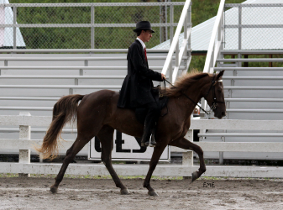
Another new exciting filly in the Stoner Ridge Farm line-up for 2010 is Cypress Addagirl, Addy”. She has an exceptionally solid gait for a young horse and has been a pleasure to work with. Addy has moved right through the Foundation First Mountain Horse TM training program and displayed her talent in a strong way at her very first show. Addy will be showing in the trail pleasure division with her trainer, Charlie DeAtley. She is owned by Bob and Marty Morris, New Bloomfield, PA.
- Al Prewitt Memorial - Open Four Gait - 2nd
- Al Prewitt Memorial - 2-3 Year Old Open Trail Pleasure - 2nd
- UMH Carson Masters Spring Premier - Open Four Gait - 4th
- UMH Ladies Auxiliary - Open 4 Gait - 3rd
- UMH Ladies Auxiliary - 2 & 3 Year Old Trail - 3rd
- UMH Bourbon County Fair Show - Open Four Gait - 5th
- UMH KY State Championship - Open 4 Gait - 2nd
- RMH Kentucky State Championship - 3 Year Old Trail Pleasure - 3rd
- RMH Kentucky State Championship - Trail Pleasure Championship - 3rd
- RMH Tavares Championship - 3 Year Old Trail Pleasure - 2nd
- UMH Great Smoky Mountain Championship - Mares Trail - 4th
- UMH Great Smoky Mountain Championship - Trail Championship 4^{th -} Mike
- UMH Tennessee State Championship - 2-3 year old Open Trail 2nd
- UMH Tennessee State Championship - Open Four Gait - 1st
- UMH Tennessee State Championship - Trail Pleasure Championship - 2nd - Mike
- RMH International – 14.2 – 14.3 Show Pleasure – 2nd
- RMH High Point 3 Yr. Old Trail Pleasure - 3rd
- RMH Trail Pleasure Championship – 4th
- UMH High Point - 2 & 3 YO Trail - 3rd
- UMH High Point - Open 4 Gait - 3rd

^{[top of page]}
Gaitway’s Jasmine Joy
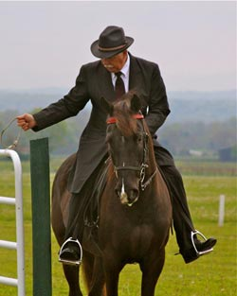
As a UMH Reserve World Grand Champion Western Pleasure horse, “Jazzy” will return to the competition show ring again in 2010. She has lots of talent and is an exceptionally versatile horse. At the Three Phase Event, she and her trainer, Robert Lawson, received the highest dressage scores of anyone in the competition (several 8’s and 9’s). She will continue to have a juvenile rider or two this year. She will be showing in the Country Trail Pleasure Division and versatility classes including: Conformation, Dressage, Cross Country, Trail Obstacle, Western, and Pro-Am. She’s well built and has a fantastic gait. She is owned by Steve Heuslein, LaCrescent, MN and is trained by Robert Lawson.
- NC State Championship - Open Western - 3rd
- NC State Championship - Country Trail Pleasure Mares - 5th - Steve
- NC State Championship - Country Trail Pleasure Pro-Am - 2nd Steve/Robert
- Al Prewitt Memorial - Trail Obstacle - 3rd
- Al Prewitt Memorial - Open Western - 3rd
- Al Prewitt Memorial - Country Trail Pleasure Mares - 3rd
- Al Prewitt Memorial - Pro Am Country Trail - 3rd - Robert/Steve
- Al Prewitt Memorial - Amateur Country Trail - 3rd - Steve
- Al Prewitt Memorial - Adult Versatility - 3rd
- UMH Carson Masters Spring Premier - Trail Obstacle - 3rd
- UMH Carson Masters Spring Premier - Mares Country Trail Pleasure - 4th
- UMH Carson Masters Spring Premier - Open Western - 3rd
- UMH Carson Masters Spring Premier – Versatility Award – 4th
- Three Phase Event - Youth Novice Level - 1st - Lauren Hickey
- Three Phase Event - Adult Novice Level
- UMH Stidham Memorial - Mares Country Trail - 1st
- UMH Stidham Memorial - 12 – 17 Juvenile Trail - 3rd - Lauren
- UMH Ladies Auxiliary - Juvenile Versatility - 2nd
- UMH Ladies Auxiliary - Trail Obstacle - 1st - Lauren
- UMH Ladies Auxiliary - Youth 17 & Under Showmanship - 2nd - Lauren
- UMH Ladies Auxiliary - 12 – 17 Juvenile Western - 3rd - Lauren
- UMH Ladies Auxiliary - 17 & Under Equitation - 3rd – Lauren
- UMH Ladies Auxiliary - Open Western - 5th
- UMH Ladies Auxiliary - Showmanship - 2nd - Lauren
- UMH Ladies Auxiliary - 4 Year Old Geldings Classic - 3rd
- UMH Ladies Auxiliary - Mares Country Trail - 5th
- UMH Bourbon County Fair Show - Leadline - Ruby DeAtley - 1st
- UMH Bourbon County Fair Show - Mares CTP - 2nd - Kim Pitts
- UMH Bourbon County Fair Show - 11 & Under CTP - 1st - Thomas Howard (His very first show!)
- UMH Bourbon County Fair Show - CTP Championship - 3rd
- UMH KY State Championship - Trail Obstacle - 1st
- UMH KY State Championship - Amateur CTP - 4th - Steve
- UMH KY State Championship - 11 & Under CTP - 3rd - Thomas
- UMH KY State Championship - Showmanship - 1st - Lauren
- UMH KY State Championship - Equitation - 2nd - Lauren
- UMH KY State Championship - Adult Versatility - 4th
- RMH International – 7-8 Year Old Mares & Geldings Conformation – 4th
- RMH International – Men’s Amateur Trail Pleasure – 5th – Steve
- RMH International – Youth 8-11 Trail Pleasure – 4th – Thomas
- RMH International – Mentor and Me – 6th – Thomas & Erin
- ACTHA (American Competitive Trail Horse Assoc.) Taylorsville – Open 1st – Erin
- UMH Summer Celebration – Amateur Country Trail Pleasure – 1st – Steve
- UMH Summer Celebration – 17 & Under Showmanship – 2nd – Lauren
- UMH Summer Celebration – 11 & Under Country Trail Pleasure – 2nd – Thomas
- UMH Summer Celebration – 17 & Under Equitation – 2nd – Lauren
- UMH Summer Celebration – Adult Versatility – 5th
- UMH World Show – Juvenile 11 & Under CTP – 1st – Thomas
- UMH World Show – Amateur CTP – 5th – Steve
- UMH World Show – Pro Am CTP – 4th - Robert & Kim
- UMH World Show – Open Western Sr. Horse – 6th
- UMH World Show – Trail Obstacle Sr. Horse – 3rd
- UMH World Show – Juvenile Showmanship – 1st – Lauren
- UMH World Show – Lead Line – 1st – Ruby DeAtley
- UMH World Show – Juvenile Equitation – 6th – Lauren
- KMSHA International - 11 & Under Country Trail - 4th
- KMSHA International - You and Me Country Trial - 5th - Charlie & Thomas
- KMSHA International - 11 & Under Country Trail Championship - 5th
- KMSHA International - Novice Country Trail - 2nd - Kim
- KMSHA International - Am/Novice Championship - 5th
- KMSHA International - Trail Obstacle - 1st
- KMSHA International - Natural Horsemanship - 1st
- KMSHA High Point Dressage - 4th
- KMSHA Trail Obstacle High Point - 5th
- UMH Youth 11 and Under Country Trail – Thomas - 3rd
- KMSHA High Point Juvenile Dressage - Lauren - 1st
- UMH High Point Honor -Lead Line - Ruby DeAtley
- UMH High Point - Youth 11 & Under CTP - Thomas Howard - 3rd
- UMH High Point - Mares CTP - 2nd
- UMH High Point - Adult Trail Obstacle - 3rd
^{top of page]}
Pepper’s Capital Venture
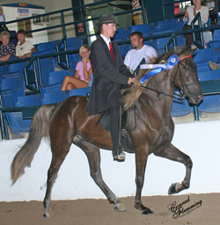
Capital Venture made his show-ring debut during the Kentucky State Championship in 2008 at the new Kentucky Equestrian Center in Winchester. He did a great job! This up-and-coming guy is fluid and exciting to watch. He has an outstanding gait and a beautiful flowing mane. We’re going to enjoy watching this 4 year old as he matures in 2010. He is a half brother to Pepper’s Just Plain Pretty. Watch for him in the Open Geldings and the Four Year Old Classic Pleasure classes this year. We’re sure you’ll like what you see! Capital Venture is owned by Steve Heuslein, LaCrescent, MN and trained by Charlie DeAtley.
- NC State Championship - Classic Pleasure Championship - 4th - Mike
- Al Prewitt Memorial - Geldings Classic - 2nd - Mike
- Al Prewitt Memorial - 4 Year Old Stallions/Geldings - 2nd
- UMH Carson Masters Spring Premier - 4 YO Stallions & Geldings Classic - 2nd
- UMH Carson Masters Spring Premier - Geldings Classic Pleasure - 3rd
- UMH Ladies Auxiliary - 4 Year Old Geldings Classic - 3rd
- UMH Bourbon County Fair Show - Geldings Classic - 1st
- UMH Bourbon County Fair Show - Classic Pleasure Championship - 5th
- UMH KY State Championship - 4 YO Stallions/Geldings Classic - 4th
- UMH KY State Championship - Amateur Classic - 3rd - Steve
- UMH KY State Championship - Geldings Classic - 1st - Mike
- RMH Kentucky State Championship - Show Pleasure Geldings - 4th
- RMH Tavares Championship - Show Pleasure Geldings - 1st
- UMH Tennessee State Championship - Geldings Classic Pleasure - 2nd
- UMH Tennessee State Championship - 4 YO Stallions/Geldings Classic - 1st
- UMH Tennessee State Championship - Classic Pleasure Stallions - 5th
- RMH International – 4 Year Old Mares & Geldings Show Pleasure – 3rd
- RMH International – 3-4 Amateur Show Pleasure – 3rd – Steve
- UMH Summer Celebration – 4 Year Old Stallions & Geldings Classic Pleasure – 5th
- UMH World Show – 4 yo Stallions/Geldings Classic – 5th
- KMSHA International - 4 YO Mares/Geldings - 4th
- RMH High Point Show Pleasure Geldings – 3rd
- UMH High Point - 4 YO Classic Pleasure Stallions/Geldings - 1st
- UMH High Point - Geldings Classic - 1st
^{[top of page]}
Pepper’s Just Plain Pretty
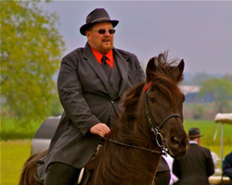
Returning to the show ring in 2010 is Pepper’s Just Plain Pretty. In the past Pepper has demonstrated her skill by obtaining the Open Four Gait high point award and the RMH Western World Grand Champion titles. This year she will be ridden and shown primarily by Tim and Marcia Spencer. She is owned by Charlie and Erin DeAtley.
- NC State Championship - Country Trail Pleasure Mares - 4th - Tim
- NC State Championship - Country Trail Pleasure Pro-Am - 3rd - Tim/Marcia
- Al Prewitt Memorial - Country Trail Pleasure Mares - 6th - Tim
- UMH Stidham Memorial - Open Amateur Trail - 5th - Tim
- UMH Stidham Memorial - Open Novice Trail - 3rd - Marcia
- UMH Stidham Memorial - Juvenile 12 to 17 Trail - 3rd - Lauren
- UMH Ladies Auxiliary - Youth Trail Obstacle - 1st - Lauren
- UMH Ladies Auxiliary - Juvenile 17 & Under Western - 3rd - Lauren
- UMH Ladies Auxiliary - 4 YO Stallions/Geldings - 3rd
- UMH Bourbon County Fair Show - Geldings Classic - 1st
- UMH Bourbon County Fair Show - Classic Pleasure Championship - 5th
- UMH KY State Championship - Juvenile 12 - 17 Open Western - 2nd - Lauren
- UMH KY State Championship - Juvenile 12 – 17 Trail Pleasure - 5th - Lauren
- UMH KY State Championship - Trail Obstacle - 1st - Lauren
- RMH Kentucky State Championship - Novice Trail Pleasure - 3rd - Marcia
- RMH Kentucky State Championship - Gaited Dressage - 2nd - Robert
- RMH Tavares Championship - Novice Trail Pleasure - 2nd - Marcia
- RMH Tavares Championship - Gaited Dressage - 2nd - Robert
- UMH Great Smoky Mountain Championship - Amateur Trail - 3rd - Tim
- UMH Great Smoky Mountain Championship - Novice Trail - 1st - Marcia
- UMH Tennessee State Championship - Amateur Trail - 4th - Tim
- UMH Tennessee State Championship - Novice Trail - 1st - Marcia
- UMH Tennessee State Championship - Adult Trail Obstacle - 4th
- UMH Tennessee State Championship - Adult Versatility - 5th
- ACTHA (American Competitive Trail Horse Assoc.) Taylorsville – Youth 1st – Lauren Hickey
- UMH Summer Celebration – Youth Trail Obstacle – 3rd – Lauren
- UMH Summer Celebration – 17 & Under Western Pleasure – 2nd – Lauren
- UMH Summer Celebration – Amateur Trail Pleasure - 5th – Tim
- UMH World Show – Juvenile 17 & Under – 2nd – Lauren
- UMH World Show – Juvenile Trail Obstacle – 3rd
- UMH World Show – Amateur 2 + In Hand – 3rd - Tim Spencer
- UMH World Show – Open Amateur Western – 3rd – Tim
- UMH World Show – Open Amateur Trail Obstacle – 3rd – Tim
- UMH World Show – Amateur Versatility – 3rd – Tim
- UMH World Show – Juvenile Versatility – 2nd – Lauren
- ACTHA Vanbert Ride 10/16/10 - Pleasure Division - 3rd - Tim
- KMSHA International - Amateur Trail - 3rd
- RMH High Point Novice Trail Pleasure – 2nd – Marcia
- KMSHA High Point Juvenile Trail Obstacle - 2nd
- UMH Youth Versatility - 3rd
- UMH Youth Trail Obstacle – 3rd
- UMH Juvenile Western 12 – 17 - 2nd
- UMH High Point - 12 – 17 Juvenile Western - Lauren Hickey - 2nd
- UMH High Point - Trail Obstacle - Lauren Hickey - 3rd
- UMH High Point - Youth Versatility - Lauren Hickey - 3rd
- UMH High Point - Novice Trail - Marcia Spencer - 3rd
^{[top of page]}
RRF Gold Nugget
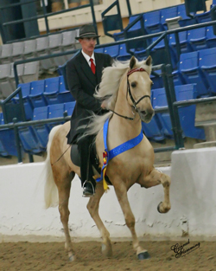
Sam Tuttle Memorial Award winner RRF Gold Nugget has come out strong again in 2010. He won the Adult Versatility Award and the Al Prewitt Memorial Award at the first show of the season in North Carolina. His excellent versatility skills allow him to be competitive in Conformation, Trail Obstacle, Open Driving, Pro-Am, and in on-the-rail classes. His owner, Steve Heuslein from LaCrescent, MN, shows him in the Open Amateur Classic Division as well. Charlie and Nugget received the 4 yo Classic Pleasure Stallions & Geldings High Point for 2008 and the Classic Geldings High Point for 2009. Lyngle and Nugget also received the Non-Pro Classic Pleasure High Point award in 2008. Look for this beautiful palomino in the show ring this year. He is truly a joy to watch.
- NC State Championship - Open Amateur Classic - 3rd - Steve
- Al Prewitt Memorial - Adult Versatility Award
- Al Prewitt Memorial - Al Prewitt Memorial Award
- Al Prewitt Memorial - 4 and Older Conformation - 2nd
- Al Prewitt Memorial - Trail Obstacle - 2nd
- Al Prewitt Memorial - Geldings Classic - 1st
- Al Prewitt Memorial - Pro Am Classic - 3rd - Robert/Steve
- UMH Carson Masters Spring Premier - Trail Obstacle - 4th
- UMH Carson Masters Spring Premier - Geldings Classic Pleasure - 2nd
- UMH North Middletown - Amateur Classic - 4th - Lyngle
- UMH KY State Championship - Geldings Classic - 4th
- RMH International – 5-6 Year Old Mares & Geldings Conformation – 5th
- RMH International – 6-8 Year Old Mares & Geldings Show Pleasure - 5th
- RMH International – Men’s Amateur Show Pleasure - 3rd – Steve
- RMH International – Adult Trail Obstacle – 1st
- UMH Summer Celebration – Geldings Classic Pleasure – 2nd
- UMH World Show – 4 + Geldings in Hand – 4th
- UMH World Show – Regional Amateur Classic – 4th – Steve
- UMH World Show – Trail Obstacle Sr. Horse – 2nd
- UMH World Show – Open Pleasure Driving – 1st
- KMSHA International - Trail Obstacle - 3rd
- KMSHA International - Open Driving - 1st
- UMH High Point - Geldings Classic - 2nd

^{[top of page]}
SRF’s Silver Sundown
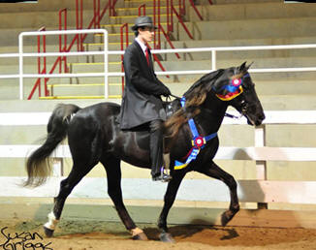
Seven year-old Silver, is simply awesome! He is one of our favorite horses to ride on trail, but he is also spectacular in the show ring no matter who rides him. 2009 was a fabulous year for this wonderful stallion. He displayed his talent by winning championships, trail obstacle classes, cross country events, pole bending, and even carrying the flag at the Lexington Junior League Horse Show. He won amateur classes with his owner and was even the very first horse for Baby Ruby to ever ride at the tender age of 3 months. You won’t find a more versatile horse than SRF’s Silver Sundown. On the trail or in the show ring, Silver performs like a true champion. In 2010, SRF’s Silver Sundown will continue his tradition of excellence. He is owned by Steve Heuslein, LaCrescent, MN and trained by Charlie DeAtley. Silver is a breeding stallion. See his pedigree on the Stallion’s page.
- NC State Championship - Open Amateur Trail - 2nd - Steve
- NC State Championship - Trail Pleasure Championship - 3rd
- NC State Championship - Open Western - 2nd
- Al Prewitt Memorial - Trail Obstacle - 1st
- Al Prewitt Memorial - Open Western - 1st
- Al Prewitt Memorial - Trail Pleasure Championship - 3rd
- Al Prewitt Memorial - Adult Versatility - 4th
- UMH Carson Masters Spring Premier - Trail Obstacle - 1st
- UMH Carson Masters Spring Premier - Stallions Trail Pleasure - 2nd
- UMH Carson Masters Spring Premier - Open Western - 2nd
- UMH Carson Masters Spring Premier – Versatility Award - 2nd
- UMH North Middletown - Stallions Trail - 3rd
- Three Phase Event - AGMH Association High Point
- Three Phase Event - Beginner Novice/Novice High Point Overall
- Three Phase Event - Cross Country Winner (tie with April Culbertson)
- Three Phase Event - Adult Novice Level Winner
- UMH Stidham Memorial - Stallions Trail Pleasure - 2nd
- UMH Stidham Memorial - Trail Pleasure Championship - 2nd
- UMH Ladies Auxiliary - Open Western - 4th
- UMH Ladies Auxiliary - Stallions Trail - 5th
- UMH Ladies Auxiliary - Adult Trail Obstacle - 2nd
- UMH Ladies Auxiliary - Adult Versatility - 3rd
- UMH Ladies Auxiliary - Men’s Open Pleasure - 4th
- UMH KY State Championship - Adult Trail Obstacle - 4th
- UMH KY State Championship - Stallions Trail - 4th
- UMH KY State Championship - Pro Am Trail - 3rd
- UMH KY State Championship - Open Western - 1st
- UMH KY State Championship - Trail Pleasure Championship - 3rd
- UMH Great Smoky Mountain Championship - Open Western - 1st
- UMH Great Smoky Mountain Championship - Stallions Trail - 2nd
- UMH Great Smoky Mountain Championship - Trail Pleasure Championship - 5th
- UMH Tennessee State Championship - Open Western - 1st
- UMH Tennessee State Championship - Stallions Trail - 1st
- UMH Tennessee State Championship - Adult Trail Obstacle - 1st
- UMH Tennessee State Championship - Trail Pleasure Championship - 4th
- UMH Tennessee State Championship - Adult Versatility - 2nd
- RMH International – 7-8 Year Old Western Pleasure – 1st
- RMH International – 7-8 Year Old Stallions Conformation – 1st
- RMH International – 7-8 Year Old Amateur Trail Pleasure – 2nd – Steve
- RMH International – 6-8 Year Old Stallions Trail Pleasure – 1st
- RMH International – Adult Trail Obstacle – 2nd
- RMH International – Water Glass Class – 3rd
- RMH International – Pole Bending – 2nd
- RMH International – Western Pleasure Grand Championship – 3rd
- 2010 Rea Swan Versatility Award Winner
- UMH Summer Celebration – Adult Trail Obstacle – 2nd
- UMH Summer Celebration – Stallions Trail Pleasure –1st
- UMH Summer Celebration – 4 & Older Conformation – 5th
- UMH Summer Celebration – Open Western Pleasure – 1st (unanimous)
- UMH Summer Celebration – Trail Pleasure Championship – 3rd – Steve
- UMH Summer Celebration – Adult Versatility – 1st
- UMH World Show – Regional Trail – 1st – Steve
- UMH World Show – Open Western Sr. Horse – 2nd
- UMH World Show – Trail Obstacle Sr. Horse – 1st
- UMH World Show – Trail Pleasure Stallions – 4th
- UMH World Show – Amateur Trail Pleas WGC – 5th – Steve
- UMH World Show – Open Western WGC – 1st (Unanimous)
- ACTHA Vanbert Ride 10/15/10 - Open Division - 2nd - Charlie
- AGMH Platinum Under Saddle
- AGMH Platinum Versatility
- AGMH Hall of Fame
- KMSHA High Point Dressage - 1st (tie)
- KMSHA High Point Trail Obstacle - 3rd
- UMH High Point - Open Western - 1st
- UMH High Point - Adult Trail Obstacle - 1st
- UMH High Point - Adult Versatility - 1st
- UMH High Point - Stallions Trail - 2nd
- UMH High Point - Trail Pleasure Championship - 3rd

^{[top of page]}
Silver’s Blue Plate Special (see more)
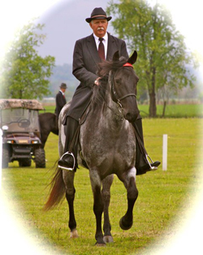
Affectionately called “Penny” around the barn, this filly is accomplished in Western, Under Saddle, Conformation, Trail Obstacle, Gaited Dressage, as well as having a lovely canter. She was started by Robert using the Foundation First Rocky Mountain Horse Training TM system for which he has become so well known. Penny went through the program effortlessly demonstrating intelligence and a willing attitude. Since that time, Penny has had many great accomplishments. She was the gaited horse selected by Gill Merrick, U.S.A. Dressage Olympic Team Leader, as the World Show Gaited Dressage demo horse. After riding her in the exhibition, Gill absolutely raved about the quality of her canter. She had a great year in 2008 culminating with a Versatility Award that consists of such competition elements as Western, Under Saddle, Conformation, Trail Obstacle, and Professional/Amateur classes. Penny was taken home by her owner to be enjoyed in 2009. She was re-entered into training here at Stoner Ridge Farm for competition again in 2010 and continues to be ridden and trained by Robert. She is owned by Don and Nancy Copland from Brookville, IN. Penny is also for sale. Please contact Robert for additional information 859.749.3008.
- UMH Carson Masters Spring Premier - Open Four Gait - 3rd
- UMH Carson Masters Spring Premier - Mares Trail Pleasure - 1st (Unanimous)
- UMH Carson Masters Spring Premier - Trail Pleasure Championship - 2nd
- UMH Carson Masters Spring Premier – Versatility Award – 5th
- UMH North Middletown - Novice Rider Trail - 3rd - Jim Wilkerson
- UMH North Middletown - Amateur Rider Trail - 4th - Jim Wilkerson
- UMH North Middletown - Mares Trail - 4th
- Three Phase Event - Training Level - 4th
- TPE (Three Phase Event) ACTHA Ride - 1st
- VanBert ACTHA Ride- 3rd (Only one point separated 1st–3rd)- Charlie
- UMH Stidham Memorial - Mares Trail Pleasure - 3rd
- UMH Ladies Auxiliary - Trail Obstacle - 3rd
- UMH Ladies Auxiliary - 4 + Open Conformation - 4th
- UMH Ladies Auxiliary - Open 4 Gait - 1st
- UMH Ladies Auxiliary - Men’s Open Trail - 3rd
- UMH Ladies Auxiliary - Adult Versatility - 2nd
- UMH KY State Championship - Adult Trail Obstacle - 2nd
- UMH KY State Championship - Open 4 Gait - 4th
- RMH Kentucky State Championship - 5 & Over Conformation - 2nd
- RMH Kentucky State Championship - Conformation Championship - 2nd
- RMH Kentucky State Championship - Western Pleasure - 2nd
- RMH Kentucky State Championship - Trail Pleasure Mares - 3rd
- RMH Kentucky State Championship - Working Trail Pleasure with Obstacles - 1st
- RMH Tavares Championship - 5 & Older Conformation 2nd
- RMH Tavares Championship - Conformation Championship - 2nd
- RMH Tavares Championship - Western Pleasure - 4th
- RMH Tavares Championship - Working Trail Pleasure with Obstacles - 1st
- RMH Tavares Championship - Gaited Dressage - 1st
- RMH International – 5 Year Old Mares & Geldings Trail Pleasure – 4th
- RMH International – 5-6 Year Old Western Pleasure – 3rd
- RMH International – Western Pleasure Grand Championship – 5th
- ACTHA (American Competitive Trail Horse Assoc.) Taylorsville – Open 6th – Robert
- UMH Summer Celebration – Mare’s Trail Pleasure – 3rd
- UMH Summer Celebration – Open 4-Gait – 5th
- UMH World Show – Open 4 Gait – 4th
- ACTHA Vanbert Ride 10/16/10 - Open Division - 4th - Robert
- KMSHA International - Open Four Gait - 3rd
- KMSHA International - Trail Obstacle - 5th
- RMH High Point Conformation (5 Yrs. & Older) – 5th
- RMH High Point Western Pleasure – 5th
- RMH Trail Pleasure Mares – 5th
- RMH Working Trail Pleasure with Obstacles – 2nd

^{[top of page]}
C.D.’s Girl’s Got Rhythm
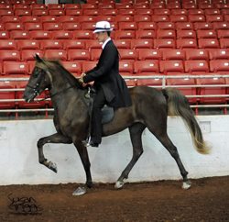
- UMH Carson Masters Spring Premier - 4 YO Mares Classic - 4th
^{[top of page]}
Branson Blue
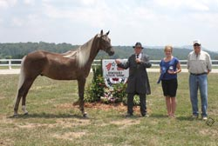
- NC State Championship - 2 & 3 YO Conformation - 4th
- AL Prewitt Memorial - 2 YO Stallions & Geldings Classic Pleasure - 1st
- UMH Carson Masters Spring Premier - 2 YO Stallions & Geldings Classic - 1st
- UMH Carson Masters Spring Premier - 2 & 3 YO Conformation - 3rd
- UMH Stidham Memorial - 2 Year Old Classic Pleasure Stallions - 1st
- UMH Ladies Auxiliary - 2 & 3 Year Old Conformation - 2nd
- UMH Ladies Auxiliary - 2 Year Old Classic Pleasure - 2nd
- UMH Ky State Championship - 2 – 3 YO Conformation - 1st
- UMH Ky State Championship - 2 yo Stallions/Geldings Classic - 1st - Unanimous
- UMH Great Smoky Mountain Championship - 2 & 3 YO Conformation - 2nd
- UMH Tennessee State Championship - 2 & 3 YO Conformation - 1st
- UMH Tennessee State Championship - 2 YO Stallions/Geldings Classic - 2nd
- UMH Summer Celebration – 2 Year Old Stallions & Geldings Classic Pleasure – 2nd
- UMH World Show – 2-3 yo Stallions/Geldings in Hand – 2nd
- UMH World Show – 2 yo Stallions/Geldings Classic – 3rd
- UMH World Show – 2 yo Classic Breeder’s Cup – 2nd
- KMSHA International - 2/3 YO Conformation - 4th
- KMSHA International - 2 YO Mares/Geldings Classic - 4th
- UMH High Point - 2 YO Open Classic - 1st
- UMH High Point - 2 & 3 YO Open Conformation - 2nd
- 2010 UMH 2 Year Old Classic Pleasure High Point winner

^{[top of page]}
Rebel’s High and Mighty
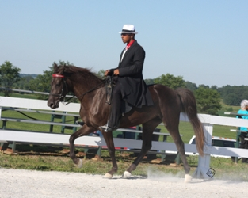
Another new comer to the show ring this year, is cute little three year old “Heidi” who will be showing in the Country Trail Pleasure Division this year. We are excited to see what this filly will become. Every day she is learning new skills. She’s owned by Bob and Marty Morris in New Bloomfield, PA and she is being trained by Michael Butler.
- UMH Carson Masters Spring Premier - 2 & 3 YO Country Trail Pleasure - 2nd
- UMH Stidham Memorial - Mares Country Trail - 4th
- UMH KY State Championship - 2 – 3 yo CTP - 3rd
- UMH High Point - 2 & 3 YO Open Country Trail - 3rd
^{[top of page]}
David James
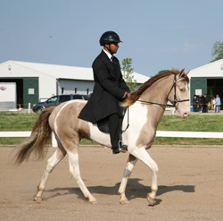
David James, a beautiful champagne Spotted Mountain Horse, is a shining example of what we all want in our horses. He’s smooth; he’s intelligent; he’s well built – and he is so easy on the eyes. When Martha Gilley, David James’s owner, started coming for lessons with him back in the winter, I doubt she anticipated winning a dressage/stadium obstacle/cross country event. Robert gave Martha lessons but Michael Butler worked and rode in the event. Congratulations to this outstanding horse, his owners, and trainers!
- Three Phase Event - Beginner Novice Level Winner
- KMSHA High Point Dressage - 1st (tie)
- KMSHA High Point Trail Obstacle - 3rd
^{[top of page]}
Lilly Bean
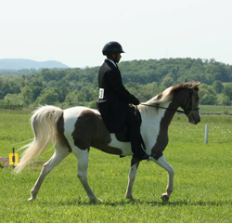
Like David James, Lilly Bean is a beautiful champagne Spotted Mountain Horse owned by Martha Gilley. She is lovely in appearance and in temperament. She came with David James and Martha’s friend, Sue, for lessons this winter. She did an outstanding job competing in the Three Phase Event with Michael. They really made a great team.
- Three Phase Event - Novice Level - 2nd (by only a very few seconds)
^{[top of page]}
MX Wrangler
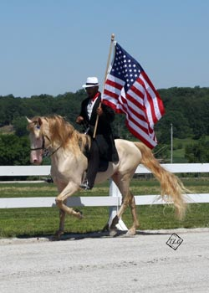
Wrangler is a beautiful smoky crème 4 year old stallion with a fantastic temperament! He is a young horse with a lot of talent. He has an easy going nature about him and takes everything in stride. He carries the flag with pride, performs well in trail obstacle, and wins on the rail. Congratulations to Wrangler for becoming the 2010 RMH Show Pleasure Kentucky State Champion! We are excited to have this talented stallion in our barn. If you are looking to add a little color to your herd, take a look at Wrangler. We know you’ll be as impressed as we are. He is owned by Jim and Kathy Wilkerson from Wappapello, MO and he’s being trained and shown by Michael Butler.
- UMH Stidham Memorial - Stallions Trail 5th
- UMH Ladies Auxiliary - Open 4 Gait - 4th
- UMH Ladies Auxiliary - Men’s Open Pleasure - 5th
- UMH Bourbon County Fair Show - Open Four Gait - 2nd
- UMH KY State Championship - 4 yo Classic Stallions/Geldings - 5th
- UMH KY State Championship - Open 4 Gait - 1st
- RMH Kentucky State Championship - Show Pleasure Stallions - 1st
- RMH Kentucky State Championship - Show Pleasure Championship - 1st
- RMH Kentucky State Championship - H.T. Derickson Championship - 3rd
- RMH Kentucky State Championship - Gaited Dressage - 1st
- RMH Tavares Championship - Show Pleasure Stallions - 2nd
- UMH Great Smoky Mountain Championship - Classic Pleasure Stallions - 4th
- UMH Great Smoky Mountain Championship - Classic Pleasure Championship - 3rd
- UMH Tennessee State Championship - Open Four Gait - 2nd
- UMH Tennessee State Championship - 4 YO Stallions and Geldings - 2nd
- UMH Tennessee State Championship - Classic Pleasure Championship - 5th
- UMH Tennessee State Championship - Adult Versatility Award – 4th
- RMH International – 4 Year Old Stallions Show Pleasure – 5th
- RMH International – Open Amateur Show Pleasure – 3rd – Jim Wilkerson
- RMH International – Amateur Show Pleasure Grand Championship – 5th – Jim
- UMH Summer Celebration – 4 Year Old Stallion & Geldings Classic Pleasure – 2nd
- UMH Summer Celebration – Open 4-Gait – 1st (Unanimous)
- UMH Summer Celebration – Classic Pleasure Championship - 3rd
- UMH Summer Celebration – Adult Versatility – 3rd
- UMH World Show – Pro Am Classic – 2nd – Mike & David Yarber
- UMH World Show – Trail Obstacle Jr. Horse – 2nd
- UMH World Show – Open 4 Gait – 1st (Unanimous)
- UMH World Show – 4 YO WGC – 6th
- UMH World Show – Jr. Robinson Super Horse Award
- KMSHA International - 4+ Stallions Classic - 2nd
- KMSHA International - Open 4 Gait - 1st
- KMSHA International - Natural Horsemanship - 2nd
- KMSHA International - You and Me Classic - 5th
- KMSHA International - Al Prewitt Versatility Award
- RMH High Point Show Pleasure Championship – 2nd
- UMH High Point - Open 4 Gait - 2nd
- UMH High Point - 4 YO Classic Stallions/Geldings - 3rd

^{[top of page]}
Jake's Comet
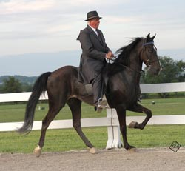
- UMH Ladies Auxiliary - 4 Year Old Stallions/Geldings - 2nd
- UMH Ladies Auxiliary - 14.3 and Under Classic - 2nd
- UMH Summer Celebration – 4 Year Old Stallion & Geldings Classic Pleasure – 3rd

^{[top of page]}
Maximum Blue
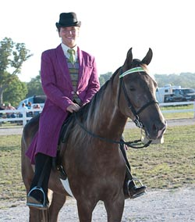
Maximum Blue is under saddle and being ridden daily here at Stoner Ridge Farm. He is out of Miss Minga, and he’s by World Grand Champion Merry Go Blue. He has that beautiful chocolate coat that folks find so desirable. He has great ground manners and a solid gait. Blue is ready for the trail or the show ring. He is definitely show quality and would be in the Trail Pleasure Division. He has that puppy-dog disposition that we all want in our horses. Blue recently made his debut at the Bourbon County Fair and Horse Show where he placed 3rd with his trainer, Lisa Sidwell. Maevis Solomon from Jonesborough, TN recently purchased this fine gelding. She plans to enjoy his loving attitude and show him some herself. We’re excited about this new venture for Maevis. Cheer her on when you see Maevis and Blue in their trail pleasure classes!
- UMH Bourbon County Fair Show - Geldings Trail - 3rd
^{[top of page]}

Sam's Little Buddy
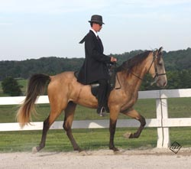
- UMH KY State Championship - 2 – 3 yo Stallions/ Geldings CTP - 2nd
- UMH KY State Championship - Stallions/Geldings CTP - 3rd
- UMH Summer Celebration – Stallions & Geldings Country Trail Pleasure – 5th
- UMH Summer Celebration – 2 & 3 Year Old Country Trail Pleasure -2nd
- UMH World Show – Open 4 Gait – 2nd
- KMSHA International - 2 YO Mares/Geldings Trail - 2nd
- KMSHA International - 2/3 YO Trail Championship - 3rd
- KMSHA International - Open Four Gait - 5th
^{[top of page]}

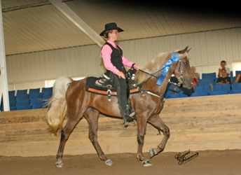
My Sweet Sydney
Another new filly that we have the privilege to work with this year is 4 year old, My Sweet Sydney. She was already under saddle when she was purchased by Steve Heuslein in June. Her trainer, Lisa Sidwell, is helping her gain confidence in the show ring and in trail obstacle. Sydney is intelligent and curious. Watch for Lisa and Sydney in the Country Trail Pleasure and Trail Obstacle classes.
- RMH Kentucky State Championship - Trail Pleasure Mares - 5th
- RMH Kentucky State Championship - 4-5 Year Old Trail - 5th
- RMH Kentucky State Championship - Working Trail Pleasure with Obstacles - 4th
- RMH Tavares Championship - Working Trail Pleasure with Obstacles - 2nd
- RMH International – 4 Year Old Mares & Geldings Trail Pleasure -5th
- RMH International – 3-4 Year Old Amateur Trail Pleasure – 1st – Steve
- RMH International – Amateur Trail Pleasure – 4th – Steve
- RMH International – 3-4 Year Old Western Pleasure – 1st
- UMH World Show – Western Pleasure Jr. Horse – 2nd
- UMH World Show – Trail Obstacle Jr. Horse – 3rd
- UMH World Show – Amateur WGC Country Trail – 2nd – Steve
- KMSHA International - 4 and Older Mares/Geldings Country Trail - 4th
- RMH High Point Trail Pleasure with Obstacles - 4th
- RMH Ladies Trail Pleasure – 5th – Lisa
^{[top of page]}
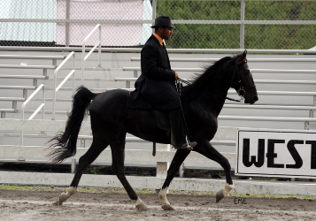
Mountain Vista Diamond
- UMH Great Smoky Mountain Championship - SE Regional Open Trail - 5th
- UMH Tennessee State Championship - SE Regional Open Trail - 5th
^{[top of page]}

Gobel's Wind Chill
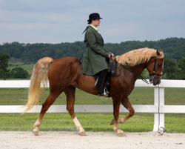
- UMH Summer Celebration – Amateur Country Trail Pleasure – 5th – Liz Merner
- UMH Summer Celebration – Mares Country Trail Pleasure – 2nd
- UMH Summer Celebration – Pro-Am Country Trail Pleasure - 2nd – Charlie & Liz
- UMH World Show – CTP Novice Horse – 5th
- UMH World Show – Novice Rider CTP – 3rd – Liz Merner
- UMH World Show – CTP Amateur WGC – 4th – Liz
^{[top of page]}
Diamonds in the Rough
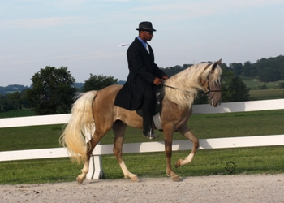
- UMH Summer Celebration – 2 & 3 Year Old Country Trail Pleasure -3rd
- UMH World Show – 2-3 YO CTP Mares – 3rd
- UMH World Show – 2-3 YO CTP WGC – 3rd
- KMSHA International - 2 YO Mares/Geldings Trail - 1st
- KMSHA International - 14.3 & Under Trail - 4th
- KMSHA International - 2/3 YO Trail Championship - 4th
^{top of page]}

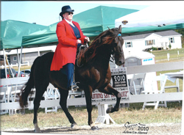
Barb's Stormy Knight
- UMH World Show – Ladies Auxiliary Trail - 4th – Nancy
- UMH World Show – Amateur Trail Obstacle – 2nd – Nancy
- UMH World Show – Lead Line – 1st – Ella Tillery
- ACTHA Vanbert Ride 10/16/10 - Pleasure Division - 1st - Lyngle
- KMSHA International - Open Amateur Trail - 4th - Nancy
- KMSHA International - First Pre-Juvenile Class - Ella - 1st
- KMSHA International - Lead Line - Addison Hargis
- UMH High Point Honor - Lead Line - Ella Tillery
^{[top of page]}
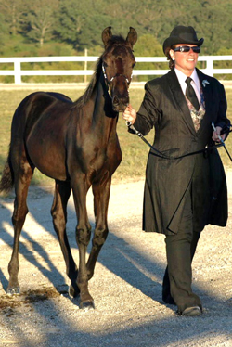
After Sundown
- UMH World Show – Trail Obstacle/Obedience – 4th – Kim Pitts
- UMH World Show – Breeder’s Cup Weanling Colts – 5th – Kim
- UMH World Show – Weanling Colts – 4th - Kim
^{[top of page]}
Venture’s Capital Venture
^{[top of page]}
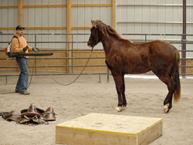
Singing the Blues
- KMSHA International - Natural Horsemanship - 3rd - Tim Scarberry
^{[top of page]}
Lauren Hickey
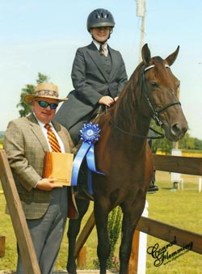
Here at SRF we are happy to have 14 year old Lauren Hickey back showing with us again this year. She is a dedicated equestrienne and strives to improve her horsemanship with each and every practice session. She and Erin have developed a strong bond during their lessons. Lauren is also an outstanding author. She frequently writes about horses and has published several stories and poems. Last summer, Lauren wrote about the joy she feels with a horse beneath her and the wind in her hair. Click here to read and enjoy Simple Freedom by Lauren Hickey.
2010 Wins
Lauren Hickey
- Three Phase Event - Juvenile Novice Division (Jazzy) - 1st
- Three Phase Event - Novice (Jazzy) - 4th
- UMH Stidham Memorial - 12 – 17 Juvenile Trail (Pepper's Just Plain Pretty) - 3rd
- UMH Ladies Auxiliary - Juvenile Versatility - 2nd
- UMH Ladies Auxiliary - Trail Obstacle - (Pepper) - 1st
- UMH Ladies Auxiliary - Youth 17 & Under Showmanship (Jazzy) - 2nd
- UMH Ladies Auxiliary - 12 – 17 Juvenile Western (Pepper ) - 3rd
- UMH Ladies Auxiliary - 17 & Under Equitation (Jazzy) - 3rd
- UMH KY State Championship - Showmanship - 1st
- UMH KY State Championship - Equitation - 2nd
- UMH KY State Championship - Juvenile 12 - 17 Open Western - 2nd
- UMH KY State Championship - Juvenile 12 – 17 Trail Pleasure - 5th
- UMH KY State Championship - Trail Obstacle - 1st
- UMH KY State Championship - Juvenile Versatility - 1st
- ACTHA (American Competitive Trail Horse Assoc.) Taylorsville – Youth 1st
- KMSHA High Point Juvenile Dressage - 1st
- KMSHA High Point Juvenile Trail Obstacle - 2nd
- UMH Youth Versatility - 3rd
- UMH Youth Trail Obstacle – 3rd
- UMH Juvenile 12 – 17 Western - 2nd
^{[top of page]}

Thomas Howard
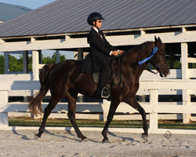
Ten year old Thomas started taking lessons from Erin last year. He has had a great work ethic and has been wanting to show for some time. Thomas finally got his wish. He made his first show on Gaitway’s Jasmine Joy at the Bourbon County Fair and Horse Show on June 17th. His hard work and dedication paid off earning him a blue ribbon. Thomas wants to continue showing. He just loves it. Congratulations Thomas!
- UMH Bourbon County Fair Show - 11 & Under CTP - 1st - Thomas Howard (His very first show!)
- UMH KY State Championship - 11 & Under CTP - 3rd
- RMH International – Youth 8-11 Trail Pleasure – 4th
- RMH International – Mentor and Me – 6th – Thomas & Erin
- UMH Youth 11 and Under Country Trail

