Advanced Horsemanship Clinic
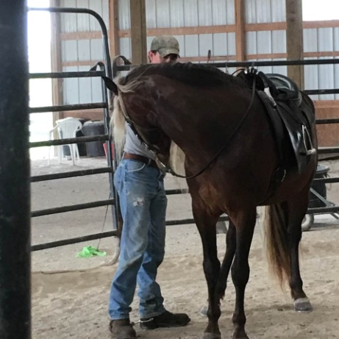
The Advanced Horsemanship Clinic will review and build on what has been learned in the Basic Horsemanship Clinic. Elements of the Basic Horsemanship Clinic include:
- Basic horse handling
- Leading
- Cueing the horse from the ground
- Yielding fore and hind quarters
- Lateral flexing
- Moving away from pressure
- Establishing trust and respect
- One rein stop
Additional Advanced Horsemanship Elements include:
- Bits and bitting
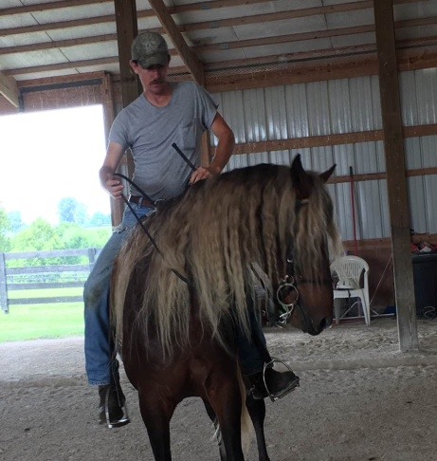
- Riding centered
- Moving the horse off your legs
- Vertical flexion
- Rein management
- Collection
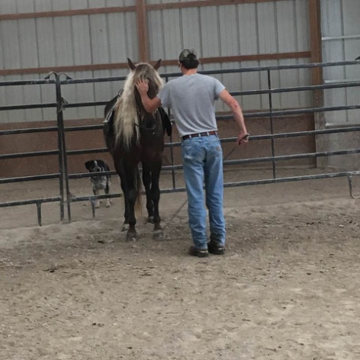
“It is essential that your horse knows how to move away from pressure and that you, as a trainer or a rider, realize the importance and power of this strategy. We begin teaching our horse to move away from pressure quite inadvertently when we lead him. When we pull on the lead rope, we are actually putting pressure on the opposite side of his head. We are not really pulling at all but creating pressure that the horse will want to move away from. With that knowledge in mind, we can begin to use our hands to help horses learn to move away from pressure. By placing a hand on their flank and pushing until our horse moves away, we begin to help them understand that they must move away when they feel that pressure on their side. Eventually, that pressure will come from our legs when we have our horse under saddle.”

