PBF’s Simon Barjonah

RMHA and KMSHA Registered

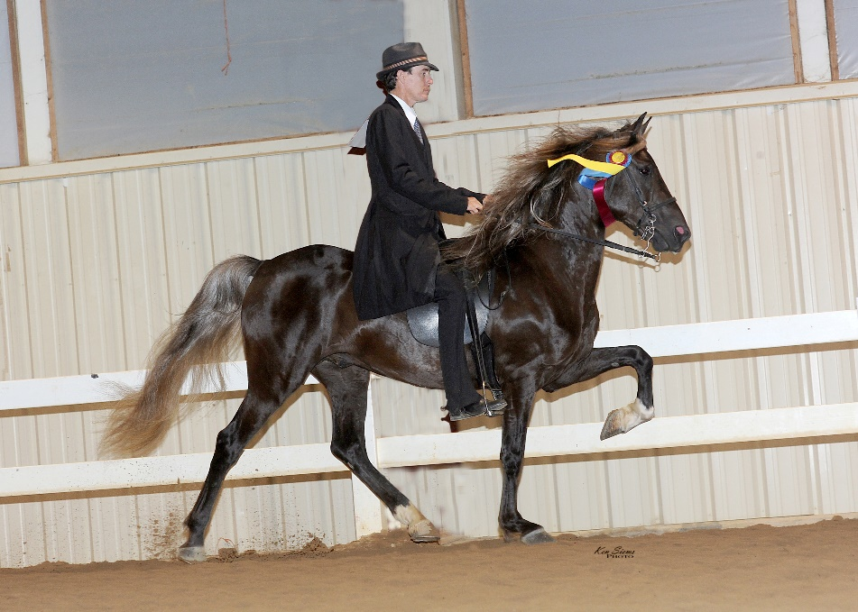

Simon is owned by Steve and Susan Heuslein from LaCrescent, MN. He is an outstanding chocolate stallion who has wonderful conformation and an evenly timed, consistent, four beat gait. He is by Purdue’s Spellbound out of Tobe’s Little Honey (see pedigree below or visit rmhorse.com). He loves his job. Has the intelligence and drive to perform regardless of the venue. He is intelligent and curious, but he is calm and quiet on the ground. He has wonderful manners. He loads easily and hauls with no issues whether he is with mares or other stallions. His personality is exceptional for a breeding stallion. He was shown lightly during the 2018 show season with a first-place win at the RMHA and KMSHA International in the 4-5 y.o. Show Pleasure Stallion Division. Simon was also the RMHA Reserve Show Pleasure High Point Stallion with limited shows. He will continue his show career in 2019. Simon’s first foals are due in the spring and we can’t wait. It is exciting to stand such a beautiful, well-mannered stallion at Stoner Ridge Farm. Breedings to Simon come with a Live Foal Guarantee. Call, message, or text Charlie DeAtley at Stoner Ridge Farm for additional information or book your mare to this stunning stallion. 859.749.1586.

 |  |  |  | Sam Clemon's Tim
 |  |  | Nick | April's Delight
 |  | Purdue's Showtime |  | Sonny
 | Purdue's Spellbound |  | Little Nicky | Clemon's Firecracker
 |  |  | Purdue's Rocky Dancer | Buddy Roe
 |  | Purdue's Timeless Treasure |  | Sly Di ASB
PBF's Simon Barjonah |  |  | Foxie Roxie II | Nuncio
 |  |  |  | Foxie Roxie
 |  |  | Dock | Choco
 |  | Dock's Rocky |  | Stith Mare
 | Tobe's Little Honey |  | Mecedora | Johnson's Toby
 |  |  |  | C Charles Ray Mare
 |  |  | Maple's Squirrel | Tobe
 |  | Dapples Too |  | Goodpastures Maude
 |  |  | Dapples | Unknown
 |  |  |  | High Top Lady

