SRF's Silver Sundown
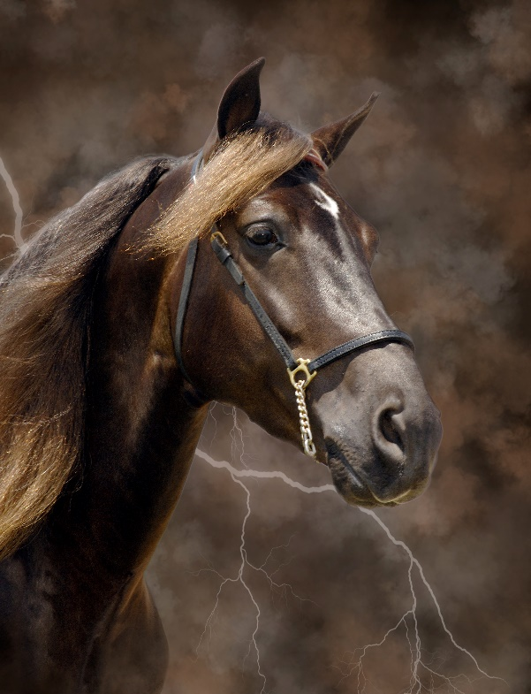
Registered: | RMHA, KMSHA, MPHA, AGMH
Color: | Chocolate
Sire: | J. Lee Walker
Dam: | Fry's Gliding Lass

Sixteen year-old SRF’s Silver Sundown, has a temperament and intelligence that are unsurpassed. Silver is the horse of choice for the novice or amateur rider no matter what discipline because he is so easy going and responsive regardless of the fact that he is a stallion. He’s willing, gentle, and calm. He is one of our favorite horses to ride on trails and to compete in the show ring. He can demonstrate brilliance that attracts the Judge’s attention then come right back to the trail walk like he’s out for a Sunday stroll.
Silver had many outstanding accomplishments over his life-time. In 2018 Silver was brought back to the show ring to compete with his amateur owners, Steve and Susan Heuslein. All year he continued to get better and better. When it came time to show at the RMHA International, Silver was in top form. Competing in the Country Trail Pleasure, he was nearly unbeatable! His performance led to capturing the elusive Sam Tuttle Memorial Award and to winning the Rea Swan Versatility Award with a perfect score. He was the Open Western Grand Champion for the sixth time! Silver also was recognized as the Reserve Grand Champion Conformation and Reserve Country Trail Pleasure Grand Champion. While awards are wonderful, it is the essence of Silver that makes him what he is. What better quality is there to pass on to your foals than this?
You won’t find a more versatile horse than SRF’s Silver Sundown. Through the years Silver has had a multitude of fabulous experiences. He’s a winner in every venue – trail, show, versatility, and on and on. He’s won in the show ring, he’s a winner on the trail, and he has even shown that winning attitude as the lead horse for the Mountain Rhythm Riders Drill Team where he demonstrated his willingness and talent.
His progeny are a mirror their sire. In 2017, Moriah Mae, won the RMHA International Western Grand Championship . . . as her sire has won so many times. Silver is the “complete package.” An evenly timed four beat gait, intelligence, temperament, conformation and that gorgeous chocolate color help make him all you could want as the sire of your next foal. On the trail, in the show ring, or in the breeding shed, Silver performs like a true champion. Silver has foals all over the U.S and has a few foals in Europe. He is available for live cover or AI. Call, text, or message Charlie DeAtley at 859.749.8982 for more information or to book your mare to this fabulous stallion.
Pedigree SRF’s Silver Sundown
Sire  J. Lee Walker | Stoney B. Walker | Nuncio
 |  | Hope Spring's Blossom
 | Tabby Rea | Johnson's Toby
 |  | Hope Springs Rocky
Dam  Fry's Gliding Lass | French's Glider | Cocoa
 |  | French Princess
 | Joco's Shadow Lass | Jocko Bean
 |  | Snookie

Championship/High Point Awards:
2018
- RMHA Tollesboro Lions Club - Open CTP - 2nd - Susan
- RMHA Tollesboro Lions Club - Amateur CTP - 2nd - Steve
- RMHA Tollesboro Lions Club - Amateur Trail - 3rd - Susan
- RMHA Tollesboro Lions Club - AOT/Amateur/Novice CTP Championship - 1st - Susan RMHA Gaited Gala - Amateur CTP - 2nd - Susan
- RMHA Gaited Gala - CTP Stallions - 4th
- RMHA Get Your Pink On - CTP Stallions - 1st - McKayla Hall
- RMHA Get Your Pink On - CTP Championship - 2nd - McKayla Hall
- RMHA Lady Eagles – Amateur Trail Pleasure - 3rd - Susan
- RMHA Open CTP - 2nd Susan
- RMHA Amateur CTP - 2nd - Steve
- RMHA Amateur Trail Pleasure - 3rd - Susan
- RMHA AOT Amateur & Novice CTP Championship - 1st - Susan’s first Championship
- KMSHA Summer Kick-Off - 5+ Stallions CTP - 1st - Susan
- KMSHA Summer Kick-Off - Men’s Open Trail - 3rd - Steve
- KMSHA Summer Kick-Off - 5+ Stallions Trail Pleasure - 3rd - Susan
- KMSHA Summer Kick-Off - Amateur/Novice/AOT CTP Championship - 3rd
- RMHA International - 10+ yo Master Stallions Conformation - 3rd
- RMHA International - 5+ yo Open Conformation Championship - 1st
- RMHA International 10+ yo M/S/G Trail - 3rd
- RMHA International - Adult Trail Obstacle - 1st
- RMHA International - Adult Pole Bending - 1st
- RMHA International - 10 + yo M/S/G CTP - 1st
- RMHA International - 6+ yo Open Western - 1st
- RMHA International - Western Grand Championship - 1st
- RMHA International - Stallions CTP Championship - 1st
- RMHA International - Adult Bareback - 1st
- RMHA International - 3+ yo Open Conformation Grand Championship - 2nd
- RMHA International - CTP Grand Championship - 2nd
- RMHA International - Ras Swan Versatility Award
- RMHA International - Sam Tuttle Memorial Award
- RMHA High Point Award - Country Trail Pleasure Championship - 3rd (tie)

2015
- RMH Western Grand Champion
- RMH Rea Versatility Award Winner
- RMH High Point Trail Pleasure Champion
- UMH Western Grand Champion
- High Point Western
- High Point Trail Obstacle

2014
- UMH Western Grand Champion
- UMH High Point Western
- UMH High Point Breeder's Cup Stallion
- RMH Rea Swan Versatility Award
- RMH High Point Western

2013
- RMHA Open Western Grand Champion
- KMSHA Open Western Champion
- RMH Trail Pleasure Champion
2012
- RMH High Point Award - Trail Pleasure Stallions - 1st
- RMH High Point Award - Trail Obstacle ACTHA Rider - Gold Level
- RMH High Point Award - Working Trail With Obstacles – 1st
- KMSHA Open Western Champion
- UMH Open Western Grand Champion
2011
- RMHA Open Western Grand Champion
- KMSHA Open Western Grand Champion
- UMH Open Western Grand Champion
- UMH Adult Versatility High Point Award
- UMH Adult Trail Obstacle High Point Award
- UMH Stallions Trail Pleasure High Point Award
2010
- AGMH Hall of Fame
- AGMH Platinum Under Saddle
- AGMH Platinum Versatility
- KMSHA High Point Dressage
- UMH High Point - Open Western
- UMH High Point - Adult Trail Obstacle
- UMH High Point - Adult Versatility
- UMH Open Western World Grand Champion (by unanimous decision)
- Three Phase Event over-all winner
- RMHA Rea Swan Versatility Award Winner
- UMH High Point - Trail Pleasure Championship - 3rd
2009
- UMH Open Western World Grand Champion
- UMH High Point Trail Pleasure Stallions
- UMH High Point Trail Pleasure Championship
- UMH High Point Open Western
- UMH High Money Horse Award
2008
- High Point Award -Three Phase Event
- UMH Classic Stallions High Point Award
2007
- UMH High Point 4 Year-Old Stallions and Geldings Classic Pleasure
2006
- Open Amateur Classic High Point
BOOKING & FEES:
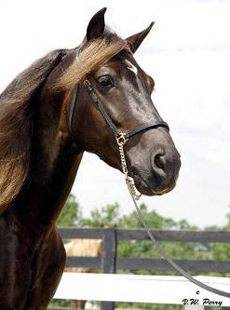
To book your mares, call Charlie DeAtley at SRF 859-749-8982 or emal charlied8282@gmail.com. Breeding fee is $600, LFG
