Champions 2014
SRF’s Silver Sundown
Eleven year-old Silver is a wonderful horse! He is one of our favorite horses to ride on trail, but he is also spectacular in the show ring whether being ridden by an amateur or a professional. Last year was another great year for this wonderful stallion. For the third time, he was the Western International Grand Champion for RMHA and KMSHA! On the trail or in the show ring, Silver performs like a true champion. In 2014, SRF’s Silver Sundown will continue his tradition of excellence. He is owned by Steve and Susan Heuslein, LaCrescent, MN and trained by Charlie DeAtley. Silver is a breeding stallion and has some outstanding foals on the ground. See his pedigree on the Stallion’s page. Just click on previous years to see a record of Silver’s past accomplishments.
- UMH Spring Fling - Adult Western - 1st
- UMH Spring Fling - Amateur Trail - 5th - Steve
- UMH Spring Fling - RMH Stallions Trail - 4th
- UMH Spring Fling - Novice Trail - 2nd - Susan
- UMH Spring Fling - Trail Pleas. Champ. - 3rd
- UMH Spring Fling - Stallions Trail - 4th
- UMH Spring Fling - Breeder’s Cup Stallion - 2nd
- RMH City of Prestonsburg - Western - 1st
- RMH City of Prestonsburg - Stallions Trail - 4th
- UMH KY State Championship - UMH Western - 1st
- UMH KY State Championship - UMH Amateur Trail - 4th
- UMH KY State Championship - UMH Stallions Trail - 2nd
- UMH KY State Championship - UMH Trail Champ - 4th
- UMH KY State Championship - Breeder’s Cup Stallion - 1st
- RMH Bluegrass Summer Jubilee - RMHA Western - 1st
- RMH Bluegrass Summer Jubilee - RMH Trail Pl. Stallions - 3rd
- RMH Charles Kilburn Memorial - RMHA Western - 1st
- RMH Charles Kilburn Memorial - RMHA Trail Pleas. Stallions - 2nd
- RMH Charles Kilburn Memorial - RMHA Trail Pleas. Champ - 5th
- Fonzie Graham Memorial - Adult Western - 1st
- Fonzie Graham Memorial - UMH Stallion Trail - 5th
- Fonzie Graham Memorial - UMH Adult Trail Obstacle - 2nd
- Fonzie Graham Memorial - UMH Men’s Trail - 2nd
- Fonzie Graham Memorial - UMH Trail Pleas. Champ - 5th
- Mountain Horse Classic – UMH 3 & 4 YO Trail - 5th
- Mountain Horse Classic – 14.3 & Under Trail - 3rd - Steve
- Mountain Horse Classic – UMH Adult Western - 1st
- Mountain Horse Classic – UMH Amateur Trail - 5th - Susan
- Mountain Horse Classic – UMH Stallions Trail Pleas. - 2nd
- Mountain Horse Classic – RMH Western Pleas. - 2nd
- Mountain Horse Classic – UMH Novice Trail - 1st - Susan
- Mountain Horse Classic – UMH Open Trail Pleas. Champ. - 5th
- UMH World Show - Sr. Horse Trail Obstacle - 1st
- UMH World Show - Men’s Trail - 3rd
- UMH World Show - Novice Trail - 3rd - Susan
- UMH World Show - Sr. Western Pleasure - 1st
- UMH World Show - Am/AOT/Novice Trail WCG - 5th - Susan
- UMH World Show - Western Pleasure WGC - 1st
- UMH World Show - 4+ Stallions Conf. - 5th
- RMH International - Rea Swan Versatility Award
- RMH International - 10+ Stallions Conformation - 5th
- RMH International - Novice Trail - 3rd - Susan
- RMH International - 10+ Master Stallions Tr. - 1st
- RMH International - Adult Trail Obstacle - 2nd
- RMH International - Pole Bending - 1st
- RMH International - 6+ Open Western - 2nd
- RMH International - Stallions Trail Pleas. Champ. - 6th
- RMH International - Adult Water Glass - 1st
- RMH International - Adult Bareback - 2nd
- RMH International - Western Pleas. Grand Champ. - 2nd
- RMH International - Amateur Trail Pleas. Grand Champ. 6th - Susan
- UMH High Point Adult Western - 1st
- UMH High Point Trail Obstacle - 2nd
- UMH High Point Stallions Trail - 3rd
- UMH High Point Breeder’s Cup Stallion - 1st
- UMH High Point Novice Trail - 3rd - Susan
- RMH High Point Western Pleasure - 1st
- RMH High Point Trail Pleas. Stallions - 4th
- RMH High Point Adult Trail Obstacle - 1st
- RMH High Point Novice Trail - 5th - Susan
^{[top of page]}

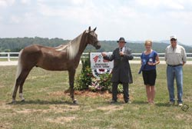
Branson Blue
Six year old, Branson exudes talent on every level. As a three year old, he was the RMH Sam Tuttle Memorial Winner! He is calm and easy going as he works his way through trail obstacle and is a beauty as he stands for inspection during conformation classes. If you crave excitement, he is one to watch. His natural talent is awesome! Branson is owned by Steve and Susan Heuslein, LaCrescent, MN and is trained by Charlie DeAtley.
- RMH City of Prestonsburg - RM 5+ Conf. - 5th
- RMH City of Prestonsburg - Men’s Trail - 2nd
- RMH City of Prestonsburg - Trail Pleas. M/G - 4th
- UMH KY State Championship - UMH M/G Trail - 4th
- UMH KY State Championship - RMH AM Trail - 5th - Steve
- UMH KY State Championship - RMH Geld. Trail - 2nd
- RMH Bluegrass Summer Jubilee - RMHA Trail M/G - 5th
- RMH Bluegrass Summer Jubilee - UMH Trail - 1st
- RMH Charles Kilburn Memorial - RMHA Trail M/G - 5th
- RMH Charles Kilburn Memorial - UMH Trail Pl - 5th
- Mountain Horse Classic – RMH Show Pleas. Geldings - 3rd
- Mountain Horse Classic – RMH Bluegrass Show Pleas. Champ. - 5th
- RMH International - 5-9 yr M/G Conformation - 6th
- RMH International - 6-9 yr M/G Show Pleas. - 5th
- RMH International - M/G Show Pleas. Champ - 6th
- RMH High Point Trail Pleas. Geldings - 2nd
- RMH High Point Show Pleasure Geldings - 5th
- RMH High Point Men’s Trail Pleasure - 5th – Charlie
^{[top of page]}
RRF Gold Nugget
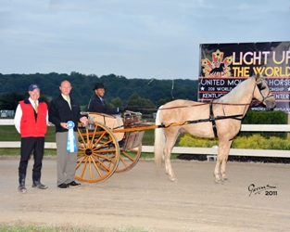
2009 Sam Tuttle Memorial Award winner RRF Gold Nugget is a beautiful sooty palamino. His excellent versatility skills allow him to be competitive in Conformation, Trail Obstacle, Open Driving, Pro-Am, ACTHA competitive trail and in on-the-rail classes. His owner, Steve Heuslein, shows him in the Open Amateur Classic Division and his wife, Susan, shows him in the Novice classes as well. He is being trained by Charlie DeAtley and Mary Kelley Tucker. Look for this beautiful palomino in the show ring again this year. He is truly a joy to watch.
- UMH Spring Fling - M/G Classic - 5th
- UMH Spring Fling - RMH Geldings Show Pleas. - 3rd
- UMH Spring Fling - Novice Classic - 3rd - Susan
- RMH City of Prestonsburg - RM 5+ Conformation - 4th
- RMH City of Prestonsburg - RM Show Pleas. M/G - 4th
- RMH City of Prestonsburg - RM Show Pleas. Champ. - 3rd
- UMH KY State Championship - RMHA Amateur Show - 3rd - Steve
- UMH KY State Championship - RMHA Geld. Show - 1st
- UMH KY State Championship - UMH M/G Classic - 2nd
- UMH KY State Championship - Novice Classic - 2nd
- RMH Bluegrass Summer Jubilee - UMH Classic - 1st
- RMH Bluegrass Summer Jubilee - RMG Show Pleas. Champ. - 3rd
- RMH Charles Kilburn Memorial - RMH Men’s Show Pleas. - 3rd
- RMH Charles Kilburn Memorial - RMHA Show Pleas. Champ. - 2nd
- Fonzie Graham Memorial - UMH M/G Classic - 2nd
- Fonzie Graham Memorial - UMH Adult Trail Obstacle - 1st
- Fonzie Graham Memorial - RMH Geld Show Pleas. - 1st
- Fonzie Graham Memorial - UMH Classic Champ - 5th
- Mountain Horse Classic – UMH M/G Classic 2nd
- Mountain Horse Classic – RMH Amateur Show Pleas. - 5th - Susan
- Mountain Horse Classic – UMH Novice Classic - 1st - Susan
- UMH World Show - Sr. Horse Trail Obstacle - 4th
- UMH World Show - Open Driving - 1st
- UMH World Show - 5+ M/G Classic Pleas. Champ. - 5th
- RMH International - 10+ M/G Conformation - 1st
- RMH International - 5+ Open Conformation Champ. - 8th
- RMH International - Adult Trail Obstacle - 8th
- RMH International - M/G Show Pleas. - 1st
- RMH International - M/G Show Pleas. Champ. - 3rd
- RMH International - RMH International - Show Pleas. Gr. Champ. - 2nd
- RMH International - Novice Show Pleas. - 5th - Susan
- UMH High Point Adult Trail Obstacle - 1st
- UMH High Point Driving - 1st
- UMH High Point M/G Classic - 2nd & 3rd
- UMH High Point Novice Classic - 2nd & 3rd - Susan
- RMH High Point Show Pleas. Geldings - 3rd
- RMH High Point Novice Show Pleasure 4th - Susan
- RMH High Point Men’s Show Pleasure - 3rd – Charlie
- RMH High Point Show Pleas. Championship - 2nd
^{[top of page]}
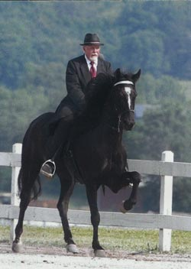
HBF Furious Revenge
Style baby style is what you’ll see with six year old HBF Furious Revenge who is better known as “Duncan” around the barn. He has conformation that allows him to move well under saddle and really get your attention in the show ring. He will show in both Classic/Show Pleasure and Park classes this year. Duncan is also great on competitive trail rides. You won’t want to miss this fella’s exciting performances. Duncan is owned by Don and Nancy Copland and is being trained by Robert Lawson.
- UMH Spring Fling - M/G Classic - 3rd
- UMH Spring Fling - RMH Geldings Show Pleas. - 2nd
- UMH Spring Fling - Classic Champ. - 4th
- RMH City of Prestonsburg - Show Pleas. M/G - 3rd
- ACTHA Indian Old Fields - AOC 5/9/14 - 4th
- ACTHA Indian Old Fields - CTC 5/10/14 - 4th
- ACTHA Indian Old Fields - CTC 5/11/14 - 3rd
- UMH KY State Championship - M/G Park - 2nd
- UMH KY State Championship - Open Park Champ. - 2nd
- RMH Bluegrass Summer Jubilee - UMH Park - 2nd
- RMH Bluegrass Summer Jubilee - RMHA Men’s Show Pleas. - 3rd
- RMH Charles Kilburn Memorial - RMHA Show Pleas. Geld. – 1st
- RMH Charles Kilburn Memorial - Charles Kilburn Open Champ. - 2nd
- Fonzie Graham Memorial - UMH M/G Park Pleas. - 2nd
- Fonzie Graham Memorial - UMH Adult Trail Obstacle - 5th
- Fonzie Graham Memorial - UMH Park Pleas. Champ - 3rd
- Mountain Horse Classic – UMH M/G Park Pleas. - 1st
- Mountain Horse Classic – UMH Open Park Champ. - 2nd
- UMH World Show - Sr. Horse Trail Obstacle - 5th
- UMH World Show - 5+ M/G Champ. - 2nd
- UMH World Show - Park WGC - 3rd
- RMH International - 5-9 yr M/G Conformation - 4th
- RMH International - 6-9 yr M/G Show Pleas - 6th
- RMH International - Adult Trail Obstacle 9th
- RMH International - Ladies Show Pleas. - 8th
- RMH High Point Show Pleasure Geldings - 2nd
- RMH High Point Show Pleasure Championship HBF Furious Revenge - 5th
^{[top of page]}
Barb's Stormy Knight
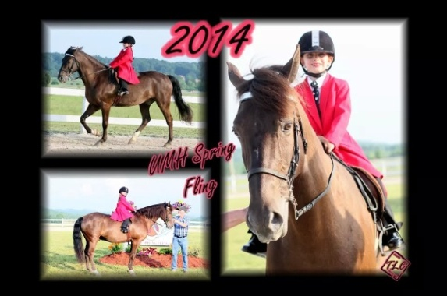
Barb’s Stormy Knight continues to wear many hats as far as his equine jobs go. Even though he’s in the AGMH Hall of Fame and has been the winner of numerous World Grand Championships including the Western World Grand Championships in all three Mountain Horse associations, he continues to be busy this year giving lessons and introducing the novice and juvenile rider to the show ring. He gave Ella and Drew, Don and Nancy’s grand children their first ride. Stormy is also a two time American Competitive Trail Horse (ACTHA) RMHA High Point winner and maintains that competitive spirit. Everyone loves Stormy. He’s owned by Don and Nancy Copland of Brookville, IN.
- UMH Spring Fling - Juvenile 11 & Under Trail - 1st - Carollynn
- UMH Spring Fling - Juvenile Western Pleas. - 1st - Carollynn
- ACTHA Indian Old Fields - AOC 5/9/14 - 1st
- ACTHA Indian Old Fields - CTC 5/10/14 - 3rd
- ACTHA Indian Old Fields - CTC 5/11/14 - 4th
- Fonzie Graham Memorial - UMH 11 & Under Country Trail - 2nd - Carollynn
- Fonzie Graham Memorial - UMH Juvenile Western Pleas. - 1st - Carollynn
- Fonzie Graham Memorial - Drew Tillery Lead Line
- Mountain Horse Classic – UMH M/G CTP - 5th
- Mountain Horse Classic – Lead Line - Drew - 1st
- UMH World Show - Lead Line - 1st - Drew Tillery
- UMH World Show - First Solo - 1st - Ruby
- UMH World Show - 17 & Under Western WGC - 2nd - Carollynn
- UMH World Show - 11 & Under CTp - Carollynn - 2nd
- RMH International - 11 & Under Western - 3rd
- RMH International - 11 & Under CTP - 3rd
- UMH High Point ACTHA AOC - 1st
- UMH High Point Juve. 11 & Under - 2nd - Carollynn
- UMH High Point Juve. Western - 1st
- UMH High Point Lead Line - 1st - Ruby DeAtley
- HBF Furious Revenge
- UMH High Point ACTHA AOC - 2nd
- UMH High Point M/G Park Pleasure - 2nd
- UMH High Point Park Pleas. Champ. - 2nd
- RMH High Point Youth 11 & Under Western - 3rd
- RMH High Point Youth 11 & Under CTP - 5th
^{[top of page]}

Pepper's Just Plain Pretty
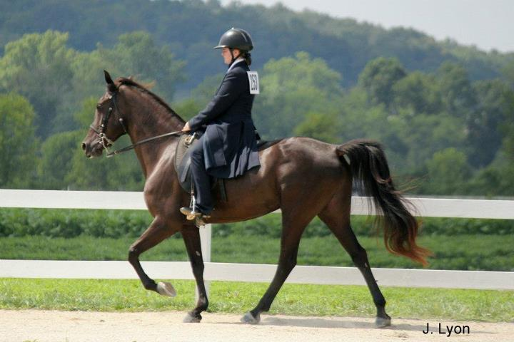
Eleven year old Pepper has become an awesome competitive trail horse. Even though she has won many awards in the show ring including the RMH International Western Grand Championship, she excels at trail obstacle. Look for her at fun shows and ACTHA rides this year. She is owned by Charlie and Erin DeAtley, Carlisle, KY.
^{[top of page]}
Gaitway's Jasmine Joy
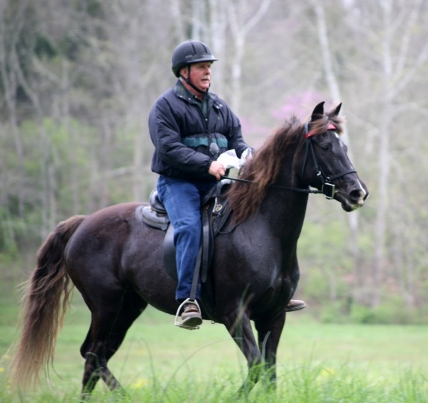
As a UMH Reserve World Grand Champion Western Pleasure horse, “Jazzy” will be competing again in 2014. She has lots of talent and versatility. At the Three Phase Event, she and her trainer, Robert Lawson, received the highest dressage scores of anyone in the competition (several 8’s and 9’s). In addition to Steve and Robert showing her in the Country Trail Pleasure and versatility classes, Susan will be showing her in Novice classes this year. She’s well built and has a fantastic gait. She is owned by Steve and Susan Heuslein, LaCrescent, MN.
- UMH Spring Fling - Amateur CTP - 3rd - Steve
- UMH Spring Fling - M/G CTP - 3rd
- UMH Spring Fling - Novice CTP - 2nd - Susan
- UMH Spring Fling - CTP Championship - 3rd
- RMH City of Prestonsburg - RM CTP M/G - 2nd
- RMH City of Prestonsburg - RM CTP Champ. - 1st
- RMH Bluegrass Summer Jubilee - RMHA CTP M/G - 5th
- Fonzie Graham Memorial - UMH M/G Country Trail - 2nd
- Fonzie Graham Memorial - UMH Adult Trail Obstacle - 4th
- Fonzie Graham Memorial - RMH M/G Country Trail - 3rd
- Fonzie Graham Memorial - UMH Country Trail Champ - 3rd
- Mountain Horse Classic – UMH Novice CTP - 3rd - Susan
- Mountain Horse Classic – RMH Amateur CTP - 1st - Steve
- Mountain Horse Classic – UMH M/G CTP - 1st - Charlie
- Mountain Horse Classic – Lead Line - 1st - Aailyah Estes
- Mountain Horse Classic – UMH Open CTP Championship - 1st
- UMH World Show - Sr. Horse Trail Obstacle - 2nd
- UMH World Show - 5+ M/G Conformation - 4th
- RMH International - 10 + M/G Conformation - 4th
- RMH International - 10+ Amateur CTP - 6th - Steve
- RMH International - Novice CTP - 6th - Susan
- RMH International - 10+ M/G CTP - 4th
- RMH International - Adult Trail Obstacle - 4th
- RMH International - 6+ yr Open Western Pleas. - 4th
- UMH High Point Trail Obstacle - 3rd
- UMH High Point M/G CTP - 3rd
- UMH High Point Novice CTP - 2nd & 3rd - Susan
- RMH High Point CTP Mares - 1st
- RMH High Point Adult Trail Obstacle - 4th
- RMH High Point Novice CTP - 2nd – Susan
- RMH High Point Ladies CTP - 3rd - Susan
- RMH High Point Amateur CTP - 2nd - Steve
- RMH High Point CTP Championship - 4th
^{[top of page]}
Hidden Asset (Whiskey)
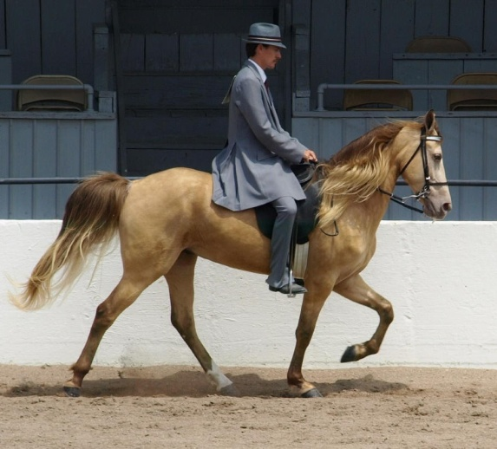
Five year old “Whiskey” is a beautiful Silver Buckskin. With his silky flowing mane, he sure catches your attention in the show ring. This year we will broaden his skill by adding western competition. Whiskey has a lovely spirit. Everyone around the barn enjoys riding him. Charlie, Robert, and Mary Kelly all share in his training. He’s a sweetheart.
- UMH Spring Fling - Adult Western - 3rd
- UMH Spring Fling - M/G CTP - 4th
- UMH Spring Fling - RMH - Geldings CTP - 2nd
- RMH Bluegrass Summer Jubilee - RMHA Western - 2nd
- RMH Bluegrass Summer Jubilee - RMHA CTP M/G - 3rd
- RMH Bluegrass Summer Jubilee - RMHA CTP Champ. - 2nd
- RMH Charles Kilburn Memorial - RMHA Western - 2nd
- RMH Charles Kilburn Memorial - RMHA CTP Trail M/G - 5th
- Fonzie Graham Memorial - UMH Adult Western - 3rd
- Fonzie Graham Memorial - UMH M/G Country Trail - 4th
- Mountain Horse Classic – UMH Adult Western - 4th
- Mountain Horse Classic – RMH CTP M/G - 3rd
- Mountain Horse Classic – RMH Western – 1st
- UMH World Show - Sr. Horse Western Pleasure - 2nd
- UMH World Show - Western WGC - 2nd
- UMH World Show - CTP WGC - 4th
- UMH World Show - 4+ M/G CTP - 4th
- RMH International - 5-9 yr M/G Conformation - 3rd
- RMH International - 4-5 yr M/G CTP - 2nd
- RMH International - Pole Bending - 5th
- RMH International - 5 yr Open Western - 2nd
- RMH International - M/G CTP Champ. - 7th
- UMH High Point Adult Western - 2nd
- RMH High Point Western Pleasure - 2nd
- RMH High Point Adult Trail Obstacle - 4th
^{[top of page]}
Silver's Midnight Special
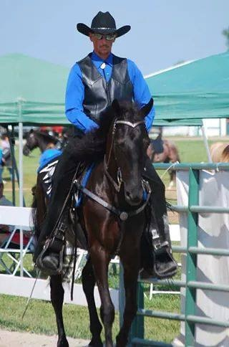
Silver’s Midnight Special is following in the footsteps of her sire SRF’s Silver Sundown. She is sure-footed, willing, and talented. We are so pleased with her debut as a three year old this season. She wrapped up the season with two RMH High Point Awards in both the 3 Year Old Trail and the 3 Year Old Country Trail divisions. Congratulations to Steve and Susan Heuslein on this outstanding filly!
- RMH Charles Kilburn Memorial - UMH CTP Trail - 3rd
- RMH Charles Kilburn Memorial - RMHA 3 & 4 YO Trail - 3rd
- RMH Bluegrass Summer Jubilee - RMHA 3 & 4 YO Trail - 2nd
- Fonzie Graham Memorial - UMH 3-4 YO Trail - 5th
- Fonzie Graham Memorial - M/G Trail - 5th
- UMH World Show - Jr. Horse Trail Obstacle - 5th
- UMH World Show - Q - 2 & 3 YO M/G CTP - 1st
- UMH World Show - 2 & 3 YO M/G CTP - 4th
- UMH World Show - Novice CTP - 2nd - Susan
- RMH International - 3-4 yr M/G Conformation - 8th
- RMH International - Novice CTP - 2nd - Susan
- RMH International - 3 yr Open CTP - 1st
- RMH International - Pole Bending - 7th
- RMH International - 3 yr Amateur CTP - 1st - Steve
- RMH International - 3-5 yr Open Western - 1st
- RMH International - M/G CTP Champ. - 9th
- RMH International - Western Pleas. Grand Champ. - 3rd
- RMH International - M/G CTP Grand
- UMH High Point 2 & 3 YO CTP - 3rd
- RMH High Point 3 YO CTP - 1st
- RMH High Point 3 YO Trail Pleasure 1st
^{[top of page]}
My Sweet Sydney
- RMH Bluegrass Summer Jubilee - RMH CTP M/G - 2nd
- RMH Bluegrass Summer Jubilee - RMHA CTP Champ - 4th
- RMH Charles Kilburn Memorial - RMHA CTP M/G - 3rd
- RMH Charles Kilburn Memorial - UMH CTP M/G - 2nd
- RMH Charles Kilburn Memorial - RMHA CTP Champ - 2nd
- Fonzie Graham Memorial - RMH M/G Country Trail - 5th
- Mountain Horse Classic – RMH CTP M/G - 4th
- Mountain Horse Classic – UMH Amateur CTP - 2nd - Steve
- Mountain Horse Classic – UMH M/G CTP – 4th - Mary Kelley
- RMH International - 5-9 yr M/G Conformation - 8
- RMH International - 6-9 yr M/G CTP - 7th
- RMH International - Adult Trail Obstacle - 10th
- RMH International - Men’s CTP - 7th
- RMH International - Ladies CTP - 3rd
- RMH High Point CTP Mares - 2nd
- RMH CTP Champ. - 3rd - Mary Kelley
^{[top of page]}

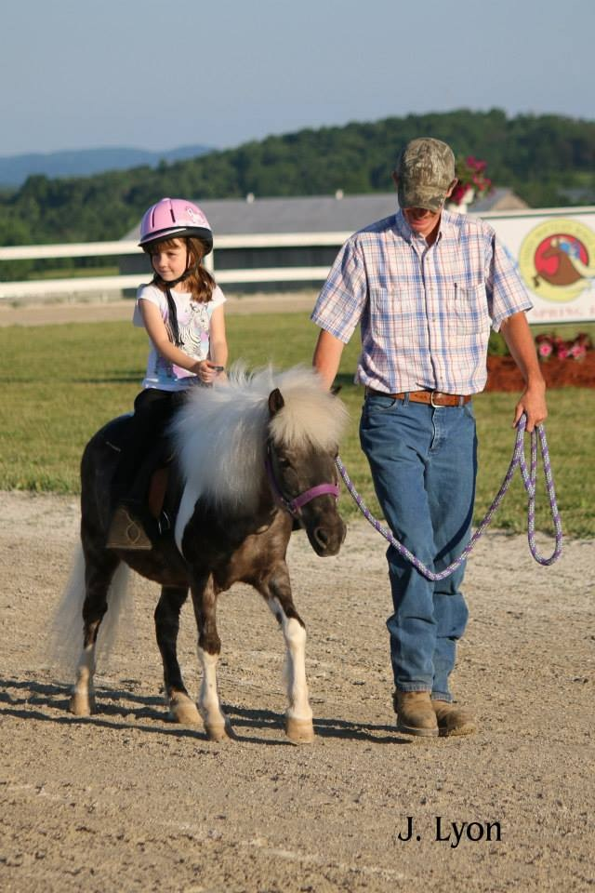
Butterscotch
What a cutie! Look for Ruby and her pony in the Lead Line classes this summer. She is excited and ready to ride. She is having a great time working with Butterscotch in the round pen, over the obstacles, and on the rail. What fun!
- UMH Spring Fling - Lead Line - 1st - Ruby
- Fonzie Graham Memorial - Lead Line - 1st
- Mountain Horse Classic – Lead Line - Ruby - 1st
^{[top of page]}
Moriah Mae
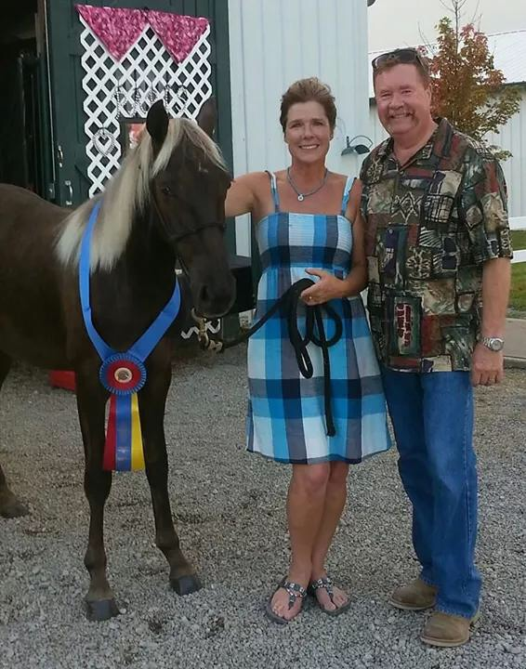
Congratulations to this beautiful filly! With only a few weeks of training, she was able to capture both the UMH Yearling Championship and the RMH International 2 Year Old and Under Conformation Championships. She is by SRF’s Silver Sundown and out of Sundown Special (a Tobe grand daughter). Keep watching for this little lady in the future. She is owned by Steve and Susan Heuslein.
- UMH World Show - Yearling Conformation WGC - 1st
- RMH International - Open Yearling Conformation - 2nd
- RMH International - 2yr and Under Open Conformation Championship - 1st
- UMH High Point Yearling Conf. Champ. - 1st
- RMH High Point Yearling Fillies & Colts 4th

