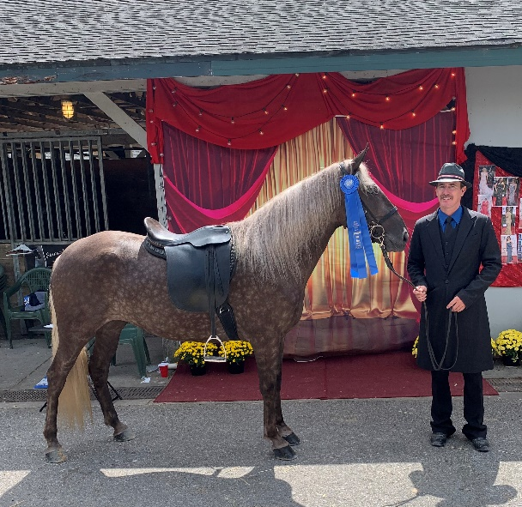

**Chicago Blues owned by Steve and Susan Heuslein**

Open 3 & 4 yo Spring Kickoff Trail Pleasure - 1st

Bluegrass Showcase Open 3 & $ YO Trail - 1st

RMHA Carter County Shrine Club M/G Trail - 3rd

RMHA Lewisburg-Millcreek Lions Club 3 YO Trail Pleasure - 1st

RMHA Get Your Pink On 3 YO Trail - 2nd

RMHA Tollesboro Lions Club 3 YO Trail Pleas. - 1st

Gaited Horse Gala Open 3 YO Trail - 1st

RMHA International 3-4 yo M/G Conformation - 5th - MK

RMHA International 3 yo F/G CTP - 2nd

RMHA International 3 yo F/G Trail - 1st

RMHA International 3 yo Trail Pleas. Champ - 2nd

RMHA High Point 3 yo Trail Pleasure - 1st