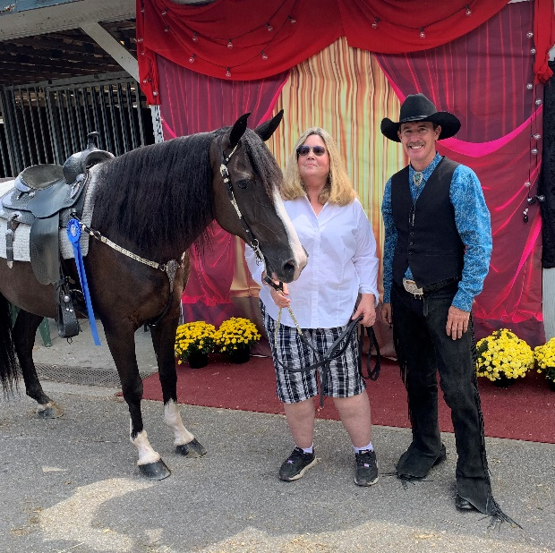

**WOF’s Wind Commander owned by Ann Day**

RMHASpring Kickoff Open Ladies Pleasure - 3rd - Ann

RMHA Sharon Copher Memorial Western - 2nd - MK

RMHA Sharon Copher Memorial Trail M/G - 3rd

RMHA Bluegrass Showcase M/G Trail - 3rd

RMHA Bluegrass Showcase Amateur Trail - 4th - Melisse

RMHA Lee County Saddle Club Summer Celebration M/G Trail - 4th

Get Your Pink On Adult Trail Obstacle - 2nd

RMHA Get Your Pink On M/G Trail - 3rd

RMHA Owingsville Lions Club M/G Trail - 5th

RMHA Tollesboro Lions Club M/G Trail - 5th

RMHA Tollesboro Lions Club Amateur Trail - 4th - Melisse

RMHA Gaited Horse Gala M/G Trail - 3rd

RMHA Annual Carter County Shrine Show Pleasure M/G Trail - 1st

RMHA Annual Carter County Shrine Show Pleasure Amateur Trail - 1st - Melisse

RMHA International 10+ M/G Conformation - 2nd

RMHA International 10+ M,G,S Trail - 5th

RMHA International Senior Rider – 2nd - Ann

RMHA International Costume Class – 1st

RMHA International 6+ Open Western - 1st

RMHA International Western Grand Champ - 2nd

RMHA International Geldings Trail Pleas. - 5th

RMHA International Adult Water Glass – 3rd

RMHA International Adult Pole Bending - 4th

RMHA International Rea Swan Versatility Award

RMHA High Point Geldings Trail Pleasure - 2nd

RMHA Versatility Award with Ann Day Bronze level